Wallkill Reporting Draft

NYSDEC SMAS

2020-10-30

# Section 1 - General

Table : Wallkill River (WALK) sampling locations. Locations are ordered from upstream to downstream according to river mile and mainstem confluence

| **Location ID** | **Group** | **Rivermile** | **WI/PWL** | **Waterbody   Classification** | **Description** | **Latitude** | **Longitude** |
| --- | --- | --- | --- | --- | --- | --- | --- |
| 13-WALK-60.1 | Wallkill Main Stem | 60.1 | 1306-0017 | C | OIL CITY RD. AT USFWS WILDLIFE REFUGE (BEFORE 2017. SAMPLES WERE TAKEN 0.4 MILES OFF STATE LINE RD. ON FARM RD.). | 41.29083 | -74.53056 |
| 13-POCH-1.8 | Upper Wallkill Trib | 1.8 | 1306-0078 | C | TRANSPORT LN OFF COUTNY ROUTE 1. ACCESS BEHIND BARN NEXT TO CALF PEN. FOLLOW PEN OM THE LEFT SIDE AND ACCESS RIVER FROM BEHIND. | 41.30042 | -74.47224 |
| 13-RUTG-1.5 | Upper Wallkill Trib | 1.5 | 1306-0006 | C | 20 METERS DOWNSTREAM OF COUNTY RTE 12. | 41.33579 | -74.48799 |
| 13-QKER-0.9 | Upper Wallkill Trib | 0.9 | 1306-0025 | C | 30 M BELOW RT. 6 BRIDGE. | 41.32722 | -74.41639 |
| 13-RIOG-0.7 | Upper Wallkill Trib | 0.7 | 1306-0061 | C | AT 6 1/2 STATION RD. OVERPASS. DOWNSTREAM OF VILLAGE OF GOSHEN. | 41.40115 | -74.35923 |
| 13-WCHEE-0.6 | Upper Wallkill Trib | 0.6 | 1306-0061 | C | HARTLEY RD. | 41.40860 | -74.37299 |
| 13-WALK-46.6 | Wallkill Main Stem | 46.6 | 1306-0017 | C | AT ECHO LAKE RD. BRIDGE. | 41.41222 | -74.37805 |
| 13-MONH-4.1 | Upper Wallkill Trib | 4.1 | 1306-0074 | C | 200 M UPSTREAM OF MIDDLETOWN STP DISCHARGE. | 41.42833 | -74.42389 |
| 13-MONH-0.4 | Upper Wallkill Trib | 0.4 | 1306-0074 | C | 20 M ABOVE GOLF LINKS RD. BRIDGE. 4.1 MI. BELOW STP. | 41.42361 | -74.38111 |
| 13-LGUN-6.0 | Upper Wallkill Trib | 6.0 | 1306-0059 | B | AT MAPES RD. BRIDGE. | 41.45587 | -74.49380 |
| 13-GUNK-40.3 | Upper Wallkill Trib | 40.3 | 1306-0048 | A | AT KOHLER RD. | 41.42198 | -74.56069 |
| 13-GUNK-37.7 | Upper Wallkill Trib | 37.7 | 1306-0047 | B | AT RTE 24 BRIDGE. | 41.44134 | -74.52977 |
| 13-GUNK_T35-0.2 | Upper Wallkill Trib | 0.2 | 1306-0047 | B | AT RTE 24 BRIDGE. | 41.43961 | -74.53890 |
| 13-MASO-0.2 | Upper Wallkill Trib | 0.2 | 1306-0072 | B | AT COUNTY ROUTE 50 (GOLF LINKS RD.) OVERPASS. UPSTREAM OF CONFLUENCE WITH WALLKILL RIVER. | 41.43765 | -74.37287 |
| 13-WALK-44.4 | Wallkill Main Stem | 44.4 | 1306-0038 | B | AT MIDWAY RD. BRIDGE. | 41.43879 | -74.36565 |
| 13-WALK-35.6 | Wallkill Main Stem | 35.6 | 1306-0038 | B | 20 M BELOW RT. 211 BRIDGE. | 41.50250 | -74.26334 |
| 13-WALK-29.9 | Wallkill Main Stem | 29.9 | 1306-0038 | B | ACCESS VIA PARK ON FARM MEADOW LANE. | 41.54217 | -74.20946 |
| 13-TINW-0.5 | Middle Wallkill Trib | 0.5 | 1306-0068 | A | AT ULSTER AVE./RTE 208 BRIDGE. | 41.57325 | -74.18353 |
| 13-WALK-26.9 | Wallkill Main Stem | 26.9 | 1306-0038 | B | DOWNSTREAM OF TIN BROOK. SR 208. | 41.57630 | -74.19071 |
| 13-DWAR-2.0 | Middle Wallkill Trib | 2.0 | 1306-0062 | C | 10 M ABOVE BATES RD. BRIDGE. | 41.62444 | -74.19945 |
| 13-WALK-22.8 | Wallkill Main Stem | 22.8 | 1306-0038 | B | 10 M ABOVE BRIDGE. | 41.63500 | -74.18889 |
| 13-WALK-19.0 | Wallkill Main Stem | 19.0 | 1306-0045 | B | LAZY RIVER CAMPGROUND-20 M ABOVE SHAWANGUNK CONFL. | 41.68306 | -74.16444 |
| 13-GUNK-0.4 | Middle Wallkill Trib | 0.4 | 1306-0045 | B | 150 M BELOW CO. RT. 9 BRIDGE. | 41.68722 | -74.17278 |
| 13-PKIL-0.4 | Middle Wallkill Trib | 0.4 | 1306-0044 | B(T) | 10 M ABOVE RTE 208 BRIDGE. | 41.72528 | -74.10472 |
| 13-WALK-9.8 | Wallkill Main Stem | 9.8 | 1306-0027 | B | (MULTIPLATE) UPSTREAM OF NEW PALTZ GOLF COURSE. BOAT LAUNCH UPSTREAM OF RTE 209 AT 41.743779 / -74.092916. | 41.76574 | -74.09297 |
| 13-WKLEI-0.6 | Lower Wallkill Trib | 0.6 | 1306-0042 | C | DUG RD. | 41.77490 | -74.09750 |
| 13-WALK-2.1 | Wallkill Main Stem | 2.1 | 1306-0027 | B | OFF SR 213. NEAR DASHVILLE. | 41.82530 | -74.04720 |
| 13-WALK-0.7 | Wallkill Main Stem | 0.7 | 1306-0037 | B | STURGEON POOL DEEP HOLE. | 41.84705 | -74.04382 |
| 13-SWAK-1.7 | Lower Wallkill Trib | 1.7 | 1306-0039 | B |  | 41.83242 | -74.03169 |
| 13-WALK-0.8 | Wallkill Main Stem | 0.8 | 1306-0037 | B | AT SHORELINE OF STURGEON POOL. CLOSEST MAY BE OFF SR 213. | 41.84790 | -74.03718 |

# Section 1A - Water Chemistry and Stream Discharge

## Analyte Table

Table : Water chemistry analytes sampled as part of the Wallkill River Stream Assessment Survey. Table lists sampled analytes and analytical specifications. ^ Precision objectives are defined by results of duplicate samples as described in Appendix III

| **Analytes** | **Analytical  Lab** | **Method** | **Precision** | **Accuracy** | **Calibration:   Initial** | **Calibration:   Ongoing** | **Calibration:   Blanks** | **Detection   Limit** | **Reporting   Limit** |
| --- | --- | --- | --- | --- | --- | --- | --- | --- | --- |
| Temperature | in situ | 2550 B | ± 1oC | ± 1.5oC | Factory Set | ~ | ~ | ~ | ~ |
| Dissolved Oxygen | in situ | 4500-O G | ± 1% | ± 2% | Daily | ~ | ~ | ~ | ~ |
| pH | in situ | 4500-H+B | ± .05 SU | ± .2 SU | Weekly | ~ | ~ | ~ | ~ |
| Salinity | in situ | Calculated | 0.001 ppt | ± 1% | N/A | ~ | ~ | ~ | ~ |
| Specific Conductance | in situ | 2510 B | ± 1µs/cm | ± 1% | Weekly | ~ | ~ | ~ | ~ |
| Ammonia | ALS | D6919-09 | ^ | ± 20% | As needed | Every 10 | Every 10 | 0.008 mg/L | 0.01 mg/L |
| Total Kjeldahl Nitrogen | ALS | EPA 351.2 | ^ | ± 20% | Daily | Every 10 | Every 10 | 0.08 mg/L | 0.1 mg/L |
| Nitrogen, Nitrate | ALS | EPA 353.2 | ^ | ± 20% | Daily | Every 10 | Every 10 | 0.02 mg/L | 0.05 mg/L |
| Nitrogen, Total | ALS | Calculated | ^ |  |  |  |  |  |  |
| Total Phosphorus | ALS | EPA 365.1 | ^ | ± 20% | Daily | Every 10 | Every 10 | 0.002 mg/L | 0.003 mg/L |
| Ortho-phosphate | ALS | EPA 365.1 | ^ | ± 20% | Daily | Every 10 | Every 10 | 0.001 mg/L | 0.005 mg/L |
| Total Dissolved Solids | ALS | SM 2540C | ^ | ± 20% | Daily | Every 20 | Every 20 | 4.0 mg/L | 10 mg/L |
| Turbidity | ALS | EPA 180.1 | ^ | ± 10% | Daily | Every 10 | Every 10 | 0.06 NTU | 0.1 NTU |
| Dissolved Organic Carbon | ALS | 5310C | ^ | ± 20% | As needed | Ever 10 | Every 10 | 0.4 mg/L | 10 mg/L |
| Alkalinity | ALS | SM 2320B | ^ | ± 20% | Daily | Every 10 | Every 10 | 1.0 mg/L | 2.0 mg/L |
| Hardness | ALS | SM 2340C | ^ | ± 20% | Daily | Every 10 | Every 10 | 0.3 mg/L | 2.0 mg/L |
| Calcium | ALS | EPA 200.7 | ^ | ± 20% | Daily | Every 10 | Every 10 | 0.1 mg/L | 1.0 mg/L |
| Magnesium | ALS | EPA 200.7 | ^ | ± 20% | Daily | Every 10 | Every 10 | 0.04 mg/L | 1.0 mg/L |
| Potassium | ALS | EPA 200.7 | ^ | ± 20% | Daily | Every 10 | Every 10 | 0.06 mg/L | 2.0 mg/L |
| Sodium | ALS | EPA 200.7 | ^ | ± 20% | Daily | Every 10 | Every 10 | 0.03 mg/L | 1.0 mg/L |
| Chloride | ALS | EPA 300.0 | ^ | ± 20% | As needed | Every 10 | Every 10 | 0.02 mg/L | 0.2 mg/L |
| Fluoride | ALS | EPA 300.0 | ^ | ± 20% | As needed | Every 10 | Every 10 | 0.004 mg/L | 0.1 mg/L |
| Sulfate | ALS | EPA 300.0 | ^ | ± 20% | As needed | Every 10 | Every 10 | 0.02 mg/L | 0.2 mg/L |
| Iron (total) | ALS | EPA 200.7 | ^ | ± 20% | Daily | Every 10 | Every 10 | 6 µ/L | 100 µ/L |
| Manganese (total) | ALS | EPA 200.7 | ^ | ± 20% | Daily | Every 10 | Every 10 | 0.5 µ/L | 10 µ/L |
| Arsenic (total) | ALS | EPA 200.8 | ^ | ± 20% | Daily | Every 10 | Every 10 | 0.3 µ/L | 1 µ/L |
| Silver (total) | ALS | EPA 200.8 | ^ | ± 20% | Daily | Every 10 | Every 10 | 0.07 µ/L | 1 µ/L |
| Aluminum (total) | ALS | EPA 200.8 | ^ | ± 20% | Daily | Every 10 | Every 10 | 4.0 µ/L | 50 µ/L |
| Cadmium (total) | ALS | EPA 200.8 | ^ | ± 20% | Daily | Every 10 | Every 10 | 0.03 µ/L | 1 µ/L |
| Copper (total) | ALS | EPA 200.8 | ^ | ± 20% | Daily | Every 10 | Every 10 | 0.04 µ/L | 1 µ/L |
| Lead (total) | ALS | EPA 200.8 | ^ | ± 20% | Daily | Every 10 | Every 10 | 0.08 µ/L | 1 µ/L |
| Nickel (total) | ALS | EPA 200.8 | ^ | ± 20% | Daily | Every 10 | Every 10 | 0.04 µ/L | 1 µ/L |
| Zinc (total) | ALS | EPA 200.8 | ^ | ± 20% | Daily | Every 10 | Every 10 | 0.7 µ/L | 10 µ/L |
| Aluminum (dissolved) | ALS | EPA 200.8 | ^ | ± 20% | Daily | Every 10 | Every 10 | 0.9 µ/L | 10 µ/L |
| Cadmium (dissolved) | ALS | EPA 200.8 | ^ | ± 20% | Daily | Every 10 | Every 10 | 0.02 µ/L | 1 µ/L |
| Copper (dissolved) | ALS | EPA 200.8 | ^ | ± 20% | Daily | Every 10 | Every 10 | 0.02 µ/L | 1 µ/L |
| Lead (dissolved) | ALS | EPA 200.8 | ^ | ± 20% | Daily | Every 10 | Every 10 | 0.02 µ/L | 1 µ/L |
| Nickel (dissolved) | ALS | EPA 200.8 | ^ | ± 20% | Daily | Every 10 | Every 10 | 0.1 µ/L | 1 µ/L |
| Zinc (dissolved) | ALS | EPA 200.8 | ^ | ± 20% | Daily | Every 10 | Every 10 | 3 µ/L | 5 µ/L |

## Water Chemistry by PWL ID

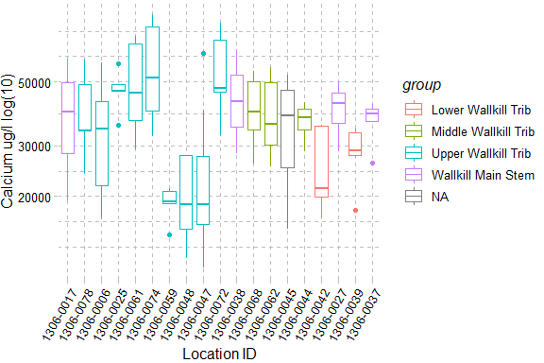

Figure : Calcium, The X-axis presents sampling locations from upstream to downstream and axis labels correspond with Table 1, Figure 1 and Figure 2. Point symbols match with WI/PWL segmentation as indicated in the plot legend. The total number of reported values illustrated for each sampling location can vary due to non-detection and QA/QC procedures. Descriptions of removed records are presented in Appendix III.

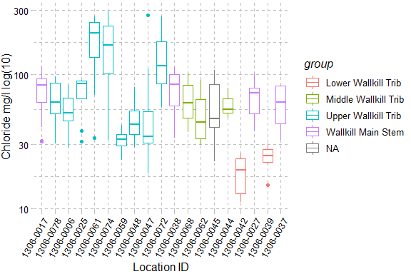

Figure : Chloride, The X-axis presents sampling locations from upstream to downstream and axis labels correspond with Table 1, Figure 1 and Figure 2. Point symbols match with WI/PWL segmentation as indicated in the plot legend. The total number of reported values illustrated for each sampling location can vary due to non-detection and QA/QC procedures. Descriptions of removed records are presented in Appendix III.

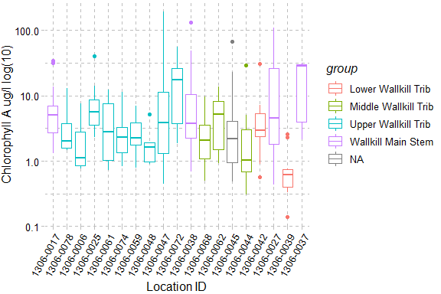

Figure : Chlorophyll A, The X-axis presents sampling locations from upstream to downstream and axis labels correspond with Table 1, Figure 1 and Figure 2. Point symbols match with WI/PWL segmentation as indicated in the plot legend. The total number of reported values illustrated for each sampling location can vary due to non-detection and QA/QC procedures. Descriptions of removed records are presented in Appendix III.

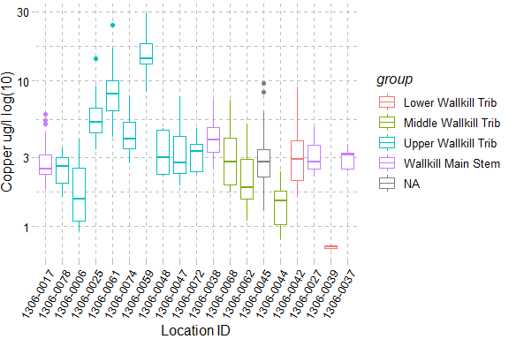

Figure : Copper, The X-axis presents sampling locations from upstream to downstream and axis labels correspond with Table 1, Figure 1 and Figure 2. Point symbols match with WI/PWL segmentation as indicated in the plot legend. The total number of reported values illustrated for each sampling location can vary due to non-detection and QA/QC procedures. Descriptions of removed records are presented in Appendix III.

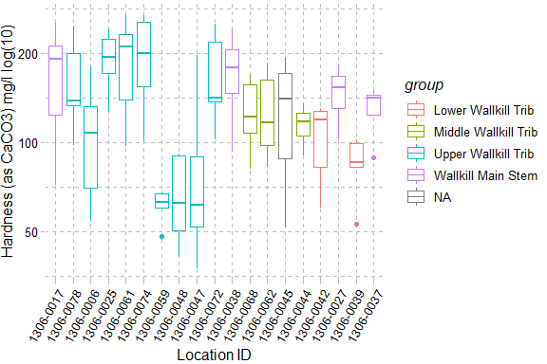

Figure : Hardness (as CaCO3), The X-axis presents sampling locations from upstream to downstream and axis labels correspond with Table 1, Figure 1 and Figure 2. Point symbols match with WI/PWL segmentation as indicated in the plot legend. The total number of reported values illustrated for each sampling location can vary due to non-detection and QA/QC procedures. Descriptions of removed records are presented in Appendix III.

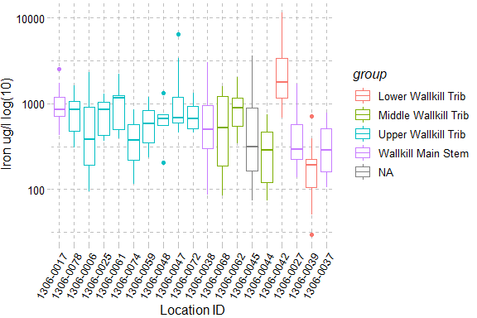

Figure : Iron, The X-axis presents sampling locations from upstream to downstream and axis labels correspond with Table 1, Figure 1 and Figure 2. Point symbols match with WI/PWL segmentation as indicated in the plot legend. The total number of reported values illustrated for each sampling location can vary due to non-detection and QA/QC procedures. Descriptions of removed records are presented in Appendix III.

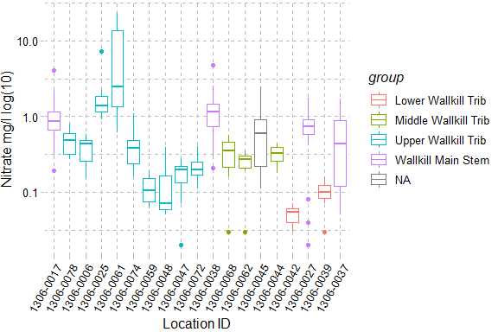

Figure : Nitrate, The X-axis presents sampling locations from upstream to downstream and axis labels correspond with Table 1, Figure 1 and Figure 2. Point symbols match with WI/PWL segmentation as indicated in the plot legend. The total number of reported values illustrated for each sampling location can vary due to non-detection and QA/QC procedures. Descriptions of removed records are presented in Appendix III.

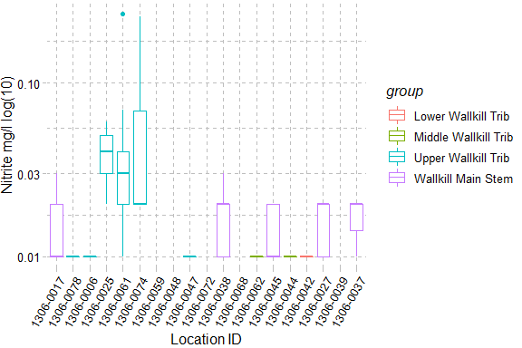

Figure : Nitrite, The X-axis presents sampling locations from upstream to downstream and axis labels correspond with Table 1, Figure 1 and Figure 2. Point symbols match with WI/PWL segmentation as indicated in the plot legend. The total number of reported values illustrated for each sampling location can vary due to non-detection and QA/QC procedures. Descriptions of removed records are presented in Appendix III.

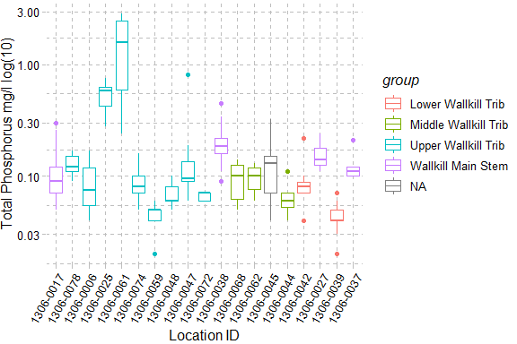

Figure : Total Phosphorus, The X-axis presents sampling locations from upstream to downstream and axis labels correspond with Table 1, Figure 1 and Figure 2. Point symbols match with WI/PWL segmentation as indicated in the plot legend. The total number of reported values illustrated for each sampling location can vary due to non-detection and QA/QC procedures. Descriptions of removed records are presented in Appendix III.

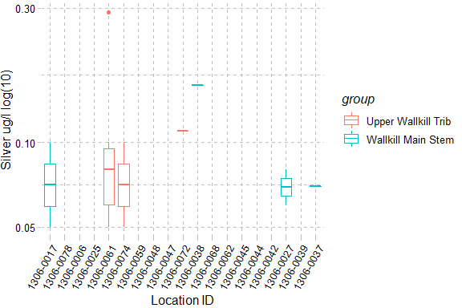

Figure : Silver, The X-axis presents sampling locations from upstream to downstream and axis labels correspond with Table 1, Figure 1 and Figure 2. Point symbols match with WI/PWL segmentation as indicated in the plot legend. The total number of reported values illustrated for each sampling location can vary due to non-detection and QA/QC procedures. Descriptions of removed records are presented in Appendix III.

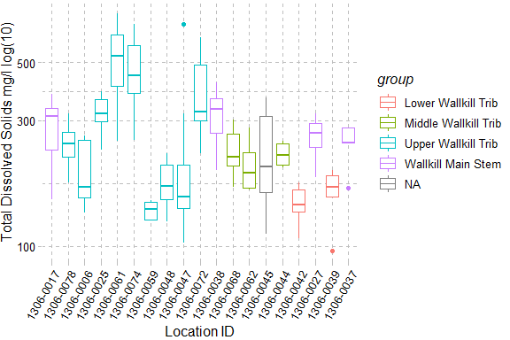

Figure : Total Dissolved Solids, The X-axis presents sampling locations from upstream to downstream and axis labels correspond with Table 1, Figure 1 and Figure 2. Point symbols match with WI/PWL segmentation as indicated in the plot legend. The total number of reported values illustrated for each sampling location can vary due to non-detection and QA/QC procedures. Descriptions of removed records are presented in Appendix III.

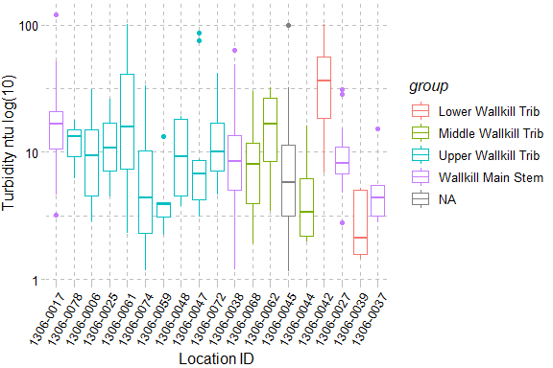

Figure : Turbidity, The X-axis presents sampling locations from upstream to downstream and axis labels correspond with Table 1, Figure 1 and Figure 2. Point symbols match with WI/PWL segmentation as indicated in the plot legend. The total number of reported values illustrated for each sampling location can vary due to non-detection and QA/QC procedures. Descriptions of removed records are presented in Appendix III.

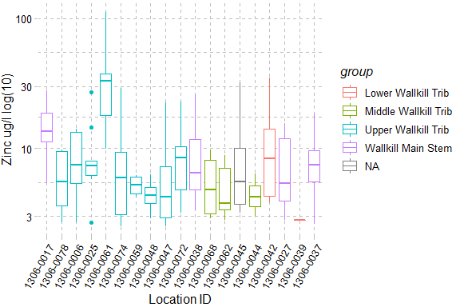

Figure : Zinc, The X-axis presents sampling locations from upstream to downstream and axis labels correspond with Table 1, Figure 1 and Figure 2. Point symbols match with WI/PWL segmentation as indicated in the plot legend. The total number of reported values illustrated for each sampling location can vary due to non-detection and QA/QC procedures. Descriptions of removed records are presented in Appendix III.

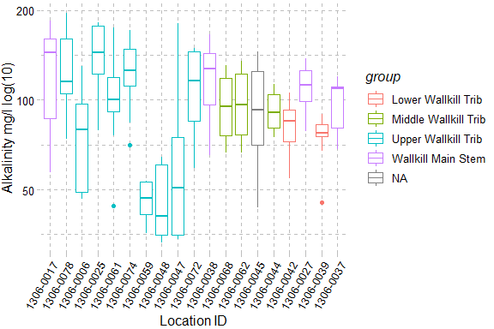

Figure : Alkalinity, The X-axis presents sampling locations from upstream to downstream and axis labels correspond with Table 1, Figure 1 and Figure 2. Point symbols match with WI/PWL segmentation as indicated in the plot legend. The total number of reported values illustrated for each sampling location can vary due to non-detection and QA/QC procedures. Descriptions of removed records are presented in Appendix III.

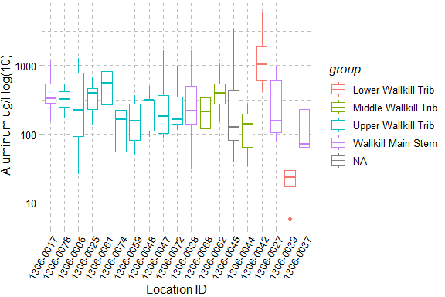

Figure : Aluminum, The X-axis presents sampling locations from upstream to downstream and axis labels correspond with Table 1, Figure 1 and Figure 2. Point symbols match with WI/PWL segmentation as indicated in the plot legend. The total number of reported values illustrated for each sampling location can vary due to non-detection and QA/QC procedures. Descriptions of removed records are presented in Appendix III.

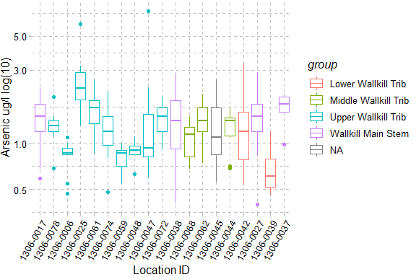

Figure : Arsenic, The X-axis presents sampling locations from upstream to downstream and axis labels correspond with Table 1, Figure 1 and Figure 2. Point symbols match with WI/PWL segmentation as indicated in the plot legend. The total number of reported values illustrated for each sampling location can vary due to non-detection and QA/QC procedures. Descriptions of removed records are presented in Appendix III.

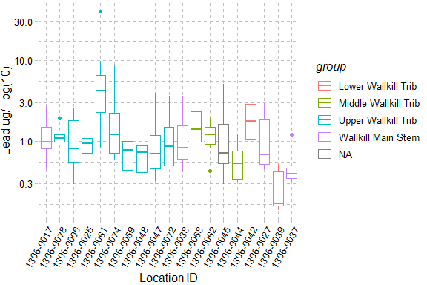

Figure : Lead, The X-axis presents sampling locations from upstream to downstream and axis labels correspond with Table 1, Figure 1 and Figure 2. Point symbols match with WI/PWL segmentation as indicated in the plot legend. The total number of reported values illustrated for each sampling location can vary due to non-detection and QA/QC procedures. Descriptions of removed records are presented in Appendix III.

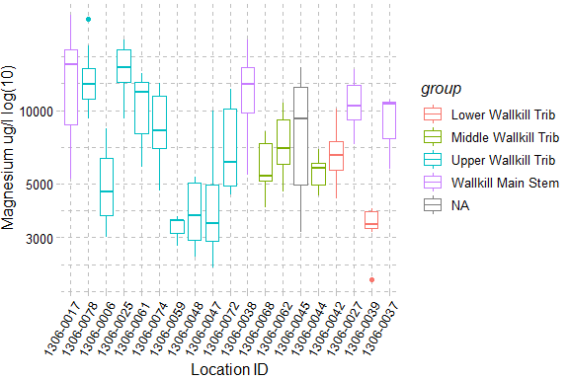

Figure : Magnesium, The X-axis presents sampling locations from upstream to downstream and axis labels correspond with Table 1, Figure 1 and Figure 2. Point symbols match with WI/PWL segmentation as indicated in the plot legend. The total number of reported values illustrated for each sampling location can vary due to non-detection and QA/QC procedures. Descriptions of removed records are presented in Appendix III.

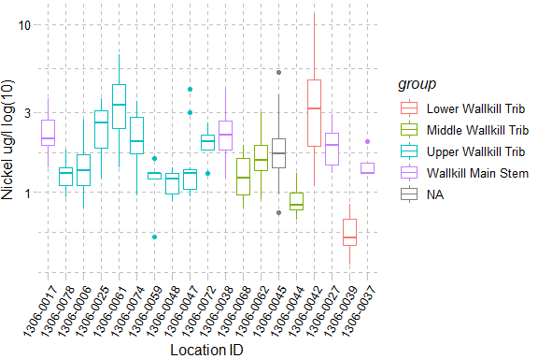

Figure : Nickel, The X-axis presents sampling locations from upstream to downstream and axis labels correspond with Table 1, Figure 1 and Figure 2. Point symbols match with WI/PWL segmentation as indicated in the plot legend. The total number of reported values illustrated for each sampling location can vary due to non-detection and QA/QC procedures. Descriptions of removed records are presented in Appendix III.

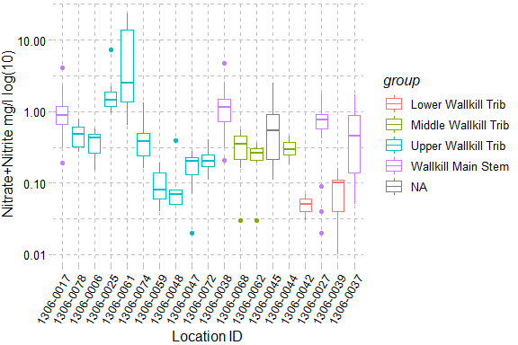

Figure : Nitrate+Nitrite, The X-axis presents sampling locations from upstream to downstream and axis labels correspond with Table 1, Figure 1 and Figure 2. Point symbols match with WI/PWL segmentation as indicated in the plot legend. The total number of reported values illustrated for each sampling location can vary due to non-detection and QA/QC procedures. Descriptions of removed records are presented in Appendix III.

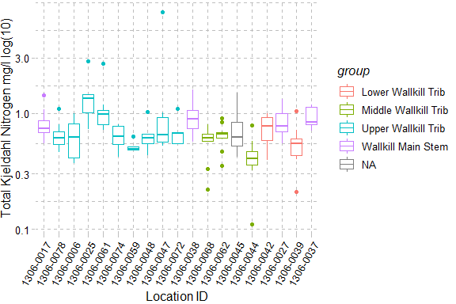

Figure : Total Kjeldahl Nitrogen, The X-axis presents sampling locations from upstream to downstream and axis labels correspond with Table 1, Figure 1 and Figure 2. Point symbols match with WI/PWL segmentation as indicated in the plot legend. The total number of reported values illustrated for each sampling location can vary due to non-detection and QA/QC procedures. Descriptions of removed records are presented in Appendix III.

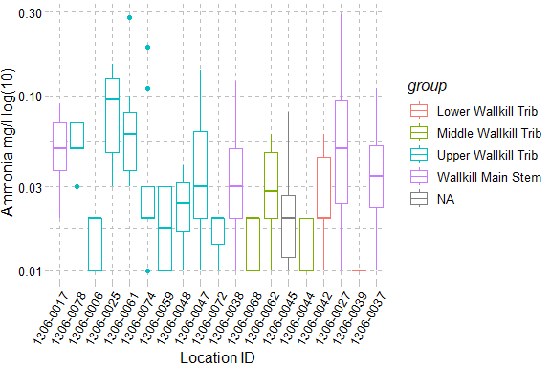

Figure : Ammonia, The X-axis presents sampling locations from upstream to downstream and axis labels correspond with Table 1, Figure 1 and Figure 2. Point symbols match with WI/PWL segmentation as indicated in the plot legend. The total number of reported values illustrated for each sampling location can vary due to non-detection and QA/QC procedures. Descriptions of removed records are presented in Appendix III.

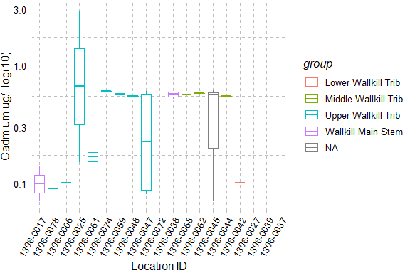

Figure : Cadmium, The X-axis presents sampling locations from upstream to downstream and axis labels correspond with Table 1, Figure 1 and Figure 2. Point symbols match with WI/PWL segmentation as indicated in the plot legend. The total number of reported values illustrated for each sampling location can vary due to non-detection and QA/QC procedures. Descriptions of removed records are presented in Appendix III.

# Section 1B - Benthic Macroinvertebrate Community

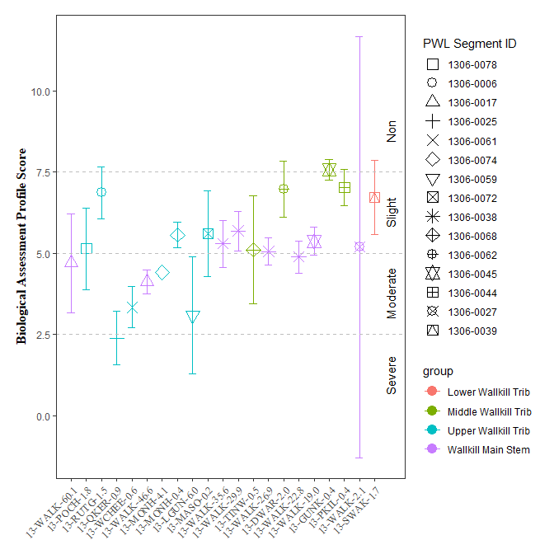

Figure : Biological Assessment Profile (BAP) Scores and 95% confidence intervals for benthic macroinvertebrate community assessment data for the Wallkill River Survey, 2017-2019. Symbology corresponds with WI/PWL segmentation as indicated in the plot legend.

# Section 1C - Stream Reach Physical Characteristics

Table : Ranked habitat characteristics and calculated HMA for the Wallkill River Survey, 2017-2019. Epifaunal substrate (Epi. Cover); Embeddedness/Pool Substrate Characterization (Embed. Pool.); Velocity Depth Regime/Pool Variability (Vel/Dep Reg.); Sediment Deposition (Sed. Dep.); Channel Flow Status (Flow Status); Channel Alteration (Chan. Alt.); Riffle Frequency/Stream Sinuosity (Rif. Freq.)

| **SITE_ID** | **Gradient** | **Epi.  Cover** | **Embed.   Pool.** | **Vel/Dep.   Reg.** | **Sed.   Dep.** | **Flow   Status** | **Chan.   Alt** | **Rif.   Freq** |
| --- | --- | --- | --- | --- | --- | --- | --- | --- |
| 13-WALK-60.1 | Low | 12.0 | 8.0 | 8.0 | 5.0 | 10.0 | 7.0 | 2.0 |
| 13-POCH-1.8 | High | 11.5 | 14.5 | 7.5 | 14.0 | 16.0 | 13.5 | 5.0 |
| 13-RUTG-1.5 | High | 15.5 | 15.0 | 15.0 | 14.0 | 16.5 | 15.5 | 14.5 |
| 13-QKER-0.9 | High | 13.0 | 3.0 | 9.0 | 3.0 | 18.0 | 12.0 | 5.0 |
| 13-QKER-0.9 | Low | 5.0 | 5.0 | 4.0 | 10.0 | 15.0 | 10.0 | 13.0 |
| 13-RIOG-0.7 | Low | 17.0 | NA | 14.0 | 15.0 | 15.0 | 16.0 | 13.0 |
| 13-WCHEE-0.6 | High | 10.5 | 12.5 | 10.5 | 10.5 | 18.5 | 15.5 | 9.5 |
| 13-WALK-46.6 | High | 13.5 | NA | NA | 7.5 | 16.5 | 11.5 | 7.5 |
| 13-MONH-4.1 | High | NA | 12.0 | 10.0 | 14.5 | 15.5 | 16.0 | 16.5 |
| 13-MONH-0.4 | High | 16.0 | 15.5 | 15.0 | 12.5 | 18.5 | 16.0 | 15.5 |
| 13-LGUN-6.0 | High | 9.0 | 20.0 | 10.0 | 11.0 | 19.0 | 19.0 | 13.0 |
| 13-GUNK-40.3 | High | 10.0 | 15.0 | 2.0 | 6.0 | 18.0 | 17.0 | 0.0 |
| 13-GUNK-37.7 | High | 11.0 | 15.0 | 10.0 | NA | 19.0 | 8.0 | 9.0 |
| 13-GUNK_T35-0.2 | High | 15.0 | 11.0 | 10.0 | 16.0 | 19.0 | 16.0 | 13.0 |
| 13-MASO-0.2 | High | 17.0 | 18.0 | 14.0 | 17.0 | 17.0 | 17.0 | 16.0 |
| 13-WALK-44.4 | High | 14.0 | 13.5 | 9.5 | 15.0 | 19.5 | 14.0 | 14.0 |
| 13-WALK-35.6 | High | 10.0 | 14.0 | 13.0 | 14.0 | 18.0 | 13.0 | 5.0 |
| 13-WALK-35.6 | Low | 11.0 | 12.0 | 18.0 | 17.0 | 19.0 | 19.0 | 9.0 |
| 13-WALK-29.9 | High | 11.0 | 17.0 | 13.5 | 18.0 | 20.0 | 19.0 | 12.0 |
| 13-TINW-0.5 | High | 10.5 | 12.5 | 11.0 | 7.5 | 17.0 | 16.5 | 11.0 |
| 13-WALK-26.9 | High | NA | 15.5 | 17.0 | 17.5 | 19.5 | 18.5 | 11.0 |
| 13-DWAR-2.0 | High | 13.5 | 18.5 | 14.5 | 16.0 | 15.5 | 18.5 | 15.0 |
| 13-WALK-22.8 | High | 15.0 | 16.0 | 14.5 | 16.0 | 20.0 | 14.0 | 15.5 |
| 13-WALK-19.0 | High | 16.0 | 17.0 | 15.0 | 11.0 | 18.5 | 13.5 | 15.5 |
| 13-GUNK-0.4 | High | 19.0 | 15.5 | 19.0 | 15.5 | 18.5 | 17.5 | 19.0 |
| 13-PKIL-0.4 | High | 14.5 | 14.0 | 14.0 | 14.5 | 15.5 | 14.5 | 16.0 |
| 13-WKLEI-0.6 | High | 9.0 | 4.0 | 10.0 | 5.0 | 14.0 | 18.0 | 5.0 |
| 13-WKLEI-0.6 | Low | 5.0 | 5.0 | 5.0 | 6.0 | 12.0 | 15.0 | 7.0 |
| 13-WALK-2.1 | Low | 15.0 | 13.0 | 11.0 | 11.0 | 17.0 | 15.0 | 14.0 |
| 13-SWAK-1.7 | High | 13.0 | 15.5 | 16.0 | 17.5 | 17.0 | 17.0 | 18.5 |

# Section 1D - User Perception

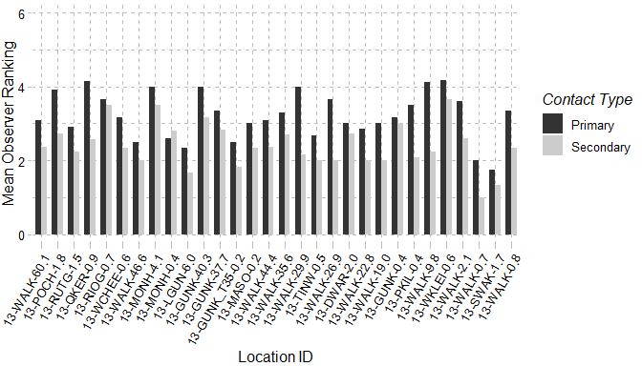

Figure : Mean observer ranking of recreational ability for Wallkill River sampling locations. Columns represent observer rankings for the desire to participate in 1° and 2° contact recreation. Ranking of recreation ability was performed for all locations during each site visit.

Table : Mean observer ranked value for factors influencing desire to participate in 1° and 2° contact recreation in the Wallkill River. Factors were ranked on a 10 scale (0 – Best/Natural; 10 Worst/Severe) according to perceived impact on a location. Ranking of recreation ability was performed for all locations during each site visit

| **Site   ID** | **Water   Clarity** | **Suspended  Phytoplankton** | **Periphyton** | **Macrophyte** | **Odor** | **Trash** | **Dishcarge   Pipes** |
| --- | --- | --- | --- | --- | --- | --- | --- |
| 13-WALK-60.1 | 5 | 0 | 1 | 1 | 0 | 1 | 0 |
| 13-POCH-1.8 | 6 | 1 | 3 | 0 | 2 | 0 | 0 |
| 13-RUTG-1.5 | 4 | 0 | 4 | 1 | 1 | 2 | 0 |
| 13-QKER-0.9 | 6 | 4 | 4 | 4 | 2 | 1 | 0 |
| 13-RIOG-0.7 | 2 | 0 | 3 | 1 | 3 | 2 | 0 |
| 13-WCHEE-0.6 | 6 | 1 | 2 | 0 | 1 | 1 | 0 |
| 13-WALK-46.6 | 4 | 0 | 3 | 1 | 0 | 1 | 0 |
| 13-MONH-4.1 | 3 | 0 | 6 | 2 | 5 | 2 | 2 |
| 13-MONH-0.4 | 2 | 0 | 3 | 0 | 5 | 2 | 1 |
| 13-LGUN-6.0 | 4 | 2 | 0 | 0 | 1 | 0 | 2 |
| 13-GUNK-40.3 | 5 | 1 | 3 | 2 | 3 | 1 | 2 |
| 13-GUNK-37.7 | 2 | 0 | 4 | 0 | 4 | 4 | 2 |
| 13-GUNK_T35-0.2 | 5 | 1 | 5 | 1 | 0 | 1 | 1 |
| 13-MASO-0.2 | 2 | 0 | 2 | 0 | 4 | 3 | 1 |
| 13-WALK-44.4 | 6 | 1 | 3 | 1 | 0 | 1 | 0 |
| 13-WALK-35.6 | 6 | 1 | 4 | 0 | 1 | 2 | 1 |
| 13-WALK-29.9 | 7 | 0 | 3 | 1 | 0 | 1 | 0 |
| 13-TINW-0.5 | 1 | 0 | 2 | 0 | 0 | 2 | 0 |
| 13-WALK-26.9 | 6 | 0 | 4 | 1 | 0 | 0 | 0 |
| 13-DWAR-2.0 | 4 | 0 | 4 | 2 | 1 | 3 | 2 |
| 13-WALK-22.8 | 6 | 0 | 3 | 1 | 0 | 2 | 0 |
| 13-WALK-19.0 | 7 | 0 | 4 | 1 | 1 | 3 | 0 |
| 13-GUNK-0.4 | 4 | 0 | 1 | 0 | 1 | 2 | 0 |
| 13-PKIL-0.4 | 3 | 0 | 4 | 2 | 0 | 1 | 0 |
| 13-WALK-9.8 | 7 | 0 | 4 | 1 | 0 | 1 | 0 |
| 13-WKLEI-0.6 | 8 | 1 | 3 | 0 | 1 | 0 | 0 |
| 13-WALK-2.1 | 6 | 0 | 2 | 2 | 0 | 1 | 0 |
| 13-WALK-0.7 | 6 | 0 | 3 | 0 | 0 | 0 | 0 |
| 13-SWAK-1.7 | 2 | 0 | 3 | 1 | 0 | 0 | 0 |
| 13-WALK-0.8 | 8 | 4 | 5 | 0 | 1 | 2 | 0 |

Table : Most frequently ranked factor influencing observer desire to participate in 1° and 2° contact recreation in the Wallkill River. Factors influencing desire to recreate were ranked and a primary factor influencing the desire to participate in 1° and 2° contact recreation was chosen during each site visit. Column values represent the factor selected most frequently at each site.

| **SITE_ID** | **Primary** | **Secondary** |
| --- | --- | --- |
| 13-WALK-60.1 | Water Clarity | None, Water clarity |
| 13-POCH-1.8 | Water Clarity | Water clarity |
| 13-RUTG-1.5 | Periphyton | Proximity to development roads |
| 13-QKER-0.9 | Water Clarity | Other, Suspended Phytoplankton, Water clarity |
| 13-RIOG-0.7 | Odor, Other | None |
| 13-WCHEE-0.6 | Water Clarity | None |
| 13-WALK-46.6 | Water Clarity | None, Other |
| 13-MONH-4.1 | Odor | Periphyton |
| 13-MONH-0.4 | Odor | Odor |
| 13-LGUN-6.0 | None, Other, Water Clarity | None |
| 13-GUNK-40.3 | Water Clarity | Other |
| 13-GUNK-37.7 | Odor, Periphyton | Trash |
| 13-GUNK_T35-0.2 | Water Clarity | Other |
| 13-MASO-0.2 | Odor | Other |
| 13-WALK-44.4 | Water Clarity | None, Water clarity |
| 13-WALK-35.6 | Water Clarity | None, Other, Water clarity |
| 13-WALK-29.9 | Water Clarity | Water clarity |
| 13-TINW-0.5 | None, Other, Water Clarity | None |
| 13-WALK-26.9 | Water Clarity | Other |
| 13-DWAR-2.0 | None, Water Clarity | None, Water clarity |
| 13-WALK-22.8 | Water Clarity | Other |
| 13-WALK-19.0 | Water Clarity | Water clarity |
| 13-GUNK-0.4 | Other, Water Clarity | None |
| 13-PKIL-0.4 | Proximity_to_Development_Roads, Water Clarity | None, Proximity to development roads |
| 13-WALK-9.8 | Water Clarity | Water clarity |
| 13-WKLEI-0.6 | Water Clarity | Water clarity |
| 13-WALK-2.1 | Water Clarity | None |
| 13-WALK-0.7 | None, Water Clarity | None |
| 13-SWAK-1.7 | None, Proximity_to_Development_Roads | None |
| 13-WALK-0.8 | Water Clarity | Suspended Phytoplankton |

# Section 1E - Sediment and Porewater Microtox® Analysis

Toxicity testing of surface waters, sediments, porewaters, and effluents are routinely performed as part of the RIBS program (<https://www.dec.ny.gov/chemical/29854.html>). Sediment toxicity was evaluated according to SOP #403-16 Microtox® Acute Toxicity Test for Sediments, Porewaters and Effluents. Testing procedures use a bioassay to assess potential acute toxicity in sediments and surface waters to aquatic life (SOP #403-16). Sediment and extracted sediment porewater samples are tested using a bioluminescent bacterium Vibrio fischeri (V. fischeri). Tests are a measure of light reduction between collected samples and a control following a 15-minute exposure period and expressed as the median effect concentration (EC50) of a sample that causes a 50% reduction in light emission from the V. fischeri. Appendix X (Fact Sheet: Acute & Chronic Toxicity Assessments of NY Streams & Rivers) describes toxicity testing procedures, Assessment criteria and results classifications.

Table : Wallkill River Microtox® sediment and porewater toxicity results for select locations in the Wallkill River Survey. Sediment samples were collected for toxicity testing in baseflow conditions during macroinvertebrate community collection at sampling locations.

| **Station ID** | **Sample Date** | **Sediment   Assessment** | **Porewater   Assessment** | **Sediment   EC50** | **Porewater   EC50** |
| --- | --- | --- | --- | --- | --- |
| 13-QKER-0.9 | 8/2/2017 | Non-toxic | Non-toxic | 78.18 | > 100 |
| 13-WCHEE-0.6 | 8/2/2017 | Non-toxic | Non-toxic | 65.38 | > 100 |
| 13-WALK-46.6 | 8/2/2017 | Severe | Non-toxic | 4.46 | > 100 |
| 13-MONH-4.1 | 7/26/2017 | Moderate | Non-toxic | 24.29 | > 100 |
| 13-MONH-0.4 | 8/2/2017 | Slight | Non-toxic | 42.21 | > 100 |
| 13-WALK-35.6 | 8/2/2017 | Moderate | Non-toxic | 38.73 | > 100 |
| 13-WALK-29.9 | 8/3/2017 | Slight | Non-toxic | 43.07 | > 100 |
| 13-WALK-26.9 | 8/3/2017 | Moderate | Toxic | 36.92 | 69.53 |
| 13-WALK-22.8 | 8/3/2017 | Slight | Non-toxic | 42.33 | > 100 |
| 13-WALK-19.0 | 8/3/2017 | Moderate | Toxic | 37.3 | 84.11 |
| 13-GUNK-0.4 | 8/3/2017 | Non-toxic | Toxic | 64.1 | 42.67 |
| 13-WKLEI-0.6 | 8/3/2017 | Slight | Non-toxic | 59.37 | > 100 |

# Section 2 - Site Specific Data Summary

### Site ID: 13-WALK-60.1

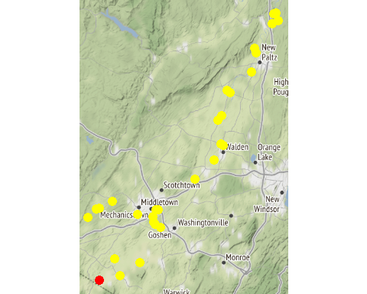

Chemistry Measurements: 13-WALK-60.1

| **SITE_ID** | **chemical_name** | **record_count** | **mean** | **num_exceed** | **min** | **max** | **median** |
| --- | --- | --- | --- | --- | --- | --- | --- |
| 13-WALK-60.1 | alkalinity, total (as caco3) | 15 | 130.053 | NA | 5.72e+01 | 1.84e+02 | 1.44e+02 |
| 13-WALK-60.1 | aluminum | 13 | 435.846 | NA | 1.80e+02 | 7.96e+02 | 3.97e+02 |
| 13-WALK-60.1 | arsenic | 15 | 1.531 | NA | 8.60e-01 | 2.10e+00 | 1.50e+00 |
| 13-WALK-60.1 | calcium | 10 | 39040.000 | NA | 1.93e+04 | 6.01e+04 | 4.29e+04 |
| 13-WALK-60.1 | chloride (as cl) | 13 | 73.723 | NA | 3.19e+01 | 1.15e+02 | 8.33e+01 |
| 13-WALK-60.1 | chlorophyll a | 15 | 7.444 | NA | 1.31e+00 | 3.42e+01 | 5.03e+00 |
| 13-WALK-60.1 | conductivity at 25 degrees celsius | 5 | 621.200 | NA | 5.62e+02 | 6.80e+02 | 6.23e+02 |
| 13-WALK-60.1 | hardness (as caco3) | 15 | 170.827 | NA | 7.14e+01 | 2.52e+02 | 1.90e+02 |
| 13-WALK-60.1 | iron | 14 | 1027.571 | NA | 5.16e+02 | 1.76e+03 | 9.17e+02 |
| 13-WALK-60.1 | magnesium | 14 | 14394.286 | NA | 5.25e+03 | 2.48e+04 | 1.56e+04 |
| 13-WALK-60.1 | nitrate+nitrite as nitrogen | 14 | 0.924 | NA | 1.90e-01 | 2.25e+00 | 7.85e-01 |
| 13-WALK-60.1 | nitrogen | 10 | 1.613 | NA | 9.30e-01 | 2.86e+00 | 1.40e+00 |
| 13-WALK-60.1 | nitrogen, kjeldahl, total | 10 | 0.725 | NA | 5.50e-01 | 1.07e+00 | 6.90e-01 |
| 13-WALK-60.1 | nitrogen, nitrate (as n) | 15 | 0.925 | NA | 1.90e-01 | 2.24e+00 | 8.60e-01 |
| 13-WALK-60.1 | nitrogen, nitrite | 7 | 0.016 | NA | 1.00e-02 | 3.00e-02 | 1.00e-02 |
| 13-WALK-60.1 | ph | 10 | 7.740 | 0 | 7.60e+00 | 7.81e+00 | 7.78e+00 |
| 13-WALK-60.1 | phosphorus, total (as p) | 15 | 0.081 | NA | 5.00e-02 | 1.30e-01 | 8.00e-02 |
| 13-WALK-60.1 | silver | 1 | 0.050 | NA | 5.00e-02 | 5.00e-02 | 5.00e-02 |
| 13-WALK-60.1 | temperature of ph analysis | 5 | 21.020 | NA | 1.92e+01 | 2.44e+01 | 2.08e+01 |
| 13-WALK-60.1 | total dissolved solids (residue, filterable) | 9 | 274000.000 | NA | 1.50e+05 | 3.36e+05 | 3.04e+05 |
| 13-WALK-60.1 | turbidity | 13 | 24.791 | NA | 3.22e+00 | 1.21e+02 | 1.80e+01 |

In-Situ Measurements: 13-WALK-60.1

| **SITE_ID** | **chemical_name** | **record_count** | **mean** | **num_exceed** | **min** | **max** | **median** |
| --- | --- | --- | --- | --- | --- | --- | --- |
| 13-WALK-60.1 | chl rfu | 4 | 0.745 | NA | 0.30 | 0.96 | 0.860 |
| 13-WALK-60.1 | chl ugl | 4 | 3.175 | NA | 1.30 | 3.85 | 3.775 |
| 13-WALK-60.1 | conductance | 13 | 357.446 | NA | 27.10 | 743.00 | 439.200 |
| 13-WALK-60.1 | dissolved oxygen | 26 | 8.258 | 2 | 4.39 | 12.29 | 7.930 |
| 13-WALK-60.1 | pc rfu | 4 | 0.000 | NA | -0.08 | 0.06 | 0.010 |
| 13-WALK-60.1 | pc ugl | 4 | 0.018 | NA | -0.05 | 0.05 | 0.035 |
| 13-WALK-60.1 | pct saturation | 11 | 81.400 | NA | 50.00 | 98.60 | 80.100 |
| 13-WALK-60.1 | ph | 26 | 7.478 | 0 | 7.07 | 8.00 | 7.500 |
| 13-WALK-60.1 | salinity | 11 | 0.155 | NA | 0.01 | 0.37 | 0.120 |
| 13-WALK-60.1 | temperature | 13 | 15.469 | NA | 3.40 | 26.00 | 19.100 |

Dependent Measurements (Metals and Ammonia): 13-WALK-60.1

| **SITE_ID** | **chemical_name** | **record_count** | **mean** | **num_exceed** | **min** | **max** | **median** |
| --- | --- | --- | --- | --- | --- | --- | --- |
| 13-WALK-60.1 | copper | 2 | 1.850 | 1 | 1.8 | 1.9 | 1.85 |
| 13-WALK-60.1 | lead | 2 | 1.000 | 0 | 0.8 | 1.2 | 1.00 |
| 13-WALK-60.1 | nickel | 3 | 1.867 | 3 | 1.6 | 2.1 | 1.90 |
| 13-WALK-60.1 | zinc | 3 | 16.900 | 1 | 13.1 | 19.6 | 18.00 |

Numeric Nutrient Criteria: 13-WALK-60.1

| **SITE_ID** | **chemical_name** | **record_count** | **mean** | **num_exceed** | **min** | **max** | **median** |
| --- | --- | --- | --- | --- | --- | --- | --- |
| 13-WALK-60.1 | phosphorus, total (as p) | 15 | 0.081 | 0 | 0.05 | 0.13 | 0.08 |

BAP Score: 13-WALK-60.1

| **SITE_ID** | **DATE** | **BAP** | **SD** | **n** |
| --- | --- | --- | --- | --- |
| 13-WALK-60.1 | 8/24/2017 | 4.7 | 0.17 | 2 |

### Site ID: 13-RUTG-1.5

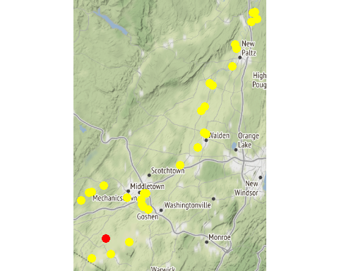

Chemistry Measurements: 13-RUTG-1.5

| **SITE_ID** | **chemical_name** | **record_count** | **mean** | **num_exceed** | **min** | **max** | **median** |
| --- | --- | --- | --- | --- | --- | --- | --- |
| 13-RUTG-1.5 | alkalinity, total (as caco3) | 10 | 79.900 | NA | 4.64e+01 | 1.30e+02 | 80.200 |
| 13-RUTG-1.5 | aluminum | 8 | 468.462 | NA | 2.60e+01 | 1.27e+03 | 231.500 |
| 13-RUTG-1.5 | arsenic | 10 | 0.839 | NA | 4.70e-01 | 1.10e+00 | 0.865 |
| 13-RUTG-1.5 | cadmium | 1 | 0.100 | NA | 1.00e-01 | 1.00e-01 | 0.100 |
| 13-RUTG-1.5 | calcium | 10 | 34580.000 | NA | 1.67e+04 | 5.82e+04 | 34750.000 |
| 13-RUTG-1.5 | chloride (as cl) | 9 | 56.078 | NA | 2.85e+01 | 8.47e+01 | 51.400 |
| 13-RUTG-1.5 | chlorophyll a | 10 | 2.483 | NA | 7.70e-01 | 7.53e+00 | 1.110 |
| 13-RUTG-1.5 | hardness (as caco3) | 10 | 108.100 | NA | 5.40e+01 | 1.80e+02 | 108.450 |
| 13-RUTG-1.5 | iron | 9 | 711.989 | NA | 9.49e+01 | 2.34e+03 | 380.000 |
| 13-RUTG-1.5 | magnesium | 9 | 5174.444 | NA | 3.00e+03 | 8.41e+03 | 4620.000 |
| 13-RUTG-1.5 | nitrate+nitrite as nitrogen | 10 | 0.348 | NA | 0.00e+00 | 5.80e-01 | 0.400 |
| 13-RUTG-1.5 | nitrogen | 10 | 0.951 | NA | 4.00e-01 | 1.36e+00 | 1.015 |
| 13-RUTG-1.5 | nitrogen, kjeldahl, total | 10 | 0.637 | NA | 3.70e-01 | 1.00e+00 | 0.630 |
| 13-RUTG-1.5 | nitrogen, nitrate (as n) | 9 | 0.386 | NA | 1.50e-01 | 5.80e-01 | 0.430 |
| 13-RUTG-1.5 | nitrogen, nitrite | 1 | 0.010 | NA | 1.00e-02 | 1.00e-02 | 0.010 |
| 13-RUTG-1.5 | phosphorus, total (as p) | 10 | 0.090 | NA | 4.00e-02 | 1.70e-01 | 0.075 |
| 13-RUTG-1.5 | total dissolved solids (residue, filterable) | 5 | 194200.000 | NA | 1.34e+05 | 2.63e+05 | 168000.000 |
| 13-RUTG-1.5 | turbidity | 8 | 11.627 | NA | 2.84e+00 | 3.09e+01 | 9.385 |

In-Situ Measurements: 13-RUTG-1.5

| **SITE_ID** | **chemical_name** | **record_count** | **mean** | **num_exceed** | **min** | **max** | **median** |
| --- | --- | --- | --- | --- | --- | --- | --- |
| 13-RUTG-1.5 | chl rfu | 5 | 1.816 | NA | 0.19 | 7.20 | 0.61 |
| 13-RUTG-1.5 | chl ugl | 5 | 1.968 | NA | 0.80 | 2.80 | 2.29 |
| 13-RUTG-1.5 | conductance | 13 | 535.731 | NA | 306.90 | 1126.00 | 452.70 |
| 13-RUTG-1.5 | dissolved oxygen | 26 | 9.246 | 0 | 7.80 | 12.40 | 8.98 |
| 13-RUTG-1.5 | pc rfu | 5 | 0.034 | NA | -0.05 | 0.12 | 0.00 |
| 13-RUTG-1.5 | pc ugl | 5 | 0.056 | NA | 0.00 | 0.15 | 0.01 |
| 13-RUTG-1.5 | pct saturation | 13 | 101.900 | NA | 80.20 | 147.00 | 94.00 |
| 13-RUTG-1.5 | ph | 24 | 7.907 | 0 | 7.42 | 8.46 | 7.89 |
| 13-RUTG-1.5 | salinity | 12 | 0.278 | NA | 0.15 | 0.56 | 0.25 |
| 13-RUTG-1.5 | temperature | 13 | 20.159 | NA | 10.60 | 25.20 | 20.80 |

Dependent Measurements (Metals and Ammonia): 13-RUTG-1.5

| **SITE_ID** | **chemical_name** | **record_count** | **mean** | **num_exceed** | **min** | **max** | **median** |
| --- | --- | --- | --- | --- | --- | --- | --- |
| 13-RUTG-1.5 | copper | 3 | 1.143 | 3 | 0.93 | 1.5 | 1.00 |
| 13-RUTG-1.5 | lead | 3 | 1.263 | 1 | 0.29 | 2.5 | 1.00 |
| 13-RUTG-1.5 | nickel | 4 | 1.600 | 3 | 1.00 | 2.7 | 1.35 |

Numeric Nutrient Criteria: 13-RUTG-1.5

| **SITE_ID** | **chemical_name** | **record_count** | **mean** | **num_exceed** | **min** | **max** | **median** |
| --- | --- | --- | --- | --- | --- | --- | --- |
| 13-RUTG-1.5 | phosphorus, total (as p) | 10 | 0.09 | 0 | 0.04 | 0.17 | 0.075 |

BAP Score: 13-RUTG-1.5

| **SITE_ID** | **DATE** | **BAP** | **SD** | **n** |
| --- | --- | --- | --- | --- |
| 13-RUTG-1.5 | 8/8/2019 | 6.87 | 0.5 | 4 |

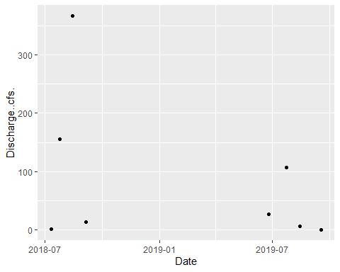

### Site ID: 13-POCH-1.8

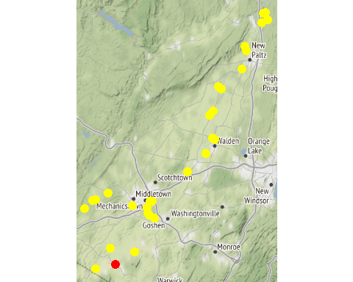

Chemistry Measurements: 13-POCH-1.8

| **SITE_ID** | **chemical_name** | **record_count** | **mean** | **num_exceed** | **min** | **max** | **median** |
| --- | --- | --- | --- | --- | --- | --- | --- |
| 13-POCH-1.8 | alkalinity, total (as caco3) | 9 | 127.378 | NA | 7.40e+01 | 1.96e+02 | 115.00 |
| 13-POCH-1.8 | aluminum | 7 | 339.571 | NA | 1.75e+02 | 5.33e+02 | 321.00 |
| 13-POCH-1.8 | arsenic | 9 | 1.321 | NA | 6.90e-01 | 2.00e+00 | 1.30 |
| 13-POCH-1.8 | cadmium | 1 | 0.090 | NA | 9.00e-02 | 9.00e-02 | 0.09 |
| 13-POCH-1.8 | calcium | 9 | 39255.556 | NA | 2.38e+04 | 5.94e+04 | 33800.00 |
| 13-POCH-1.8 | chloride (as cl) | 8 | 65.562 | NA | 3.05e+01 | 9.68e+01 | 62.05 |
| 13-POCH-1.8 | chlorophyll a | 9 | 3.597 | NA | 1.45e+00 | 1.29e+01 | 2.02 |
| 13-POCH-1.8 | hardness (as caco3) | 9 | 159.733 | NA | 9.76e+01 | 2.46e+02 | 138.00 |
| 13-POCH-1.8 | iron | 8 | 847.625 | NA | 3.04e+02 | 1.64e+03 | 863.00 |
| 13-POCH-1.8 | magnesium | 8 | 14066.250 | NA | 9.23e+03 | 2.38e+04 | 12900.00 |
| 13-POCH-1.8 | nitrate+nitrite as nitrogen | 9 | 0.484 | NA | 2.70e-01 | 8.00e-01 | 0.48 |
| 13-POCH-1.8 | nitrogen | 9 | 1.114 | NA | 6.50e-01 | 1.52e+00 | 1.15 |
| 13-POCH-1.8 | nitrogen, kjeldahl, total | 8 | 0.661 | NA | 4.60e-01 | 1.10e+00 | 0.61 |
| 13-POCH-1.8 | nitrogen, nitrate (as n) | 9 | 0.479 | NA | 2.70e-01 | 7.90e-01 | 0.48 |
| 13-POCH-1.8 | nitrogen, nitrite | 4 | 0.010 | NA | 1.00e-02 | 1.00e-02 | 0.01 |
| 13-POCH-1.8 | phosphorus, total (as p) | 9 | 0.128 | NA | 9.00e-02 | 1.70e-01 | 0.12 |
| 13-POCH-1.8 | total dissolved solids (residue, filterable) | 4 | 246000.000 | NA | 1.75e+05 | 3.18e+05 | 245500.00 |
| 13-POCH-1.8 | turbidity | 7 | 12.329 | NA | 6.23e+00 | 1.78e+01 | 13.40 |

In-Situ Measurements: 13-POCH-1.8

| **SITE_ID** | **chemical_name** | **record_count** | **mean** | **num_exceed** | **min** | **max** | **median** |
| --- | --- | --- | --- | --- | --- | --- | --- |
| 13-POCH-1.8 | chl rfu | 5 | 0.634 | NA | 0.36 | 1.25 | 0.49 |
| 13-POCH-1.8 | chl ugl | 5 | 2.470 | NA | 1.40 | 4.90 | 1.90 |
| 13-POCH-1.8 | conductance | 11 | 441.927 | NA | 174.40 | 752.00 | 406.80 |
| 13-POCH-1.8 | dissolved oxygen | 22 | 6.405 | 4 | 2.40 | 9.31 | 6.15 |
| 13-POCH-1.8 | pc rfu | 5 | 0.100 | NA | -0.04 | 0.40 | 0.02 |
| 13-POCH-1.8 | pc ugl | 5 | 0.114 | NA | 0.00 | 0.40 | 0.07 |
| 13-POCH-1.8 | pct saturation | 11 | 71.009 | NA | 28.00 | 107.60 | 70.10 |
| 13-POCH-1.8 | ph | 22 | 7.765 | 1 | 7.30 | 8.90 | 7.75 |
| 13-POCH-1.8 | salinity | 11 | 0.213 | NA | 0.08 | 0.37 | 0.19 |
| 13-POCH-1.8 | temperature | 11 | 21.091 | NA | 11.60 | 26.70 | 22.10 |

Dependent Measurements (Metals and Ammonia): 13-POCH-1.8

| **SITE_ID** | **chemical_name** | **record_count** | **mean** | **num_exceed** | **min** | **max** | **median** |
| --- | --- | --- | --- | --- | --- | --- | --- |
| 13-POCH-1.8 | copper | 2 | 2.70 | 2 | 2.60 | 2.80 | 2.70 |
| 13-POCH-1.8 | nickel | 2 | 1.55 | 1 | 1.30 | 1.80 | 1.55 |
| 13-POCH-1.8 | nitrogen, ammonia (as n) | 1 | 0.03 | 1 | 0.03 | 0.03 | 0.03 |
| 13-POCH-1.8 | zinc | 4 | 4.45 | 3 | 2.70 | 5.60 | 4.75 |

Numeric Nutrient Criteria: 13-POCH-1.8

| **SITE_ID** | **chemical_name** | **record_count** | **mean** | **num_exceed** | **min** | **max** | **median** |
| --- | --- | --- | --- | --- | --- | --- | --- |
| 13-POCH-1.8 | phosphorus, total (as p) | 9 | 0.128 | 0 | 0.09 | 0.17 | 0.12 |

BAP Score: 13-POCH-1.8

| **SITE_ID** | **DATE** | **BAP** | **SD** | **n** |
| --- | --- | --- | --- | --- |
| 13-POCH-1.8 | 8/8/2019 | 5.14 | 0.79 | 4 |

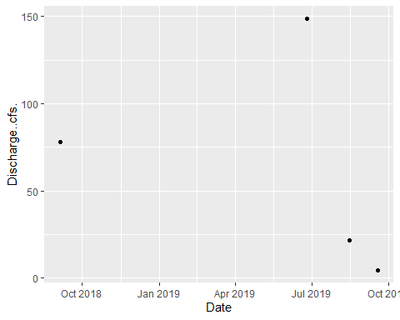

### Site ID: 13-QKER-0.9

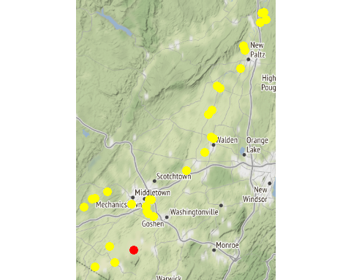

Chemistry Measurements: 13-QKER-0.9

| **SITE_ID** | **chemical_name** | **record_count** | **mean** | **num_exceed** | **min** | **max** | **median** |
| --- | --- | --- | --- | --- | --- | --- | --- |
| 13-QKER-0.9 | alkalinity, total (as caco3) | 10 | 142.620 | NA | 7.88e+01 | 1.82e+02 | 144.000 |
| 13-QKER-0.9 | aluminum | 10 | 373.700 | NA | 1.38e+02 | 6.81e+02 | 395.500 |
| 13-QKER-0.9 | arsenic | 10 | 2.640 | NA | 1.30e+00 | 6.00e+00 | 2.300 |
| 13-QKER-0.9 | cadmium | 2 | 1.525 | NA | 1.50e-01 | 2.90e+00 | 1.525 |
| 13-QKER-0.9 | calcium | 5 | 46940.000 | NA | 3.53e+04 | 5.79e+04 | 46400.000 |
| 13-QKER-0.9 | chloride (as cl) | 8 | 73.925 | NA | 3.18e+01 | 9.11e+01 | 85.650 |
| 13-QKER-0.9 | chlorophyll a | 10 | 9.610 | NA | 2.33e+00 | 4.09e+01 | 5.685 |
| 13-QKER-0.9 | conductivity at 25 degrees celsius | 5 | 668.000 | NA | 5.48e+02 | 7.27e+02 | 693.000 |
| 13-QKER-0.9 | hardness (as caco3) | 10 | 194.700 | NA | 1.26e+02 | 2.42e+02 | 194.000 |
| 13-QKER-0.9 | iron | 9 | 823.778 | NA | 3.68e+02 | 1.31e+03 | 857.000 |
| 13-QKER-0.9 | magnesium | 10 | 15157.000 | NA | 9.27e+03 | 1.96e+04 | 15000.000 |
| 13-QKER-0.9 | nitrate+nitrite as nitrogen | 10 | 2.044 | NA | 9.40e-01 | 7.28e+00 | 1.440 |
| 13-QKER-0.9 | nitrogen | 5 | 4.248 | NA | 1.67e+00 | 1.01e+01 | 2.990 |
| 13-QKER-0.9 | nitrogen, kjeldahl, total | 5 | 1.468 | NA | 7.30e-01 | 2.81e+00 | 1.350 |
| 13-QKER-0.9 | nitrogen, nitrate (as n) | 10 | 2.005 | NA | 9.10e-01 | 7.24e+00 | 1.390 |
| 13-QKER-0.9 | nitrogen, nitrite | 10 | 0.040 | NA | 2.00e-02 | 6.00e-02 | 0.040 |
| 13-QKER-0.9 | ph | 10 | 7.798 | 0 | 7.60e+00 | 8.00e+00 | 7.820 |
| 13-QKER-0.9 | phosphorus, total (as p) | 10 | 0.531 | NA | 2.80e-01 | 7.60e-01 | 0.580 |
| 13-QKER-0.9 | temperature of ph analysis | 5 | 20.860 | NA | 1.92e+01 | 2.44e+01 | 20.600 |
| 13-QKER-0.9 | total dissolved solids (residue, filterable) | 9 | 324888.889 | NA | 2.32e+05 | 3.86e+05 | 320000.000 |
| 13-QKER-0.9 | turbidity | 10 | 12.298 | NA | 4.45e+00 | 2.61e+01 | 10.825 |

In-Situ Measurements: 13-QKER-0.9

| **SITE_ID** | **chemical_name** | **record_count** | **mean** | **num_exceed** | **min** | **max** | **median** |
| --- | --- | --- | --- | --- | --- | --- | --- |
| 13-QKER-0.9 | conductance | 11 | 497.518 | NA | 189.30 | 1197.00 | 460.00 |
| 13-QKER-0.9 | dissolved oxygen | 22 | 7.304 | 6 | 0.40 | 14.00 | 7.70 |
| 13-QKER-0.9 | pct saturation | 8 | 94.675 | NA | 5.00 | 182.00 | 101.00 |
| 13-QKER-0.9 | ph | 22 | 7.795 | 1 | 7.20 | 8.60 | 7.60 |
| 13-QKER-0.9 | salinity | 5 | 0.248 | NA | 0.09 | 0.69 | 0.16 |
| 13-QKER-0.9 | temperature | 11 | 21.330 | NA | 14.90 | 28.40 | 21.20 |

Dependent Measurements (Metals and Ammonia): 13-QKER-0.9

| **SITE_ID** | **chemical_name** | **record_count** | **mean** | **num_exceed** | **min** | **max** | **median** |
| --- | --- | --- | --- | --- | --- | --- | --- |
| 13-QKER-0.9 | lead | 1 | 1.40 | 1 | 1.40 | 1.40 | 1.40 |
| 13-QKER-0.9 | nickel | 1 | 3.00 | 0 | 3.00 | 3.00 | 3.00 |
| 13-QKER-0.9 | nitrogen, ammonia (as n) | 1 | 0.12 | 1 | 0.12 | 0.12 | 0.12 |
| 13-QKER-0.9 | zinc | 2 | 4.85 | 2 | 2.70 | 7.00 | 4.85 |

Numeric Nutrient Criteria: 13-QKER-0.9

| **SITE_ID** | **chemical_name** | **record_count** | **mean** | **num_exceed** | **min** | **max** | **median** |
| --- | --- | --- | --- | --- | --- | --- | --- |
| 13-QKER-0.9 | phosphorus, total (as p) | 10 | 0.531 | 0 | 0.28 | 0.76 | 0.58 |

BAP Score: 13-QKER-0.9

| **SITE_ID** | **DATE** | **BAP** | **SD** | **n** |
| --- | --- | --- | --- | --- |
| 13-QKER-0.9 | 8/2/2017 | 2.39 | 0.52 | 4 |

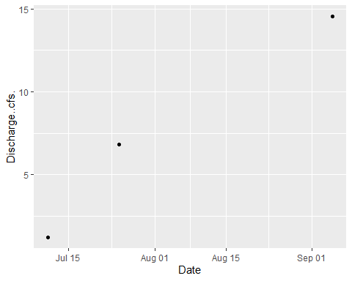

### Site ID: 13-WCHEE-0.6

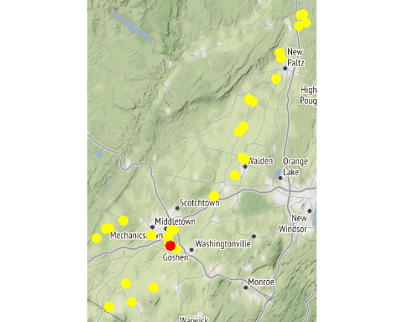

Chemistry Measurements: 13-WCHEE-0.6

| **SITE_ID** | **chemical_name** | **record_count** | **mean** | **num_exceed** | **min** | **max** | **median** |
| --- | --- | --- | --- | --- | --- | --- | --- |
| 13-WCHEE-0.6 | alkalinity, total (as caco3) | 10 | 115.940 | NA | 8.76e+01 | 1.75e+02 | 1.075e+02 |
| 13-WCHEE-0.6 | aluminum | 10 | 650.200 | NA | 2.19e+02 | 1.15e+03 | 6.185e+02 |
| 13-WCHEE-0.6 | arsenic | 10 | 1.636 | NA | 8.50e-01 | 2.60e+00 | 1.700e+00 |
| 13-WCHEE-0.6 | calcium | 5 | 51080.000 | NA | 2.91e+04 | 7.22e+04 | 4.660e+04 |
| 13-WCHEE-0.6 | chloride (as cl) | 10 | 185.310 | NA | 3.38e+01 | 2.60e+02 | 2.070e+02 |
| 13-WCHEE-0.6 | chlorophyll a | 10 | 4.433 | NA | 8.80e-01 | 1.23e+01 | 2.380e+00 |
| 13-WCHEE-0.6 | conductivity at 25 degrees celsius | 5 | 1151.200 | NA | 9.26e+02 | 1.29e+03 | 1.170e+03 |
| 13-WCHEE-0.6 | hardness (as caco3) | 10 | 198.170 | NA | 9.67e+01 | 2.70e+02 | 2.150e+02 |
| 13-WCHEE-0.6 | iron | 9 | 1165.000 | NA | 4.59e+02 | 2.11e+03 | 1.180e+03 |
| 13-WCHEE-0.6 | magnesium | 10 | 11084.000 | NA | 5.85e+03 | 1.42e+04 | 1.225e+04 |
| 13-WCHEE-0.6 | nitrate+nitrite as nitrogen | 10 | 6.837 | NA | 6.40e-01 | 1.90e+01 | 2.445e+00 |
| 13-WCHEE-0.6 | nitrogen | 5 | 8.364 | NA | 1.35e+00 | 1.99e+01 | 3.680e+00 |
| 13-WCHEE-0.6 | nitrogen, kjeldahl, total | 5 | 0.972 | NA | 7.10e-01 | 1.18e+00 | 1.000e+00 |
| 13-WCHEE-0.6 | nitrogen, nitrate (as n) | 10 | 6.781 | NA | 6.10e-01 | 1.90e+01 | 2.315e+00 |
| 13-WCHEE-0.6 | nitrogen, nitrite | 10 | 0.056 | NA | 1.00e-02 | 2.50e-01 | 3.500e-02 |
| 13-WCHEE-0.6 | ph | 10 | 7.752 | 0 | 7.41e+00 | 8.28e+00 | 7.720e+00 |
| 13-WCHEE-0.6 | phosphorus, total (as p) | 10 | 1.709 | NA | 2.40e-01 | 2.88e+00 | 1.970e+00 |
| 13-WCHEE-0.6 | silver | 4 | 0.082 | NA | 6.00e-02 | 1.00e-01 | 8.500e-02 |
| 13-WCHEE-0.6 | temperature of ph analysis | 5 | 21.020 | NA | 1.91e+01 | 2.44e+01 | 2.070e+01 |
| 13-WCHEE-0.6 | total dissolved solids (residue, filterable) | 9 | 532666.667 | NA | 2.50e+05 | 7.13e+05 | 5.990e+05 |
| 13-WCHEE-0.6 | turbidity | 10 | 28.201 | NA | 3.50e+00 | 6.25e+01 | 2.250e+01 |

In-Situ Measurements: 13-WCHEE-0.6

| **SITE_ID** | **chemical_name** | **record_count** | **mean** | **num_exceed** | **min** | **max** | **median** |
| --- | --- | --- | --- | --- | --- | --- | --- |
| 13-WCHEE-0.6 | conductance | 7 | 676.700 | NA | 365.20 | 1038.00 | 777.000 |
| 13-WCHEE-0.6 | dissolved oxygen | 14 | 6.210 | 0 | 5.50 | 6.97 | 6.300 |
| 13-WCHEE-0.6 | pct saturation | 7 | 74.200 | NA | 64.00 | 91.10 | 69.000 |
| 13-WCHEE-0.6 | ph | 14 | 7.664 | 1 | 7.21 | 8.60 | 7.400 |
| 13-WCHEE-0.6 | salinity | 6 | 0.298 | NA | 0.17 | 0.40 | 0.315 |
| 13-WCHEE-0.6 | temperature | 7 | 23.700 | NA | 16.90 | 28.50 | 23.800 |

Dependent Measurements (Metals and Ammonia): 13-WCHEE-0.6

| **SITE_ID** | **chemical_name** | **record_count** | **mean** | **num_exceed** | **min** | **max** | **median** |
| --- | --- | --- | --- | --- | --- | --- | --- |
| 13-WCHEE-0.6 | lead | 1 | 1.50 | 1 | 1.50 | 1.50 | 1.50 |
| 13-WCHEE-0.6 | nickel | 3 | 3.10 | 3 | 2.00 | 4.20 | 3.10 |
| 13-WCHEE-0.6 | nitrogen, ammonia (as n) | 1 | 0.06 | 1 | 0.06 | 0.06 | 0.06 |

Numeric Nutrient Criteria: 13-WCHEE-0.6

| **SITE_ID** | **chemical_name** | **record_count** | **mean** | **num_exceed** | **min** | **max** | **median** |
| --- | --- | --- | --- | --- | --- | --- | --- |
| 13-WCHEE-0.6 | phosphorus, total (as p) | 10 | 1.709 | 0 | 0.24 | 2.88 | 1.97 |

BAP Score: 13-WCHEE-0.6

| **SITE_ID** | **DATE** | **BAP** | **SD** | **n** |
| --- | --- | --- | --- | --- |
| 13-WCHEE-0.6 | 8/2/2017 | 3.46 | 0.39 | 4 |
| 13-WCHEE-0.6 | 8/28/2018 | 3.21 | 1.07 | 4 |

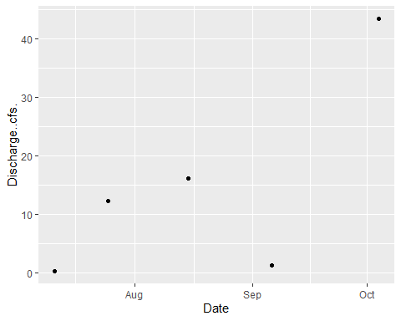

### Site ID: 13-RIOG-0.7

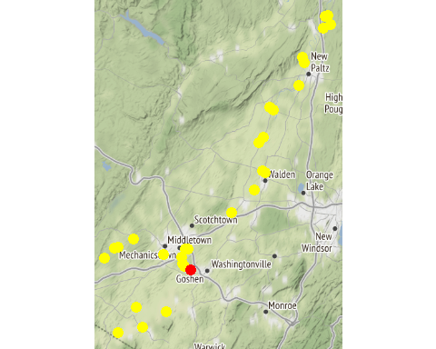

Chemistry Measurements: 13-RIOG-0.7

| **SITE_ID** | **chemical_name** | **record_count** | **mean** | **num_exceed** | **min** | **max** | **median** |
| --- | --- | --- | --- | --- | --- | --- | --- |
| 13-RIOG-0.7 | alkalinity, total (as caco3) | 5 | 90.240 | NA | 4.40e+01 | 1.20e+02 | 9.92e+01 |
| 13-RIOG-0.7 | aluminum | 5 | 899.180 | NA | 5.59e+01 | 3.40e+03 | 2.16e+02 |
| 13-RIOG-0.7 | arsenic | 5 | 1.658 | NA | 8.90e-01 | 2.40e+00 | 1.70e+00 |
| 13-RIOG-0.7 | cadmium | 2 | 0.170 | NA | 1.40e-01 | 2.00e-01 | 1.70e-01 |
| 13-RIOG-0.7 | calcium | 5 | 50720.000 | NA | 3.45e+04 | 7.17e+04 | 4.48e+04 |
| 13-RIOG-0.7 | chloride (as cl) | 5 | 169.600 | NA | 8.60e+01 | 2.70e+02 | 1.36e+02 |
| 13-RIOG-0.7 | chlorophyll a | 5 | 4.562 | NA | 7.20e-01 | 1.10e+01 | 3.33e+00 |
| 13-RIOG-0.7 | hardness (as caco3) | 5 | 167.800 | NA | 1.13e+02 | 2.38e+02 | 1.48e+02 |
| 13-RIOG-0.7 | iron | 4 | 882.000 | NA | 3.92e+02 | 2.22e+03 | 4.58e+02 |
| 13-RIOG-0.7 | magnesium | 5 | 9950.000 | NA | 6.59e+03 | 1.43e+04 | 8.71e+03 |
| 13-RIOG-0.7 | nitrate+nitrite as nitrogen | 5 | 8.612 | NA | 9.30e-01 | 2.34e+01 | 3.32e+00 |
| 13-RIOG-0.7 | nitrogen | 5 | 9.832 | NA | 1.69e+00 | 2.42e+01 | 5.98e+00 |
| 13-RIOG-0.7 | nitrogen, kjeldahl, total | 5 | 1.224 | NA | 7.60e-01 | 2.66e+00 | 8.40e-01 |
| 13-RIOG-0.7 | nitrogen, nitrate (as n) | 5 | 8.580 | NA | 9.10e-01 | 2.33e+01 | 3.30e+00 |
| 13-RIOG-0.7 | nitrogen, nitrite | 5 | 0.028 | NA | 2.00e-02 | 5.00e-02 | 2.00e-02 |
| 13-RIOG-0.7 | phosphorus, total (as p) | 5 | 1.210 | NA | 2.50e-01 | 2.67e+00 | 1.00e+00 |
| 13-RIOG-0.7 | silver | 3 | 0.133 | NA | 5.00e-02 | 2.90e-01 | 6.00e-02 |
| 13-RIOG-0.7 | total dissolved solids (residue, filterable) | 5 | 491800.000 | NA | 2.87e+05 | 7.67e+05 | 4.01e+05 |
| 13-RIOG-0.7 | turbidity | 5 | 25.270 | NA | 2.30e+00 | 1.01e+02 | 9.43e+00 |

In-Situ Measurements: 13-RIOG-0.7

| **SITE_ID** | **chemical_name** | **record_count** | **mean** | **num_exceed** | **min** | **max** | **median** |
| --- | --- | --- | --- | --- | --- | --- | --- |
| 13-RIOG-0.7 | conductance | 6 | 972.783 | NA | 469.70 | 1402.00 | 990.50 |
| 13-RIOG-0.7 | dissolved oxygen | 12 | 7.808 | 0 | 6.65 | 9.09 | 7.88 |
| 13-RIOG-0.7 | pct saturation | 6 | 90.750 | NA | 79.50 | 108.20 | 85.10 |
| 13-RIOG-0.7 | ph | 12 | 7.490 | 0 | 7.36 | 7.73 | 7.44 |
| 13-RIOG-0.7 | salinity | 6 | 0.482 | NA | 0.23 | 0.70 | 0.49 |
| 13-RIOG-0.7 | temperature | 6 | 22.033 | NA | 16.30 | 24.70 | 23.45 |

Dependent Measurements (Metals and Ammonia): 13-RIOG-0.7

| **SITE_ID** | **chemical_name** | **record_count** | **mean** | **num_exceed** | **min** | **max** | **median** |
| --- | --- | --- | --- | --- | --- | --- | --- |
| 13-RIOG-0.7 | copper | 1 | 24.20 | 1 | 24.2 | 24.2 | 24.20 |
| 13-RIOG-0.7 | lead | 2 | 5.35 | 2 | 1.4 | 9.3 | 5.35 |
| 13-RIOG-0.7 | nickel | 1 | 2.20 | 0 | 2.2 | 2.2 | 2.20 |
| 13-RIOG-0.7 | zinc | 1 | 36.00 | 1 | 36.0 | 36.0 | 36.00 |

Numeric Nutrient Criteria: 13-RIOG-0.7

| **SITE_ID** | **chemical_name** | **record_count** | **mean** | **num_exceed** | **min** | **max** | **median** |
| --- | --- | --- | --- | --- | --- | --- | --- |
| 13-RIOG-0.7 | phosphorus, total (as p) | 5 | 1.21 | 0 | 0.25 | 2.67 | 1 |

BAP Score: 13-RIOG-0.7

| **SITE_ID** | **DATE** | **BAP** | **SD** | **n** |
| --- | --- | --- | --- | --- |

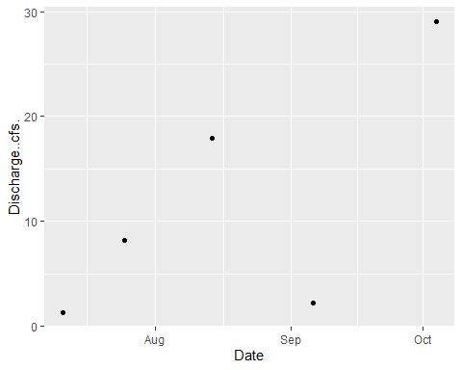

### Site ID: 13-WALK-46.6

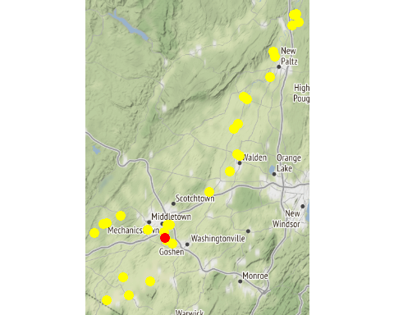

Chemistry Measurements: 13-WALK-46.6

| **SITE_ID** | **chemical_name** | **record_count** | **mean** | **num_exceed** | **min** | **max** | **median** |
| --- | --- | --- | --- | --- | --- | --- | --- |
| 13-WALK-46.6 | alkalinity, total (as caco3) | 10 | 130.300 | NA | 7.48e+01 | 1.68e+02 | 1.445e+02 |
| 13-WALK-46.6 | aluminum | 10 | 512.500 | NA | 1.58e+02 | 1.20e+03 | 3.185e+02 |
| 13-WALK-46.6 | arsenic | 10 | 1.436 | NA | 5.90e-01 | 2.30e+00 | 1.650e+00 |
| 13-WALK-46.6 | cadmium | 2 | 0.105 | NA | 7.00e-02 | 1.40e-01 | 1.050e-01 |
| 13-WALK-46.6 | calcium | 5 | 40100.000 | NA | 2.81e+04 | 5.47e+04 | 3.530e+04 |
| 13-WALK-46.6 | chloride (as cl) | 10 | 73.780 | NA | 3.15e+01 | 9.69e+01 | 7.965e+01 |
| 13-WALK-46.6 | chlorophyll a | 10 | 7.554 | NA | 2.31e+00 | 3.14e+01 | 4.465e+00 |
| 13-WALK-46.6 | conductivity at 25 degrees celsius | 5 | 655.200 | NA | 5.09e+02 | 7.32e+02 | 6.830e+02 |
| 13-WALK-46.6 | hardness (as caco3) | 10 | 180.200 | NA | 1.01e+02 | 2.40e+02 | 1.975e+02 |
| 13-WALK-46.6 | iron | 9 | 971.444 | NA | 4.26e+02 | 2.56e+03 | 7.880e+02 |
| 13-WALK-46.6 | magnesium | 10 | 14167.000 | NA | 7.45e+03 | 1.87e+04 | 1.550e+04 |
| 13-WALK-46.6 | nitrate+nitrite as nitrogen | 10 | 1.242 | NA | 5.20e-01 | 4.11e+00 | 1.030e+00 |
| 13-WALK-46.6 | nitrogen | 5 | 2.496 | NA | 1.41e+00 | 4.96e+00 | 1.970e+00 |
| 13-WALK-46.6 | nitrogen, kjeldahl, total | 5 | 0.974 | NA | 7.10e-01 | 1.43e+00 | 8.600e-01 |
| 13-WALK-46.6 | nitrogen, nitrate (as n) | 10 | 1.230 | NA | 5.10e-01 | 4.10e+00 | 1.010e+00 |
| 13-WALK-46.6 | nitrogen, nitrite | 8 | 0.015 | NA | 1.00e-02 | 3.00e-02 | 1.000e-02 |
| 13-WALK-46.6 | ph | 10 | 7.858 | 0 | 7.69e+00 | 7.94e+00 | 7.870e+00 |
| 13-WALK-46.6 | phosphorus, total (as p) | 10 | 0.150 | NA | 8.00e-02 | 3.00e-01 | 1.200e-01 |
| 13-WALK-46.6 | silver | 1 | 0.100 | NA | 1.00e-01 | 1.00e-01 | 1.000e-01 |
| 13-WALK-46.6 | temperature of ph analysis | 5 | 20.600 | NA | 1.93e+01 | 2.38e+01 | 1.990e+01 |
| 13-WALK-46.6 | total dissolved solids (residue, filterable) | 9 | 303222.222 | NA | 1.90e+05 | 3.79e+05 | 3.300e+05 |
| 13-WALK-46.6 | turbidity | 10 | 18.595 | NA | 4.62e+00 | 5.18e+01 | 1.285e+01 |

In-Situ Measurements: 13-WALK-46.6

| **SITE_ID** | **chemical_name** | **record_count** | **mean** | **num_exceed** | **min** | **max** | **median** |
| --- | --- | --- | --- | --- | --- | --- | --- |
| 13-WALK-46.6 | conductance | 8 | 413.411 | NA | 278.39 | 627.00 | 396.650 |
| 13-WALK-46.6 | dissolved oxygen | 16 | 7.867 | 0 | 6.34 | 10.30 | 7.550 |
| 13-WALK-46.6 | pct saturation | 7 | 88.786 | NA | 74.50 | 118.00 | 85.000 |
| 13-WALK-46.6 | ph | 16 | 7.713 | 0 | 7.36 | 8.03 | 7.725 |
| 13-WALK-46.6 | salinity | 6 | 0.183 | NA | 0.13 | 0.31 | 0.150 |
| 13-WALK-46.6 | temperature | 8 | 21.087 | NA | 15.30 | 24.20 | 22.400 |

Dependent Measurements (Metals and Ammonia): 13-WALK-46.6

| **SITE_ID** | **chemical_name** | **record_count** | **mean** | **num_exceed** | **min** | **max** | **median** |
| --- | --- | --- | --- | --- | --- | --- | --- |
| 13-WALK-46.6 | copper | 2 | 4.15 | 2 | 2.9 | 5.4 | 4.15 |
| 13-WALK-46.6 | nickel | 2 | 2.90 | 2 | 2.5 | 3.3 | 2.90 |
| 13-WALK-46.6 | zinc | 1 | 13.60 | 0 | 13.6 | 13.6 | 13.60 |

Numeric Nutrient Criteria: 13-WALK-46.6

| **SITE_ID** | **chemical_name** | **record_count** | **mean** | **num_exceed** | **min** | **max** | **median** |
| --- | --- | --- | --- | --- | --- | --- | --- |
| 13-WALK-46.6 | phosphorus, total (as p) | 10 | 0.15 | 0 | 0.08 | 0.3 | 0.12 |

BAP Score: 13-WALK-46.6

| **SITE_ID** | **DATE** | **BAP** | **SD** | **n** |
| --- | --- | --- | --- | --- |
| 13-WALK-46.6 | 8/2/2017 | 4.12 | 0.23 | 4 |

### Site ID: 13-MONH-0.4

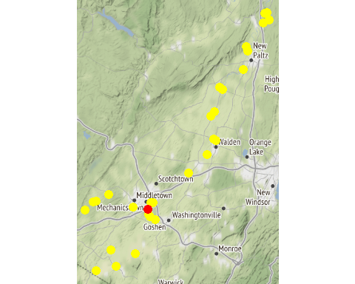

Chemistry Measurements: 13-MONH-0.4

| **SITE_ID** | **chemical_name** | **record_count** | **mean** | **num_exceed** | **min** | **max** | **median** |
| --- | --- | --- | --- | --- | --- | --- | --- |
| 13-MONH-0.4 | alkalinity, total (as caco3) | 10 | 133.780 | NA | 9.48e+01 | 1.72e+02 | 1.325e+02 |
| 13-MONH-0.4 | aluminum | 9 | 237.856 | NA | 1.95e+01 | 1.10e+03 | 1.720e+02 |
| 13-MONH-0.4 | arsenic | 9 | 1.323 | NA | 4.80e-01 | 2.20e+00 | 1.200e+00 |
| 13-MONH-0.4 | calcium | 5 | 61320.000 | NA | 3.70e+04 | 8.58e+04 | 5.050e+04 |
| 13-MONH-0.4 | chloride (as cl) | 10 | 188.070 | NA | 7.57e+01 | 2.98e+02 | 1.890e+02 |
| 13-MONH-0.4 | chlorophyll a | 10 | 3.914 | NA | 8.30e-01 | 1.13e+01 | 2.555e+00 |
| 13-MONH-0.4 | conductivity at 25 degrees celsius | 5 | 999.000 | NA | 8.38e+02 | 1.19e+03 | 9.840e+02 |
| 13-MONH-0.4 | hardness (as caco3) | 10 | 208.900 | NA | 1.15e+02 | 2.68e+02 | 2.165e+02 |
| 13-MONH-0.4 | iron | 9 | 366.222 | NA | 1.16e+02 | 6.94e+02 | 3.330e+02 |
| 13-MONH-0.4 | magnesium | 10 | 9457.000 | NA | 5.54e+03 | 1.30e+04 | 9.090e+03 |
| 13-MONH-0.4 | nitrate+nitrite as nitrogen | 10 | 0.287 | NA | 1.60e-01 | 4.40e-01 | 2.700e-01 |
| 13-MONH-0.4 | nitrogen | 5 | 0.952 | NA | 8.20e-01 | 1.08e+00 | 9.300e-01 |
| 13-MONH-0.4 | nitrogen, kjeldahl, total | 5 | 0.612 | NA | 4.60e-01 | 8.00e-01 | 5.600e-01 |
| 13-MONH-0.4 | nitrogen, nitrate (as n) | 10 | 0.287 | NA | 1.60e-01 | 4.40e-01 | 2.700e-01 |
| 13-MONH-0.4 | ph | 10 | 8.082 | 0 | 7.82e+00 | 8.46e+00 | 8.010e+00 |
| 13-MONH-0.4 | phosphorus, total (as p) | 10 | 0.089 | NA | 6.00e-02 | 1.50e-01 | 8.500e-02 |
| 13-MONH-0.4 | silver | 2 | 0.075 | NA | 5.00e-02 | 1.00e-01 | 7.500e-02 |
| 13-MONH-0.4 | temperature of ph analysis | 5 | 20.980 | NA | 1.93e+01 | 2.44e+01 | 2.070e+01 |
| 13-MONH-0.4 | total dissolved solids (residue, filterable) | 10 | 493200.000 | NA | 2.70e+05 | 6.99e+05 | 4.850e+05 |
| 13-MONH-0.4 | turbidity | 9 | 7.230 | NA | 1.16e+00 | 3.32e+01 | 3.090e+00 |

In-Situ Measurements: 13-MONH-0.4

| **SITE_ID** | **chemical_name** | **record_count** | **mean** | **num_exceed** | **min** | **max** | **median** |
| --- | --- | --- | --- | --- | --- | --- | --- |
| 13-MONH-0.4 | conductance | 9 | 733.110 | NA | 400.00 | 1073.00 | 727.000 |
| 13-MONH-0.4 | dissolved oxygen | 18 | 8.056 | 0 | 6.70 | 9.30 | 8.100 |
| 13-MONH-0.4 | pct saturation | 6 | 89.333 | NA | 71.00 | 97.00 | 92.000 |
| 13-MONH-0.4 | ph | 16 | 7.697 | 0 | 6.90 | 8.30 | 7.665 |
| 13-MONH-0.4 | salinity | 5 | 0.324 | NA | 0.22 | 0.44 | 0.280 |
| 13-MONH-0.4 | temperature | 9 | 19.822 | NA | 15.40 | 23.70 | 20.500 |

Dependent Measurements (Metals and Ammonia): 13-MONH-0.4

| **SITE_ID** | **chemical_name** | **record_count** | **mean** | **num_exceed** | **min** | **max** | **median** |
| --- | --- | --- | --- | --- | --- | --- | --- |
| 13-MONH-0.4 | copper | 1 | 4.50 | 1 | 4.5 | 4.5 | 4.50 |
| 13-MONH-0.4 | lead | 1 | 2.00 | 1 | 2.0 | 2.0 | 2.00 |
| 13-MONH-0.4 | nickel | 2 | 1.55 | 1 | 1.4 | 1.7 | 1.55 |

Numeric Nutrient Criteria: 13-MONH-0.4

| **SITE_ID** | **chemical_name** | **record_count** | **mean** | **num_exceed** | **min** | **max** | **median** |
| --- | --- | --- | --- | --- | --- | --- | --- |
| 13-MONH-0.4 | phosphorus, total (as p) | 10 | 0.089 | 0 | 0.06 | 0.15 | 0.085 |

BAP Score: 13-MONH-0.4

| **SITE_ID** | **DATE** | **BAP** | **SD** | **n** |
| --- | --- | --- | --- | --- |
| 13-MONH-0.4 | 8/2/2017 | 5.78 | 0.31 | 4 |
| 13-MONH-0.4 | 8/27/2018 | 5.35 | 0.52 | 4 |

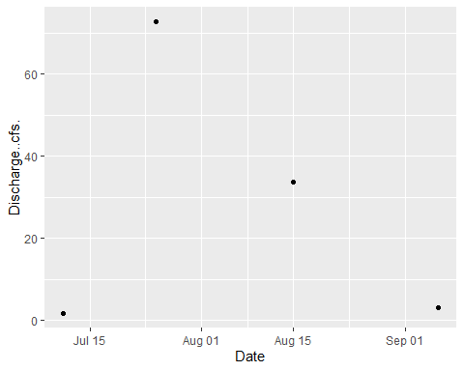

### Site ID: 13-MONH-4.1

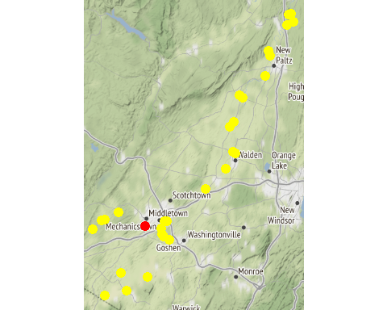

Chemistry Measurements: 13-MONH-4.1

| **SITE_ID** | **chemical_name** | **record_count** | **mean** | **num_exceed** | **min** | **max** | **median** |
| --- | --- | --- | --- | --- | --- | --- | --- |
| 13-MONH-4.1 | alkalinity, total (as caco3) | 5 | 113.160 | NA | 7.08e+01 | 1.50e+02 | 120.00 |
| 13-MONH-4.1 | aluminum | 5 | 205.300 | NA | 2.51e+01 | 4.63e+02 | 157.00 |
| 13-MONH-4.1 | arsenic | 5 | 1.224 | NA | 9.20e-01 | 1.50e+00 | 1.20 |
| 13-MONH-4.1 | cadmium | 1 | 0.600 | NA | 6.00e-01 | 6.00e-01 | 0.60 |
| 13-MONH-4.1 | calcium | 5 | 54080.000 | NA | 3.24e+04 | 7.92e+04 | 52800.00 |
| 13-MONH-4.1 | chloride (as cl) | 4 | 122.825 | NA | 3.26e+01 | 2.92e+02 | 83.35 |
| 13-MONH-4.1 | chlorophyll a | 5 | 2.068 | NA | 1.07e+00 | 3.67e+00 | 1.94 |
| 13-MONH-4.1 | hardness (as caco3) | 5 | 167.200 | NA | 1.00e+02 | 2.47e+02 | 162.00 |
| 13-MONH-4.1 | iron | 5 | 517.400 | NA | 2.20e+02 | 8.48e+02 | 422.00 |
| 13-MONH-4.1 | magnesium | 5 | 7814.000 | NA | 4.68e+03 | 1.20e+04 | 7310.00 |
| 13-MONH-4.1 | nitrate+nitrite as nitrogen | 5 | 0.716 | NA | 4.30e-01 | 1.31e+00 | 0.62 |
| 13-MONH-4.1 | nitrogen | 5 | 1.372 | NA | 1.08e+00 | 2.11e+00 | 1.16 |
| 13-MONH-4.1 | nitrogen, kjeldahl, total | 5 | 0.654 | NA | 4.20e-01 | 8.00e-01 | 0.72 |
| 13-MONH-4.1 | nitrogen, nitrate (as n) | 5 | 0.664 | NA | 4.20e-01 | 1.08e+00 | 0.62 |
| 13-MONH-4.1 | nitrogen, nitrite | 3 | 0.093 | NA | 2.00e-02 | 2.40e-01 | 0.02 |
| 13-MONH-4.1 | phosphorus, total (as p) | 5 | 0.088 | NA | 5.00e-02 | 1.60e-01 | 0.08 |
| 13-MONH-4.1 | total dissolved solids (residue, filterable) | 5 | 443600.000 | NA | 2.52e+05 | 7.00e+05 | 416000.00 |
| 13-MONH-4.1 | turbidity | 3 | 12.937 | NA | 5.21e+00 | 1.96e+01 | 14.00 |

In-Situ Measurements: 13-MONH-4.1

| **SITE_ID** | **chemical_name** | **record_count** | **mean** | **num_exceed** | **min** | **max** | **median** |
| --- | --- | --- | --- | --- | --- | --- | --- |
| 13-MONH-4.1 | conductance | 9 | 1005.222 | NA | 310.00 | 1430.00 | 1112.00 |
| 13-MONH-4.1 | dissolved oxygen | 18 | 8.703 | 0 | 7.30 | 11.90 | 8.30 |
| 13-MONH-4.1 | pct saturation | 7 | 91.957 | NA | 86.00 | 105.00 | 89.00 |
| 13-MONH-4.1 | ph | 16 | 7.808 | 0 | 7.32 | 8.50 | 7.86 |
| 13-MONH-4.1 | salinity | 7 | 0.576 | NA | 0.36 | 0.72 | 0.61 |
| 13-MONH-4.1 | temperature | 9 | 20.222 | NA | 17.40 | 23.50 | 19.40 |

Dependent Measurements (Metals and Ammonia): 13-MONH-4.1

| **SITE_ID** | **chemical_name** | **record_count** | **mean** | **num_exceed** | **min** | **max** | **median** |
| --- | --- | --- | --- | --- | --- | --- | --- |
| 13-MONH-4.1 | copper | 1 | 7.90 | 1 | 7.90 | 7.90 | 7.90 |
| 13-MONH-4.1 | nickel | 1 | 2.40 | 1 | 2.40 | 2.40 | 2.40 |
| 13-MONH-4.1 | nitrogen, ammonia (as n) | 3 | 0.08 | 3 | 0.02 | 0.19 | 0.03 |

Numeric Nutrient Criteria: 13-MONH-4.1

| **SITE_ID** | **chemical_name** | **record_count** | **mean** | **num_exceed** | **min** | **max** | **median** |
| --- | --- | --- | --- | --- | --- | --- | --- |
| 13-MONH-4.1 | phosphorus, total (as p) | 5 | 0.088 | 0 | 0.05 | 0.16 | 0.08 |

BAP Score: 13-MONH-4.1

| **SITE_ID** | **DATE** | **BAP** | **SD** | **n** |
| --- | --- | --- | --- | --- |
| 13-MONH-4.1 | 7/26/2017 | 4.41 | NA | 1 |

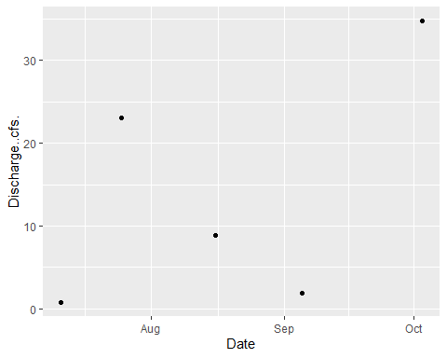

### Site ID: 13-LGUN-6.0

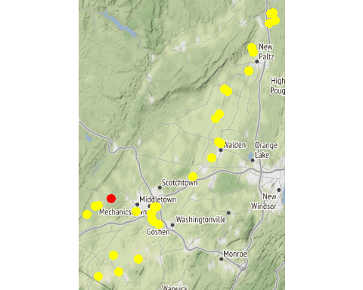

Chemistry Measurements: 13-LGUN-6.0

| **SITE_ID** | **chemical_name** | **record_count** | **mean** | **num_exceed** | **min** | **max** | **median** |
| --- | --- | --- | --- | --- | --- | --- | --- |
| 13-LGUN-6.0 | alkalinity, total (as caco3) | 5 | 46.080 | NA | 35.60 | 53.60 | 46.80 |
| 13-LGUN-6.0 | aluminum | 4 | 191.825 | NA | 49.20 | 368.00 | 175.05 |
| 13-LGUN-6.0 | arsenic | 5 | 0.802 | NA | 0.54 | 1.00 | 0.86 |
| 13-LGUN-6.0 | cadmium | 1 | 0.570 | NA | 0.57 | 0.57 | 0.57 |
| 13-LGUN-6.0 | calcium | 5 | 19000.000 | NA | 14700.00 | 21400.00 | 19200.00 |
| 13-LGUN-6.0 | chloride (as cl) | 4 | 32.750 | NA | 23.00 | 42.20 | 32.90 |
| 13-LGUN-6.0 | chlorophyll a | 5 | 3.114 | NA | 0.78 | 6.95 | 2.23 |
| 13-LGUN-6.0 | copper | 5 | 16.600 | NA | 8.40 | 29.10 | 14.30 |
| 13-LGUN-6.0 | hardness (as caco3) | 5 | 61.120 | NA | 48.00 | 68.00 | 62.50 |
| 13-LGUN-6.0 | iron | 5 | 640.000 | NA | 234.00 | 1200.00 | 587.00 |
| 13-LGUN-6.0 | lead | 5 | 0.676 | NA | 0.16 | 1.00 | 0.78 |
| 13-LGUN-6.0 | magnesium | 5 | 3318.000 | NA | 2760.00 | 3660.00 | 3510.00 |
| 13-LGUN-6.0 | nickel | 5 | 1.188 | NA | 0.54 | 1.60 | 1.30 |
| 13-LGUN-6.0 | nitrate+nitrite as nitrogen | 5 | 0.102 | NA | 0.04 | 0.19 | 0.08 |
| 13-LGUN-6.0 | nitrogen | 5 | 0.622 | NA | 0.52 | 0.69 | 0.65 |
| 13-LGUN-6.0 | nitrogen, ammonia (as n) | 4 | 0.020 | NA | 0.01 | 0.03 | 0.02 |
| 13-LGUN-6.0 | nitrogen, kjeldahl, total | 5 | 0.518 | NA | 0.48 | 0.63 | 0.49 |
| 13-LGUN-6.0 | nitrogen, nitrate (as n) | 4 | 0.118 | NA | 0.06 | 0.19 | 0.11 |
| 13-LGUN-6.0 | phosphorus, total (as p) | 5 | 0.044 | NA | 0.02 | 0.06 | 0.05 |
| 13-LGUN-6.0 | total dissolved solids (residue, filterable) | 5 | 137.000 | NA | 125.00 | 149.00 | 138.00 |
| 13-LGUN-6.0 | turbidity | 5 | 5.280 | NA | 2.24 | 13.20 | 3.91 |
| 13-LGUN-6.0 | zinc | 4 | 5.250 | NA | 4.20 | 6.20 | 5.30 |

In-Situ Measurements: 13-LGUN-6.0

| **SITE_ID** | **chemical_name** | **record_count** | **mean** | **num_exceed** | **min** | **max** | **median** |
| --- | --- | --- | --- | --- | --- | --- | --- |
| 13-LGUN-6.0 | conductance | 4 | 3577.350 | NA | 230.00 | 13379.00 | 350.200 |
| 13-LGUN-6.0 | dissolved oxygen | 8 | 7.753 | 0 | 6.70 | 8.90 | 7.705 |
| 13-LGUN-6.0 | pct saturation | 4 | 92.750 | NA | 82.00 | 104.00 | 92.500 |
| 13-LGUN-6.0 | ph | 4 | 7.852 | NA | 7.50 | 8.19 | 7.860 |
| 13-LGUN-6.0 | salinity | 4 | 2.042 | NA | 0.11 | 7.73 | 0.165 |
| 13-LGUN-6.0 | temperature | 4 | 23.700 | NA | 20.90 | 27.70 | 23.100 |

Dependent Measurements (Metals and Ammonia): 13-LGUN-6.0

| **SITE_ID** | **chemical_name** | **record_count** | **mean** | **num_exceed** | **min** | **max** | **median** |
| --- | --- | --- | --- | --- | --- | --- | --- |
| 13-LGUN-6.0 | zinc | 2 | 6.1 | 1 | 6 | 6.2 | 6.1 |

Numeric Nutrient Criteria: 13-LGUN-6.0

| **SITE_ID** | **chemical_name** | **record_count** | **mean** | **num_exceed** | **min** | **max** | **median** |
| --- | --- | --- | --- | --- | --- | --- | --- |
| 13-LGUN-6.0 | phosphorus, total (as p) | 5 | 0.044 | 0 | 0.02 | 0.06 | 0.05 |

BAP Score: 13-LGUN-6.0

| **SITE_ID** | **DATE** | **BAP** | **SD** | **n** |
| --- | --- | --- | --- | --- |
| 13-LGUN-6.0 | 8/27/2018 | 3.09 | 1.13 | 4 |

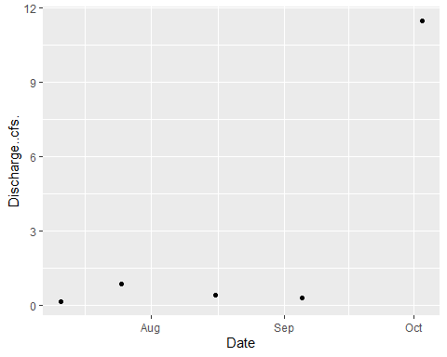

### Site ID: 13-GUNK_T35-0.2

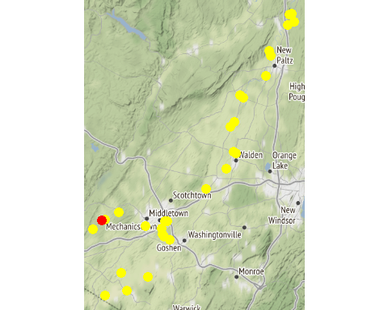

Chemistry Measurements: 13-GUNK_T35-0.2

| **SITE_ID** | **chemical_name** | **record_count** | **mean** | **num_exceed** | **min** | **max** | **median** |
| --- | --- | --- | --- | --- | --- | --- | --- |
| 13-GUNK_T35-0.2 | alkalinity, total (as caco3) | 5 | 60.960 | NA | 34.00 | 98.80 | 56.80 |
| 13-GUNK_T35-0.2 | aluminum | 5 | 490.800 | NA | 85.70 | 1640.00 | 263.00 |
| 13-GUNK_T35-0.2 | arsenic | 5 | 1.100 | NA | 0.62 | 2.30 | 0.85 |
| 13-GUNK_T35-0.2 | cadmium | 2 | 0.320 | NA | 0.08 | 0.56 | 0.32 |
| 13-GUNK_T35-0.2 | calcium | 5 | 23660.000 | NA | 11300.00 | 40000.00 | 19900.00 |
| 13-GUNK_T35-0.2 | chloride (as cl) | 4 | 49.500 | NA | 18.20 | 111.00 | 34.40 |
| 13-GUNK_T35-0.2 | chlorophyll a | 5 | 40.636 | NA | 0.45 | 194.00 | 3.13 |
| 13-GUNK_T35-0.2 | copper | 5 | 3.160 | NA | 1.90 | 5.90 | 2.40 |
| 13-GUNK_T35-0.2 | hardness (as caco3) | 5 | 77.000 | NA | 37.40 | 130.00 | 64.50 |
| 13-GUNK_T35-0.2 | iron | 5 | 1130.800 | NA | 454.00 | 3430.00 | 606.00 |
| 13-GUNK_T35-0.2 | lead | 5 | 1.286 | NA | 0.32 | 3.90 | 0.73 |
| 13-GUNK_T35-0.2 | magnesium | 5 | 4348.000 | NA | 2250.00 | 7330.00 | 3580.00 |
| 13-GUNK_T35-0.2 | nickel | 5 | 1.768 | NA | 0.94 | 4.10 | 1.30 |
| 13-GUNK_T35-0.2 | nitrate+nitrite as nitrogen | 5 | 0.232 | NA | 0.21 | 0.28 | 0.23 |
| 13-GUNK_T35-0.2 | nitrogen | 5 | 0.910 | NA | 0.74 | 1.20 | 0.80 |
| 13-GUNK_T35-0.2 | nitrogen, ammonia (as n) | 4 | 0.053 | NA | 0.01 | 0.14 | 0.03 |
| 13-GUNK_T35-0.2 | nitrogen, kjeldahl, total | 5 | 0.678 | NA | 0.52 | 0.97 | 0.58 |
| 13-GUNK_T35-0.2 | nitrogen, nitrate (as n) | 5 | 0.230 | NA | 0.21 | 0.28 | 0.22 |
| 13-GUNK_T35-0.2 | nitrogen, nitrite | 1 | 0.010 | NA | 0.01 | 0.01 | 0.01 |
| 13-GUNK_T35-0.2 | phosphorus, total (as p) | 5 | 0.106 | NA | 0.06 | 0.19 | 0.09 |
| 13-GUNK_T35-0.2 | total dissolved solids (residue, filterable) | 5 | 186.400 | NA | 103.00 | 319.00 | 150.00 |
| 13-GUNK_T35-0.2 | turbidity | 5 | 19.000 | NA | 3.08 | 74.90 | 5.20 |
| 13-GUNK_T35-0.2 | zinc | 5 | 8.040 | NA | 2.50 | 22.40 | 4.50 |

In-Situ Measurements: 13-GUNK_T35-0.2

| **SITE_ID** | **chemical_name** | **record_count** | **mean** | **num_exceed** | **min** | **max** | **median** |
| --- | --- | --- | --- | --- | --- | --- | --- |
| 13-GUNK_T35-0.2 | conductance | 6 | 550.732 | NA | 284.39 | 790.00 | 614.00 |
| 13-GUNK_T35-0.2 | dissolved oxygen | 12 | 8.977 | 0 | 6.78 | 13.10 | 7.19 |
| 13-GUNK_T35-0.2 | pct saturation | 6 | 107.583 | NA | 74.50 | 163.00 | 84.50 |
| 13-GUNK_T35-0.2 | ph | 6 | 7.800 | NA | 7.30 | 8.30 | 7.85 |
| 13-GUNK_T35-0.2 | salinity | 5 | 0.242 | NA | 0.14 | 0.34 | 0.29 |
| 13-GUNK_T35-0.2 | temperature | 6 | 23.600 | NA | 17.30 | 26.80 | 24.80 |

Dependent Measurements (Metals and Ammonia): 13-GUNK_T35-0.2

| **SITE_ID** | **chemical_name** | **record_count** | **mean** | **num_exceed** | **min** | **max** | **median** |
| --- | --- | --- | --- | --- | --- | --- | --- |
| 13-GUNK_T35-0.2 | zinc | 5 | 8.04 | 3 | 2.5 | 22.4 | 4.5 |

Numeric Nutrient Criteria: 13-GUNK_T35-0.2

| **SITE_ID** | **chemical_name** | **record_count** | **mean** | **num_exceed** | **min** | **max** | **median** |
| --- | --- | --- | --- | --- | --- | --- | --- |
| 13-GUNK_T35-0.2 | phosphorus, total (as p) | 5 | 0.106 | 0 | 0.06 | 0.19 | 0.09 |

BAP Score: 13-GUNK_T35-0.2

| **SITE_ID** | **DATE** | **BAP** | **SD** | **n** |
| --- | --- | --- | --- | --- |

### Site ID: 13-GUNK-37.7

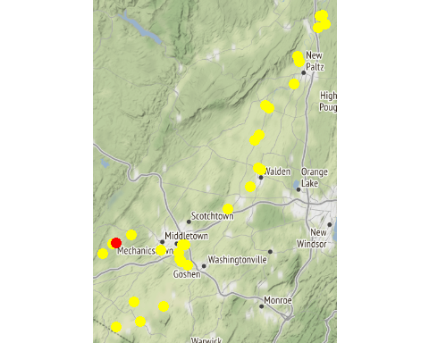

Chemistry Measurements: 13-GUNK-37.7

| **SITE_ID** | **chemical_name** | **record_count** | **mean** | **num_exceed** | **min** | **max** | **median** |
| --- | --- | --- | --- | --- | --- | --- | --- |
| 13-GUNK-37.7 | alkalinity, total (as caco3) | 5 | 71.400 | NA | 35.20 | 181.00 | 4.52e+01 |
| 13-GUNK-37.7 | aluminum | 5 | 225.200 | NA | 97.00 | 419.00 | 1.25e+02 |
| 13-GUNK-37.7 | arsenic | 5 | 2.370 | NA | 0.60 | 7.30 | 1.40e+00 |
| 13-GUNK-37.7 | cadmium | 2 | 0.345 | NA | 0.09 | 0.60 | 3.45e-01 |
| 13-GUNK-37.7 | calcium | 5 | 25860.000 | NA | 12100.00 | 62700.00 | 1.78e+04 |
| 13-GUNK-37.7 | chloride (as cl) | 4 | 93.675 | NA | 23.90 | 275.00 | 3.79e+01 |
| 13-GUNK-37.7 | chlorophyll a | 5 | 12.300 | NA | 1.19 | 38.60 | 5.78e+00 |
| 13-GUNK-37.7 | copper | 5 | 4.000 | NA | 2.30 | 7.80 | 2.90e+00 |
| 13-GUNK-37.7 | hardness (as caco3) | 5 | 82.840 | NA | 40.30 | 197.00 | 5.81e+01 |
| 13-GUNK-37.7 | iron | 5 | 1997.200 | NA | 593.00 | 6520.00 | 7.76e+02 |
| 13-GUNK-37.7 | lead | 5 | 0.994 | NA | 0.45 | 2.20 | 6.50e-01 |
| 13-GUNK-37.7 | magnesium | 5 | 4446.000 | NA | 2430.00 | 9940.00 | 3.31e+03 |
| 13-GUNK-37.7 | nickel | 5 | 1.532 | NA | 0.96 | 3.00 | 1.30e+00 |
| 13-GUNK-37.7 | nitrate+nitrite as nitrogen | 5 | 0.112 | NA | 0.02 | 0.20 | 1.30e-01 |
| 13-GUNK-37.7 | nitrogen | 5 | 2.176 | NA | 0.69 | 7.47 | 8.10e-01 |
| 13-GUNK-37.7 | nitrogen, ammonia (as n) | 4 | 0.043 | NA | 0.02 | 0.07 | 4.00e-02 |
| 13-GUNK-37.7 | nitrogen, kjeldahl, total | 5 | 2.068 | NA | 0.56 | 7.46 | 7.40e-01 |
| 13-GUNK-37.7 | nitrogen, nitrate (as n) | 5 | 0.110 | NA | 0.02 | 0.19 | 1.30e-01 |
| 13-GUNK-37.7 | nitrogen, nitrite | 1 | 0.010 | NA | 0.01 | 0.01 | 1.00e-02 |
| 13-GUNK-37.7 | phosphorus, total (as p) | 5 | 0.246 | NA | 0.07 | 0.82 | 1.00e-01 |
| 13-GUNK-37.7 | total dissolved solids (residue, filterable) | 5 | 254.800 | NA | 109.00 | 700.00 | 1.57e+02 |
| 13-GUNK-37.7 | turbidity | 5 | 22.460 | NA | 3.95 | 86.10 | 6.81e+00 |
| 13-GUNK-37.7 | zinc | 5 | 5.920 | NA | 2.70 | 14.30 | 4.00e+00 |

In-Situ Measurements: 13-GUNK-37.7

| **SITE_ID** | **chemical_name** | **record_count** | **mean** | **num_exceed** | **min** | **max** | **median** |
| --- | --- | --- | --- | --- | --- | --- | --- |
| 13-GUNK-37.7 | conductance | 6 | 1668.750 | NA | 206.50 | 6314.00 | 976.500 |
| 13-GUNK-37.7 | dissolved oxygen | 12 | 8.288 | 0 | 6.20 | 9.80 | 8.915 |
| 13-GUNK-37.7 | pct saturation | 6 | 96.917 | NA | 80.00 | 111.70 | 99.100 |
| 13-GUNK-37.7 | ph | 6 | 7.352 | NA | 6.56 | 7.77 | 7.460 |
| 13-GUNK-37.7 | salinity | 6 | 0.875 | NA | 0.10 | 3.44 | 0.480 |
| 13-GUNK-37.7 | temperature | 6 | 22.750 | NA | 16.60 | 27.10 | 23.650 |

Dependent Measurements (Metals and Ammonia): 13-GUNK-37.7

| **SITE_ID** | **chemical_name** | **record_count** | **mean** | **num_exceed** | **min** | **max** | **median** |
| --- | --- | --- | --- | --- | --- | --- | --- |
| 13-GUNK-37.7 | zinc | 5 | 5.92 | 3 | 2.7 | 14.3 | 4 |

Numeric Nutrient Criteria: 13-GUNK-37.7

| **SITE_ID** | **chemical_name** | **record_count** | **mean** | **num_exceed** | **min** | **max** | **median** |
| --- | --- | --- | --- | --- | --- | --- | --- |
| 13-GUNK-37.7 | phosphorus, total (as p) | 5 | 0.246 | 0 | 0.07 | 0.82 | 0.1 |

BAP Score: 13-GUNK-37.7

| **SITE_ID** | **DATE** | **BAP** | **SD** | **n** |
| --- | --- | --- | --- | --- |

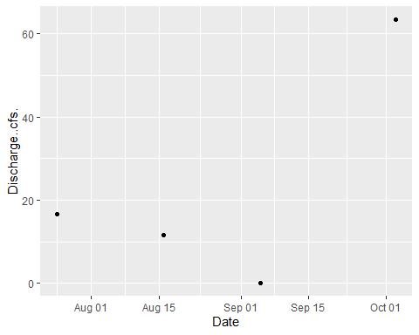

### Site ID: 13-GUNK-40.3

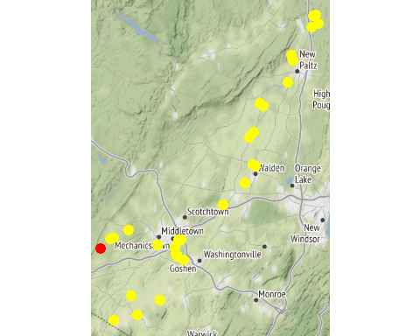

Chemistry Measurements: 13-GUNK-40.3

| **SITE_ID** | **chemical_name** | **record_count** | **mean** | **num_exceed** | **min** | **max** | **median** |
| --- | --- | --- | --- | --- | --- | --- | --- |
| 13-GUNK-40.3 | alkalinity, total (as caco3) | 5 | 46.880 | NA | 3.32e+01 | 6.44e+01 | 4.08e+01 |
| 13-GUNK-40.3 | aluminum | 5 | 268.980 | NA | 8.99e+01 | 5.08e+02 | 3.17e+02 |
| 13-GUNK-40.3 | arsenic | 5 | 0.886 | 0 | 6.30e-01 | 1.10e+00 | 9.00e-01 |
| 13-GUNK-40.3 | cadmium | 1 | 0.550 | NA | 5.50e-01 | 5.50e-01 | 5.50e-01 |
| 13-GUNK-40.3 | calcium | 5 | 20340.000 | NA | 1.22e+04 | 2.77e+04 | 1.87e+04 |
| 13-GUNK-40.3 | chloride (as cl) | 4 | 48600.000 | 4 | 2.87e+04 | 8.01e+04 | 4.28e+04 |
| 13-GUNK-40.3 | chlorophyll a | 5 | 2.132 | NA | 8.90e-01 | 5.25e+00 | 1.63e+00 |
| 13-GUNK-40.3 | copper | 5 | 3.360 | NA | 2.20e+00 | 4.70e+00 | 3.00e+00 |
| 13-GUNK-40.3 | hardness (as caco3) | 5 | 66.860 | NA | 4.09e+01 | 9.13e+01 | 6.20e+01 |
| 13-GUNK-40.3 | iron | 5 | 704.000 | 3 | 2.06e+02 | 1.34e+03 | 6.63e+02 |
| 13-GUNK-40.3 | lead | 5 | 0.678 | 0 | 2.90e-01 | 1.10e+00 | 7.20e-01 |
| 13-GUNK-40.3 | magnesium | 5 | 3894.000 | NA | 2.50e+03 | 5.34e+03 | 3.69e+03 |
| 13-GUNK-40.3 | nickel | 10 | 1.152 | 0 | 8.80e-01 | 1.40e+00 | 1.20e+00 |
| 13-GUNK-40.3 | nitrate+nitrite as nitrogen | 5 | 0.128 | NA | 5.00e-02 | 3.90e-01 | 7.00e-02 |
| 13-GUNK-40.3 | nitrogen | 5 | 0.782 | NA | 6.30e-01 | 1.09e+00 | 7.10e-01 |
| 13-GUNK-40.3 | nitrogen, ammonia (as n) | 4 | 0.025 | NA | 1.00e-02 | 4.00e-02 | 2.50e-02 |
| 13-GUNK-40.3 | nitrogen, kjeldahl, total | 5 | 0.656 | NA | 4.30e-01 | 1.03e+00 | 6.10e-01 |
| 13-GUNK-40.3 | nitrogen, nitrate (as n) | 3 | 170.000 | 3 | 5.00e+01 | 3.90e+02 | 7.00e+01 |
| 13-GUNK-40.3 | phosphorus, total (as p) | 5 | 0.070 | NA | 5.00e-02 | 1.00e-01 | 6.00e-02 |
| 13-GUNK-40.3 | total dissolved solids (residue, filterable) | 5 | 174400.000 | 0 | 1.24e+05 | 2.26e+05 | 1.69e+05 |
| 13-GUNK-40.3 | turbidity | 5 | 10.964 | NA | 3.75e+00 | 1.92e+01 | 9.21e+00 |

In-Situ Measurements: 13-GUNK-40.3

| **SITE_ID** | **chemical_name** | **record_count** | **mean** | **num_exceed** | **min** | **max** | **median** |
| --- | --- | --- | --- | --- | --- | --- | --- |
| 13-GUNK-40.3 | conductance | 6 | 637.950 | NA | 299.00 | 1083.00 | 582.600 |
| 13-GUNK-40.3 | dissolved oxygen | 12 | 7.358 | 0 | 5.30 | 8.50 | 7.580 |
| 13-GUNK-40.3 | pct saturation | 6 | 86.167 | NA | 65.00 | 101.00 | 89.750 |
| 13-GUNK-40.3 | ph | 6 | 7.627 | NA | 7.03 | 8.39 | 7.635 |
| 13-GUNK-40.3 | salinity | 6 | 0.310 | NA | 0.14 | 0.54 | 0.280 |
| 13-GUNK-40.3 | temperature | 6 | 22.467 | NA | 17.80 | 25.30 | 23.200 |

Dependent Measurements (Metals and Ammonia): 13-GUNK-40.3

| **SITE_ID** | **chemical_name** | **record_count** | **mean** | **num_exceed** | **min** | **max** | **median** |
| --- | --- | --- | --- | --- | --- | --- | --- |
| 13-GUNK-40.3 | zinc | 4 | 4.475 | 3 | 2.9 | 6.3 | 4.35 |

Numeric Nutrient Criteria: 13-GUNK-40.3

| **SITE_ID** | **chemical_name** | **record_count** | **mean** | **num_exceed** | **min** | **max** | **median** |
| --- | --- | --- | --- | --- | --- | --- | --- |
| 13-GUNK-40.3 | phosphorus, total (as p) | 5 | 0.07 | 0 | 0.05 | 0.1 | 0.06 |

BAP Score: 13-GUNK-40.3

| **SITE_ID** | **DATE** | **BAP** | **SD** | **n** |
| --- | --- | --- | --- | --- |

### Site ID: 13-MASO-0.2

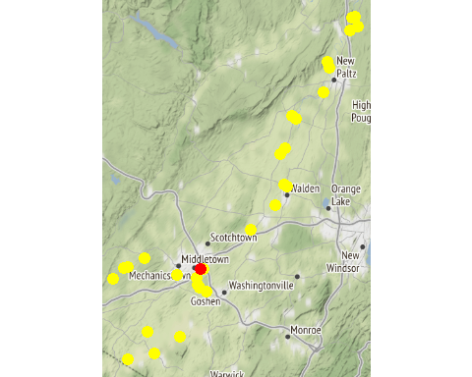

Chemistry Measurements: 13-MASO-0.2

| **SITE_ID** | **chemical_name** | **record_count** | **mean** | **num_exceed** | **min** | **max** | **median** |
| --- | --- | --- | --- | --- | --- | --- | --- |
| 13-MASO-0.2 | alkalinity, total (as caco3) | 5 | 110.880 | NA | 59.20 | 149.00 | 116.00 |
| 13-MASO-0.2 | aluminum | 5 | 350.400 | NA | 116.00 | 983.00 | 163.00 |
| 13-MASO-0.2 | arsenic | 5 | 1.462 | NA | 0.91 | 2.00 | 1.50 |
| 13-MASO-0.2 | calcium | 5 | 55320.000 | NA | 32600.00 | 80300.00 | 47400.00 |
| 13-MASO-0.2 | chloride (as cl) | 5 | 140.480 | NA | 56.70 | 269.00 | 116.00 |
| 13-MASO-0.2 | chlorophyll a | 5 | 20.920 | NA | 1.84 | 55.60 | 17.30 |
| 13-MASO-0.2 | copper | 5 | 3.280 | NA | 2.30 | 4.70 | 3.30 |
| 13-MASO-0.2 | hardness (as caco3) | 5 | 169.600 | NA | 102.00 | 251.00 | 141.00 |
| 13-MASO-0.2 | iron | 4 | 786.500 | NA | 453.00 | 1330.00 | 681.50 |
| 13-MASO-0.2 | lead | 5 | 1.372 | NA | 0.50 | 3.50 | 0.86 |
| 13-MASO-0.2 | magnesium | 5 | 7610.000 | NA | 4510.00 | 12300.00 | 6130.00 |
| 13-MASO-0.2 | nickel | 5 | 1.980 | NA | 1.30 | 2.60 | 2.00 |
| 13-MASO-0.2 | nitrate+nitrite as nitrogen | 5 | 0.226 | NA | 0.11 | 0.40 | 0.20 |
| 13-MASO-0.2 | nitrogen | 5 | 0.936 | NA | 0.72 | 1.22 | 0.93 |
| 13-MASO-0.2 | nitrogen, ammonia (as n) | 3 | 0.017 | NA | 0.01 | 0.02 | 0.02 |
| 13-MASO-0.2 | nitrogen, kjeldahl, total | 5 | 0.708 | NA | 0.54 | 1.10 | 0.67 |
| 13-MASO-0.2 | nitrogen, nitrate (as n) | 5 | 0.226 | NA | 0.11 | 0.40 | 0.20 |
| 13-MASO-0.2 | phosphorus, total (as p) | 5 | 0.066 | NA | 0.06 | 0.07 | 0.07 |
| 13-MASO-0.2 | silver | 1 | 0.110 | NA | 0.11 | 0.11 | 0.11 |
| 13-MASO-0.2 | total dissolved solids (residue, filterable) | 5 | 391.600 | NA | 225.00 | 621.00 | 324.00 |
| 13-MASO-0.2 | turbidity | 4 | 16.738 | NA | 4.63 | 41.60 | 10.36 |
| 13-MASO-0.2 | zinc | 5 | 9.920 | NA | 3.20 | 22.80 | 8.50 |

In-Situ Measurements: 13-MASO-0.2

| **SITE_ID** | **chemical_name** | **record_count** | **mean** | **num_exceed** | **min** | **max** | **median** |
| --- | --- | --- | --- | --- | --- | --- | --- |
| 13-MASO-0.2 | conductance | 6 | 748.365 | NA | 411.60 | 1605.00 | 577.145 |
| 13-MASO-0.2 | dissolved oxygen | 12 | 7.958 | 1 | 4.95 | 10.10 | 8.200 |
| 13-MASO-0.2 | pct saturation | 6 | 85.983 | NA | 58.10 | 105.00 | 92.900 |
| 13-MASO-0.2 | ph | 6 | 7.318 | NA | 6.60 | 7.97 | 7.395 |
| 13-MASO-0.2 | salinity | 6 | 0.370 | NA | 0.20 | 0.81 | 0.280 |
| 13-MASO-0.2 | temperature | 6 | 18.717 | NA | 14.60 | 24.00 | 17.600 |

Dependent Measurements (Metals and Ammonia): 13-MASO-0.2

| **SITE_ID** | **chemical_name** | **record_count** | **mean** | **num_exceed** | **min** | **max** | **median** |
| --- | --- | --- | --- | --- | --- | --- | --- |
| 13-MASO-0.2 | zinc | 5 | 9.92 | 2 | 3.2 | 22.8 | 8.5 |

Numeric Nutrient Criteria: 13-MASO-0.2

| **SITE_ID** | **chemical_name** | **record_count** | **mean** | **num_exceed** | **min** | **max** | **median** |
| --- | --- | --- | --- | --- | --- | --- | --- |
| 13-MASO-0.2 | phosphorus, total (as p) | 5 | 0.066 | 0 | 0.06 | 0.07 | 0.07 |

BAP Score: 13-MASO-0.2

| **SITE_ID** | **DATE** | **BAP** | **SD** | **n** |
| --- | --- | --- | --- | --- |
| 13-MASO-0.2 | 8/27/2018 | 5.6 | 0.83 | 4 |

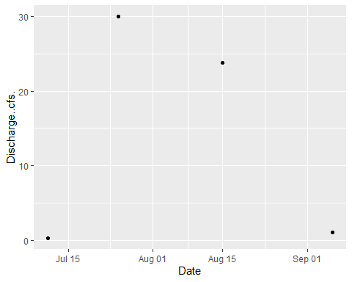

### Site ID: 13-WALK-44.4

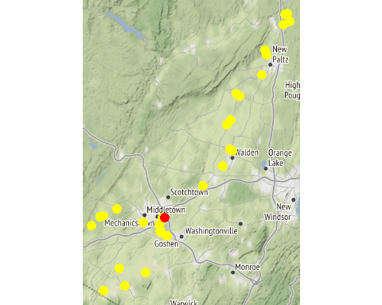

Chemistry Measurements: 13-WALK-44.4

| **SITE_ID** | **chemical_name** | **record_count** | **mean** | **num_exceed** | **min** | **max** | **median** |
| --- | --- | --- | --- | --- | --- | --- | --- |
| 13-WALK-44.4 | alkalinity, total (as caco3) | 10 | 114.120 | NA | 65.20 | 166.00 | 113.500 |
| 13-WALK-44.4 | aluminum | 8 | 693.625 | NA | 104.00 | 1660.00 | 584.000 |
| 13-WALK-44.4 | arsenic | 10 | 1.880 | NA | 1.30 | 2.80 | 1.750 |
| 13-WALK-44.4 | calcium | 10 | 43250.000 | NA | 28300.00 | 64200.00 | 39950.000 |
| 13-WALK-44.4 | chloride (as cl) | 10 | 71.520 | NA | 33.60 | 110.00 | 67.800 |
| 13-WALK-44.4 | chlorophyll a | 10 | 5.621 | NA | 1.28 | 22.00 | 2.995 |
| 13-WALK-44.4 | copper | 10 | 4.820 | NA | 2.70 | 6.90 | 4.550 |
| 13-WALK-44.4 | hardness (as caco3) | 10 | 160.800 | NA | 101.00 | 241.00 | 153.500 |
| 13-WALK-44.4 | iron | 9 | 1143.889 | NA | 208.00 | 3040.00 | 655.000 |
| 13-WALK-44.4 | lead | 7 | 1.721 | NA | 0.45 | 2.90 | 1.500 |
| 13-WALK-44.4 | magnesium | 9 | 12398.889 | NA | 7240.00 | 19500.00 | 12900.000 |
| 13-WALK-44.4 | nickel | 10 | 2.420 | NA | 1.20 | 4.10 | 2.150 |
| 13-WALK-44.4 | nitrate+nitrite as nitrogen | 10 | 1.716 | NA | 0.60 | 4.76 | 1.350 |
| 13-WALK-44.4 | nitrogen | 10 | 2.522 | NA | 1.34 | 5.48 | 2.450 |
| 13-WALK-44.4 | nitrogen, ammonia (as n) | 6 | 0.060 | NA | 0.03 | 0.12 | 0.045 |
| 13-WALK-44.4 | nitrogen, kjeldahl, total | 10 | 0.868 | NA | 0.56 | 1.60 | 0.760 |
| 13-WALK-44.4 | nitrogen, nitrate (as n) | 10 | 1.701 | NA | 0.59 | 4.74 | 1.330 |
| 13-WALK-44.4 | nitrogen, nitrite | 9 | 0.018 | NA | 0.01 | 0.03 | 0.020 |
| 13-WALK-44.4 | phosphorus, total (as p) | 10 | 0.246 | NA | 0.14 | 0.45 | 0.235 |
| 13-WALK-44.4 | silver | 1 | 0.160 | NA | 0.16 | 0.16 | 0.160 |
| 13-WALK-44.4 | total dissolved solids (residue, filterable) | 5 | 282.200 | NA | 195.00 | 404.00 | 247.000 |
| 13-WALK-44.4 | turbidity | 8 | 28.489 | NA | 8.22 | 63.30 | 18.600 |
| 13-WALK-44.4 | zinc | 10 | 12.850 | NA | 3.90 | 26.00 | 11.200 |

In-Situ Measurements: 13-WALK-44.4

| **SITE_ID** | **chemical_name** | **record_count** | **mean** | **num_exceed** | **min** | **max** | **median** |
| --- | --- | --- | --- | --- | --- | --- | --- |
| 13-WALK-44.4 | chl rfu | 4 | 0.870 | NA | 0.29 | 1.51 | 0.840 |
| 13-WALK-44.4 | chl ugl | 4 | 3.520 | NA | 1.26 | 6.10 | 3.360 |
| 13-WALK-44.4 | conductance | 11 | 532.609 | NA | 241.20 | 948.00 | 469.400 |
| 13-WALK-44.4 | dissolved oxygen | 22 | 7.085 | 1 | 4.70 | 9.95 | 7.130 |
| 13-WALK-44.4 | pc rfu | 4 | -0.005 | NA | -0.07 | 0.08 | -0.015 |
| 13-WALK-44.4 | pc ugl | 4 | 0.027 | NA | -0.04 | 0.15 | 0.000 |
| 13-WALK-44.4 | pct saturation | 11 | 78.973 | NA | 58.00 | 97.80 | 80.200 |
| 13-WALK-44.4 | ph | 11 | 7.515 | NA | 7.22 | 8.02 | 7.520 |
| 13-WALK-44.4 | salinity | 10 | 0.262 | NA | 0.11 | 0.47 | 0.245 |
| 13-WALK-44.4 | temperature | 11 | 21.045 | NA | 14.50 | 25.70 | 22.100 |

Dependent Measurements (Metals and Ammonia): 13-WALK-44.4

| **SITE_ID** | **chemical_name** | **record_count** | **mean** | **num_exceed** | **min** | **max** | **median** |
| --- | --- | --- | --- | --- | --- | --- | --- |
| 13-WALK-44.4 | zinc | 10 | 12.85 | 5 | 3.9 | 26 | 11.2 |

Numeric Nutrient Criteria: 13-WALK-44.4

| **SITE_ID** | **chemical_name** | **record_count** | **mean** | **num_exceed** | **min** | **max** | **median** |
| --- | --- | --- | --- | --- | --- | --- | --- |
| 13-WALK-44.4 | phosphorus, total (as p) | 10 | 0.246 | 0 | 0.14 | 0.45 | 0.235 |

BAP Score: 13-WALK-44.4

| **SITE_ID** | **DATE** | **BAP** | **SD** | **n** |
| --- | --- | --- | --- | --- |

### Site ID: 13-WALK-35.6

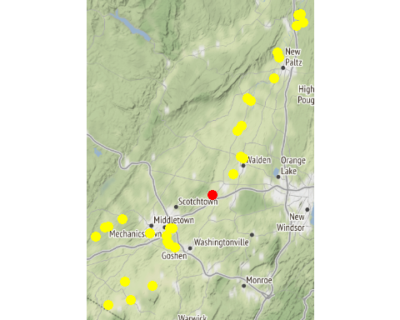

Chemistry Measurements: 13-WALK-35.6

| **SITE_ID** | **chemical_name** | **record_count** | **mean** | **num_exceed** | **min** | **max** | **median** |
| --- | --- | --- | --- | --- | --- | --- | --- |
| 13-WALK-35.6 | alkalinity, total (as caco3) | 10 | 126.820 | NA | 79.20 | 158.00 | 142.000 |
| 13-WALK-35.6 | aluminum | 10 | 498.300 | NA | 90.00 | 1530.00 | 244.000 |
| 13-WALK-35.6 | arsenic | 10 | 1.481 | NA | 0.43 | 2.20 | 1.550 |
| 13-WALK-35.6 | cadmium | 1 | 0.590 | NA | 0.59 | 0.59 | 0.590 |
| 13-WALK-35.6 | calcium | 5 | 42520.000 | NA | 32700.00 | 55700.00 | 36200.000 |
| 13-WALK-35.6 | chloride (as cl) | 9 | 82.900 | NA | 42.70 | 115.00 | 89.900 |
| 13-WALK-35.6 | chlorophyll a | 10 | 6.706 | NA | 1.68 | 32.90 | 2.560 |
| 13-WALK-35.6 | conductivity at 25 degrees celsius | 5 | 679.000 | NA | 540.00 | 762.00 | 706.000 |
| 13-WALK-35.6 | copper | 10 | 4.360 | NA | 2.70 | 6.30 | 4.100 |
| 13-WALK-35.6 | hardness (as caco3) | 10 | 179.900 | NA | 117.00 | 230.00 | 199.500 |
| 13-WALK-35.6 | iron | 10 | 1035.400 | NA | 140.00 | 2830.00 | 606.500 |
| 13-WALK-35.6 | lead | 10 | 1.362 | NA | 0.46 | 3.50 | 0.825 |
| 13-WALK-35.6 | magnesium | 10 | 13577.000 | NA | 8560.00 | 17200.00 | 15200.000 |
| 13-WALK-35.6 | nickel | 10 | 2.800 | NA | 1.80 | 3.70 | 2.650 |
| 13-WALK-35.6 | nitrate+nitrite as nitrogen | 10 | 1.100 | NA | 0.21 | 1.59 | 1.295 |
| 13-WALK-35.6 | nitrogen | 5 | 2.216 | NA | 1.62 | 2.77 | 2.440 |
| 13-WALK-35.6 | nitrogen, ammonia (as n) | 8 | 0.043 | NA | 0.02 | 0.06 | 0.045 |
| 13-WALK-35.6 | nitrogen, kjeldahl, total | 5 | 1.078 | NA | 0.90 | 1.55 | 0.940 |
| 13-WALK-35.6 | nitrogen, nitrate (as n) | 10 | 1.087 | NA | 0.21 | 1.59 | 1.275 |
| 13-WALK-35.6 | nitrogen, nitrite | 8 | 0.019 | NA | 0.01 | 0.02 | 0.020 |
| 13-WALK-35.6 | ph | 5 | 7.866 | NA | 7.71 | 8.02 | 7.920 |
| 13-WALK-35.6 | phosphorus, total (as p) | 10 | 0.213 | NA | 0.16 | 0.32 | 0.205 |
| 13-WALK-35.6 | temperature of ph analysis | 5 | 21.100 | NA | 19.20 | 23.90 | 20.700 |
| 13-WALK-35.6 | total dissolved solids (residue, filterable) | 10 | 326.900 | NA | 226.00 | 418.00 | 340.500 |
| 13-WALK-35.6 | turbidity | 8 | 16.481 | NA | 3.33 | 47.30 | 10.065 |
| 13-WALK-35.6 | zinc | 9 | 10.978 | NA | 5.50 | 21.40 | 7.800 |

In-Situ Measurements: 13-WALK-35.6

| **SITE_ID** | **chemical_name** | **record_count** | **mean** | **num_exceed** | **min** | **max** | **median** |
| --- | --- | --- | --- | --- | --- | --- | --- |
| 13-WALK-35.6 | conductance | 9 | 520.789 | NA | 294.10 | 663.00 | 575.00 |
| 13-WALK-35.6 | dissolved oxygen | 18 | 7.707 | 0 | 6.70 | 9.65 | 7.60 |
| 13-WALK-35.6 | pct saturation | 7 | 87.143 | NA | 76.00 | 100.00 | 87.00 |
| 13-WALK-35.6 | ph | 9 | 7.652 | NA | 7.32 | 8.20 | 7.60 |
| 13-WALK-35.6 | salinity | 6 | 0.242 | NA | 0.14 | 0.32 | 0.25 |
| 13-WALK-35.6 | temperature | 9 | 22.822 | NA | 16.90 | 26.00 | 24.30 |

Dependent Measurements (Metals and Ammonia): 13-WALK-35.6

| **SITE_ID** | **chemical_name** | **record_count** | **mean** | **num_exceed** | **min** | **max** | **median** |
| --- | --- | --- | --- | --- | --- | --- | --- |
| 13-WALK-35.6 | zinc | 5 | 14.18 | 3 | 6 | 21.4 | 17 |

Numeric Nutrient Criteria: 13-WALK-35.6

| **SITE_ID** | **chemical_name** | **record_count** | **mean** | **num_exceed** | **min** | **max** | **median** |
| --- | --- | --- | --- | --- | --- | --- | --- |
| 13-WALK-35.6 | phosphorus, total (as p) | 10 | 0.213 | 0 | 0.16 | 0.32 | 0.205 |

BAP Score: 13-WALK-35.6

| **SITE_ID** | **DATE** | **BAP** | **SD** | **n** |
| --- | --- | --- | --- | --- |
| 13-WALK-35.6 | 8/3/2017 | 5.29 | 0.46 | 4 |

### Site ID: 13-WALK-29.9

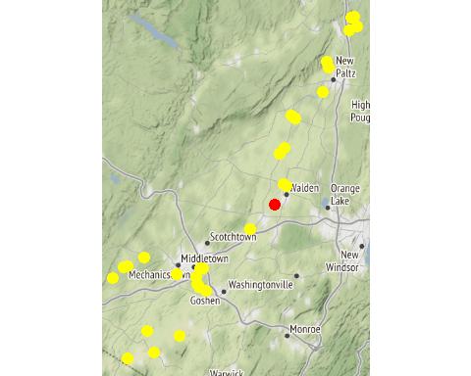

Chemistry Measurements: 13-WALK-29.9

| **SITE_ID** | **chemical_name** | **record_count** | **mean** | **num_exceed** | **min** | **max** | **median** |
| --- | --- | --- | --- | --- | --- | --- | --- |
| 13-WALK-29.9 | alkalinity, total (as caco3) | 10 | 124.040 | NA | 88.80 | 156.00 | 128.000 |
| 13-WALK-29.9 | aluminum | 10 | 361.010 | NA | 95.10 | 1010.00 | 234.000 |
| 13-WALK-29.9 | arsenic | 10 | 1.323 | NA | 0.41 | 2.70 | 1.200 |
| 13-WALK-29.9 | cadmium | 1 | 0.590 | NA | 0.59 | 0.59 | 0.590 |
| 13-WALK-29.9 | calcium | 5 | 44920.000 | NA | 34700.00 | 52600.00 | 45500.000 |
| 13-WALK-29.9 | chloride (as cl) | 9 | 83.500 | NA | 48.50 | 108.00 | 90.600 |
| 13-WALK-29.9 | chlorophyll a | 10 | 18.961 | NA | 0.69 | 132.00 | 5.150 |
| 13-WALK-29.9 | conductivity at 25 degrees celsius | 5 | 632.400 | NA | 531.00 | 678.00 | 648.000 |
| 13-WALK-29.9 | copper | 10 | 3.980 | NA | 2.50 | 7.40 | 3.700 |
| 13-WALK-29.9 | hardness (as caco3) | 10 | 175.700 | NA | 126.00 | 214.00 | 179.500 |
| 13-WALK-29.9 | iron | 10 | 762.200 | NA | 116.00 | 2540.00 | 513.500 |
| 13-WALK-29.9 | lead | 10 | 1.065 | NA | 0.48 | 3.10 | 0.715 |
| 13-WALK-29.9 | magnesium | 10 | 13148.000 | NA | 9490.00 | 17800.00 | 13100.000 |
| 13-WALK-29.9 | nickel | 10 | 2.380 | NA | 1.60 | 4.00 | 2.200 |
| 13-WALK-29.9 | nitrate+nitrite as nitrogen | 10 | 1.205 | NA | 0.31 | 2.53 | 1.205 |
| 13-WALK-29.9 | nitrogen | 5 | 2.380 | NA | 1.78 | 4.08 | 2.090 |
| 13-WALK-29.9 | nitrogen, ammonia (as n) | 9 | 0.032 | NA | 0.02 | 0.06 | 0.030 |
| 13-WALK-29.9 | nitrogen, kjeldahl, total | 5 | 1.122 | NA | 0.78 | 1.55 | 0.890 |
| 13-WALK-29.9 | nitrogen, nitrate (as n) | 10 | 1.196 | NA | 0.29 | 2.51 | 1.195 |
| 13-WALK-29.9 | nitrogen, nitrite | 6 | 0.015 | NA | 0.01 | 0.02 | 0.015 |
| 13-WALK-29.9 | ph | 5 | 7.942 | NA | 7.78 | 8.11 | 7.960 |
| 13-WALK-29.9 | phosphorus, total (as p) | 10 | 0.192 | NA | 0.11 | 0.34 | 0.175 |
| 13-WALK-29.9 | temperature of ph analysis | 5 | 21.600 | NA | 19.30 | 26.20 | 20.800 |
| 13-WALK-29.9 | total dissolved solids (residue, filterable) | 10 | 325.000 | NA | 231.00 | 406.00 | 335.500 |
| 13-WALK-29.9 | turbidity | 8 | 10.312 | NA | 3.34 | 22.10 | 9.750 |
| 13-WALK-29.9 | zinc | 9 | 8.600 | NA | 3.60 | 24.70 | 5.600 |

In-Situ Measurements: 13-WALK-29.9

| **SITE_ID** | **chemical_name** | **record_count** | **mean** | **num_exceed** | **min** | **max** | **median** |
| --- | --- | --- | --- | --- | --- | --- | --- |
| 13-WALK-29.9 | conductance | 7 | 451.671 | NA | 350.20 | 627.00 | 423.50 |
| 13-WALK-29.9 | dissolved oxygen | 14 | 7.034 | 0 | 6.40 | 8.20 | 6.74 |
| 13-WALK-29.9 | pct saturation | 7 | 82.143 | NA | 68.00 | 100.00 | 79.00 |
| 13-WALK-29.9 | ph | 7 | 7.589 | NA | 7.39 | 7.74 | 7.60 |
| 13-WALK-29.9 | salinity | 7 | 0.216 | NA | 0.17 | 0.30 | 0.20 |
| 13-WALK-29.9 | temperature | 7 | 22.486 | NA | 17.50 | 25.40 | 23.30 |

Dependent Measurements (Metals and Ammonia): 13-WALK-29.9

| **SITE_ID** | **chemical_name** | **record_count** | **mean** | **num_exceed** | **min** | **max** | **median** |
| --- | --- | --- | --- | --- | --- | --- | --- |
| 13-WALK-29.9 | zinc | 5 | 10.9 | 3 | 3.6 | 24.7 | 9.1 |

Numeric Nutrient Criteria: 13-WALK-29.9

| **SITE_ID** | **chemical_name** | **record_count** | **mean** | **num_exceed** | **min** | **max** | **median** |
| --- | --- | --- | --- | --- | --- | --- | --- |
| 13-WALK-29.9 | phosphorus, total (as p) | 10 | 0.192 | 0 | 0.11 | 0.34 | 0.175 |

BAP Score: 13-WALK-29.9

| **SITE_ID** | **DATE** | **BAP** | **SD** | **n** |
| --- | --- | --- | --- | --- |
| 13-WALK-29.9 | 8/3/2017 | 5.69 | 0.38 | 4 |

### Site ID: 13-TINW-0.5

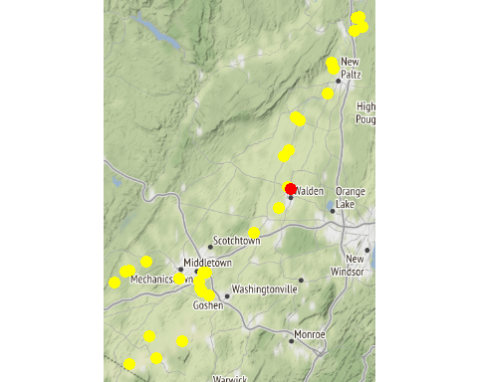

Chemistry Measurements: 13-TINW-0.5

| **SITE_ID** | **chemical_name** | **record_count** | **mean** | **num_exceed** | **min** | **max** | **median** |
| --- | --- | --- | --- | --- | --- | --- | --- |
| 13-TINW-0.5 | alkalinity, total (as caco3) | 10 | 97.160 | NA | 6.64e+01 | 1.31e+02 | 9.570e+01 |
| 13-TINW-0.5 | aluminum | 8 | 274.312 | NA | 2.72e+01 | 6.85e+02 | 2.230e+02 |
| 13-TINW-0.5 | arsenic | 10 | 1.071 | 0 | 6.80e-01 | 1.50e+00 | 1.150e+00 |
| 13-TINW-0.5 | cadmium | 1 | 0.560 | NA | 5.60e-01 | 5.60e-01 | 5.600e-01 |
| 13-TINW-0.5 | calcium | 10 | 40940.000 | NA | 2.60e+04 | 5.45e+04 | 3.955e+04 |
| 13-TINW-0.5 | chloride (as cl) | 10 | 65460.000 | 9 | 3.71e+04 | 1.02e+05 | 6.145e+04 |
| 13-TINW-0.5 | chlorophyll a | 10 | 3.074 | NA | 5.00e-01 | 9.57e+00 | 2.085e+00 |
| 13-TINW-0.5 | copper | 10 | 3.250 | NA | 1.70e+00 | 7.40e+00 | 2.800e+00 |
| 13-TINW-0.5 | hardness (as caco3) | 10 | 127.320 | NA | 8.12e+01 | 1.70e+02 | 1.225e+02 |
| 13-TINW-0.5 | iron | 10 | 737.180 | 4 | 8.38e+01 | 1.59e+03 | 5.225e+02 |
| 13-TINW-0.5 | lead | 7 | 1.664 | 0 | 4.70e-01 | 3.10e+00 | 1.400e+00 |
| 13-TINW-0.5 | magnesium | 9 | 5983.333 | NA | 3.99e+03 | 8.21e+03 | 5.360e+03 |
| 13-TINW-0.5 | nickel | 20 | 1.308 | 0 | 8.10e-01 | 1.90e+00 | 1.245e+00 |
| 13-TINW-0.5 | nitrate+nitrite as nitrogen | 10 | 0.333 | NA | 3.00e-02 | 5.60e-01 | 3.500e-01 |
| 13-TINW-0.5 | nitrogen | 10 | 0.877 | NA | 4.40e-01 | 1.18e+00 | 9.450e-01 |
| 13-TINW-0.5 | nitrogen, ammonia (as n) | 5 | 0.016 | NA | 1.00e-02 | 2.00e-02 | 2.000e-02 |
| 13-TINW-0.5 | nitrogen, kjeldahl, total | 10 | 0.576 | NA | 2.20e-01 | 8.00e-01 | 6.150e-01 |
| 13-TINW-0.5 | nitrogen, nitrate (as n) | 10 | 333.000 | 10 | 3.00e+01 | 5.60e+02 | 3.500e+02 |
| 13-TINW-0.5 | phosphorus, total (as p) | 10 | 0.095 | NA | 5.00e-02 | 1.40e-01 | 1.000e-01 |
| 13-TINW-0.5 | total dissolved solids (residue, filterable) | 5 | 231600.000 | 0 | 1.68e+05 | 3.02e+05 | 2.190e+05 |
| 13-TINW-0.5 | turbidity | 7 | 10.369 | NA | 1.89e+00 | 3.01e+01 | 7.970e+00 |

In-Situ Measurements: 13-TINW-0.5

| **SITE_ID** | **chemical_name** | **record_count** | **mean** | **num_exceed** | **min** | **max** | **median** |
| --- | --- | --- | --- | --- | --- | --- | --- |
| 13-TINW-0.5 | chl rfu | 5 | 0.506 | NA | 0.18 | 0.64 | 0.580 |
| 13-TINW-0.5 | chl ugl | 5 | 2.006 | NA | 0.65 | 2.48 | 2.310 |
| 13-TINW-0.5 | conductance | 12 | 282.433 | NA | 32.60 | 545.00 | 320.500 |
| 13-TINW-0.5 | dissolved oxygen | 24 | 10.312 | 0 | 7.72 | 12.60 | 10.515 |
| 13-TINW-0.5 | pc rfu | 5 | 0.038 | NA | -0.04 | 0.08 | 0.050 |
| 13-TINW-0.5 | pc ugl | 5 | 0.046 | NA | 0.02 | 0.08 | 0.050 |
| 13-TINW-0.5 | pct saturation | 12 | 97.742 | NA | 86.60 | 111.00 | 95.200 |
| 13-TINW-0.5 | ph | 12 | 8.160 | NA | 7.69 | 8.90 | 8.140 |
| 13-TINW-0.5 | salinity | 12 | 0.136 | NA | 0.01 | 0.27 | 0.155 |
| 13-TINW-0.5 | temperature | 12 | 13.267 | NA | 2.70 | 24.00 | 15.750 |

Dependent Measurements (Metals and Ammonia): 13-TINW-0.5

| **SITE_ID** | **chemical_name** | **record_count** | **mean** | **num_exceed** | **min** | **max** | **median** |
| --- | --- | --- | --- | --- | --- | --- | --- |
| 13-TINW-0.5 | zinc | 7 | 5.729 | 6 | 2.9 | 9.8 | 4.8 |

Numeric Nutrient Criteria: 13-TINW-0.5

| **SITE_ID** | **chemical_name** | **record_count** | **mean** | **num_exceed** | **min** | **max** | **median** |
| --- | --- | --- | --- | --- | --- | --- | --- |
| 13-TINW-0.5 | phosphorus, total (as p) | 10 | 0.095 | 0 | 0.05 | 0.14 | 0.1 |

BAP Score: 13-TINW-0.5

| **SITE_ID** | **DATE** | **BAP** | **SD** | **n** |
| --- | --- | --- | --- | --- |
| 13-TINW-0.5 | 8/27/2018 | 3.36 | 0.98 | 4 |
| 13-TINW-0.5 | 8/8/2019 | 6.85 | 0.35 | 4 |

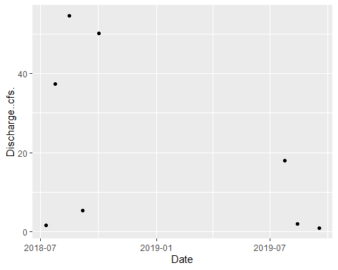

### Site ID: 13-WALK-26.9

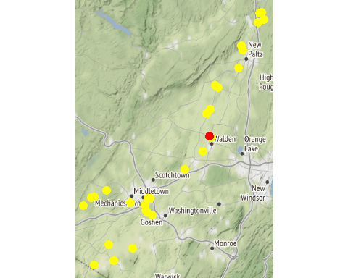

Chemistry Measurements: 13-WALK-26.9

| **SITE_ID** | **chemical_name** | **record_count** | **mean** | **num_exceed** | **min** | **max** | **median** |
| --- | --- | --- | --- | --- | --- | --- | --- |
| 13-WALK-26.9 | alkalinity, total (as caco3) | 10 | 118.960 | NA | 78.00 | 162.00 | 121.500 |
| 13-WALK-26.9 | aluminum | 10 | 220.200 | NA | 101.00 | 432.00 | 200.000 |
| 13-WALK-26.9 | arsenic | 10 | 1.196 | NA | 0.55 | 2.30 | 1.200 |
| 13-WALK-26.9 | cadmium | 1 | 0.520 | NA | 0.52 | 0.52 | 0.520 |
| 13-WALK-26.9 | calcium | 5 | 41640.000 | NA | 28200.00 | 56200.00 | 41300.000 |
| 13-WALK-26.9 | chloride (as cl) | 10 | 78.870 | NA | 40.40 | 111.00 | 77.600 |
| 13-WALK-26.9 | chlorophyll a | 10 | 11.018 | NA | 0.70 | 45.00 | 5.055 |
| 13-WALK-26.9 | conductivity at 25 degrees celsius | 5 | 617.200 | NA | 527.00 | 689.00 | 628.000 |
| 13-WALK-26.9 | copper | 10 | 3.860 | NA | 2.60 | 6.00 | 3.500 |
| 13-WALK-26.9 | hardness (as caco3) | 10 | 163.380 | NA | 92.80 | 211.00 | 168.500 |
| 13-WALK-26.9 | iron | 10 | 581.300 | NA | 168.00 | 1360.00 | 489.000 |
| 13-WALK-26.9 | lead | 9 | 1.030 | NA | 0.44 | 2.00 | 0.750 |
| 13-WALK-26.9 | magnesium | 10 | 11194.000 | NA | 5420.00 | 16600.00 | 12250.000 |
| 13-WALK-26.9 | nickel | 10 | 2.080 | NA | 1.20 | 3.40 | 2.000 |
| 13-WALK-26.9 | nitrate+nitrite as nitrogen | 10 | 0.926 | NA | 0.41 | 1.48 | 0.870 |
| 13-WALK-26.9 | nitrogen | 5 | 1.572 | NA | 1.10 | 2.16 | 1.480 |
| 13-WALK-26.9 | nitrogen, ammonia (as n) | 8 | 0.029 | NA | 0.01 | 0.06 | 0.025 |
| 13-WALK-26.9 | nitrogen, kjeldahl, total | 5 | 0.814 | NA | 0.62 | 1.12 | 0.750 |
| 13-WALK-26.9 | nitrogen, nitrate (as n) | 10 | 0.915 | NA | 0.41 | 1.47 | 0.855 |
| 13-WALK-26.9 | nitrogen, nitrite | 7 | 0.016 | NA | 0.01 | 0.02 | 0.020 |
| 13-WALK-26.9 | ph | 5 | 7.994 | NA | 7.83 | 8.24 | 7.970 |
| 13-WALK-26.9 | phosphorus, total (as p) | 10 | 0.168 | NA | 0.09 | 0.20 | 0.170 |
| 13-WALK-26.9 | temperature of ph analysis | 5 | 21.640 | NA | 19.40 | 26.10 | 20.900 |
| 13-WALK-26.9 | total dissolved solids (residue, filterable) | 10 | 308.900 | NA | 194.00 | 410.00 | 314.000 |
| 13-WALK-26.9 | turbidity | 9 | 7.448 | NA | 2.10 | 17.70 | 7.920 |
| 13-WALK-26.9 | zinc | 8 | 6.987 | NA | 4.50 | 11.30 | 5.750 |

In-Situ Measurements: 13-WALK-26.9

| **SITE_ID** | **chemical_name** | **record_count** | **mean** | **num_exceed** | **min** | **max** | **median** |
| --- | --- | --- | --- | --- | --- | --- | --- |
| 13-WALK-26.9 | conductance | 7 | 578.414 | NA | 330.00 | 822.00 | 668.00 |
| 13-WALK-26.9 | dissolved oxygen | 14 | 10.457 | 0 | 6.40 | 19.00 | 8.90 |
| 13-WALK-26.9 | pct saturation | 7 | 126.286 | NA | 77.00 | 251.00 | 101.00 |
| 13-WALK-26.9 | ph | 7 | 8.247 | NA | 7.77 | 9.09 | 8.33 |
| 13-WALK-26.9 | salinity | 6 | 0.272 | NA | 0.16 | 0.40 | 0.26 |
| 13-WALK-26.9 | temperature | 7 | 23.314 | NA | 15.60 | 30.60 | 21.70 |

Dependent Measurements (Metals and Ammonia): 13-WALK-26.9

| **SITE_ID** | **chemical_name** | **record_count** | **mean** | **num_exceed** | **min** | **max** | **median** |
| --- | --- | --- | --- | --- | --- | --- | --- |
| 13-WALK-26.9 | zinc | 4 | 7.3 | 4 | 4.6 | 11.3 | 6.65 |

Numeric Nutrient Criteria: 13-WALK-26.9

| **SITE_ID** | **chemical_name** | **record_count** | **mean** | **num_exceed** | **min** | **max** | **median** |
| --- | --- | --- | --- | --- | --- | --- | --- |
| 13-WALK-26.9 | phosphorus, total (as p) | 10 | 0.168 | 0 | 0.09 | 0.2 | 0.17 |

BAP Score: 13-WALK-26.9

| **SITE_ID** | **DATE** | **BAP** | **SD** | **n** |
| --- | --- | --- | --- | --- |
| 13-WALK-26.9 | 8/3/2017 | 5.06 | 0.26 | 4 |

### Site ID: 13-DWAR-2.0

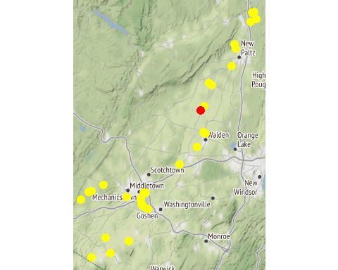

Chemistry Measurements: 13-DWAR-2.0

| **SITE_ID** | **chemical_name** | **record_count** | **mean** | **num_exceed** | **min** | **max** | **median** |
| --- | --- | --- | --- | --- | --- | --- | --- |
| 13-DWAR-2.0 | alkalinity, total (as caco3) | 10 | 99.060 | NA | 6.64e+01 | 1.35e+02 | 9.680e+01 |
| 13-DWAR-2.0 | aluminum | 8 | 460.750 | NA | 1.52e+02 | 1.10e+03 | 3.935e+02 |
| 13-DWAR-2.0 | arsenic | 10 | 1.413 | NA | 7.40e-01 | 2.10e+00 | 1.400e+00 |
| 13-DWAR-2.0 | cadmium | 1 | 0.580 | NA | 5.80e-01 | 5.80e-01 | 5.800e-01 |
| 13-DWAR-2.0 | calcium | 10 | 39130.000 | NA | 2.54e+04 | 5.61e+04 | 3.585e+04 |
| 13-DWAR-2.0 | chloride (as cl) | 10 | 50.180 | NA | 2.99e+01 | 9.04e+01 | 4.445e+01 |
| 13-DWAR-2.0 | chlorophyll a | 10 | 5.655 | NA | 9.20e-01 | 1.39e+01 | 5.200e+00 |
| 13-DWAR-2.0 | hardness (as caco3) | 10 | 127.210 | NA | 8.24e+01 | 1.85e+02 | 1.165e+02 |
| 13-DWAR-2.0 | iron | 10 | 956.300 | NA | 3.46e+02 | 2.04e+03 | 8.975e+02 |
| 13-DWAR-2.0 | magnesium | 9 | 7375.556 | NA | 4.63e+03 | 1.08e+04 | 7.000e+03 |
| 13-DWAR-2.0 | nitrate+nitrite as nitrogen | 9 | 0.240 | NA | 3.00e-02 | 3.60e-01 | 2.600e-01 |
| 13-DWAR-2.0 | nitrogen | 10 | 0.828 | NA | 2.80e-01 | 1.21e+00 | 9.150e-01 |
| 13-DWAR-2.0 | nitrogen, kjeldahl, total | 10 | 0.651 | NA | 3.50e-01 | 9.10e-01 | 6.650e-01 |
| 13-DWAR-2.0 | nitrogen, nitrate (as n) | 10 | 0.245 | NA | 3.00e-02 | 3.50e-01 | 2.700e-01 |
| 13-DWAR-2.0 | nitrogen, nitrite | 1 | 0.010 | NA | 1.00e-02 | 1.00e-02 | 1.000e-02 |
| 13-DWAR-2.0 | phosphorus, total (as p) | 10 | 0.097 | NA | 6.00e-02 | 1.30e-01 | 1.000e-01 |
| 13-DWAR-2.0 | total dissolved solids (residue, filterable) | 5 | 205800.000 | NA | 1.64e+05 | 2.81e+05 | 1.900e+05 |
| 13-DWAR-2.0 | turbidity | 8 | 17.569 | NA | 3.41e+00 | 3.25e+01 | 1.680e+01 |

In-Situ Measurements: 13-DWAR-2.0

| **SITE_ID** | **chemical_name** | **record_count** | **mean** | **num_exceed** | **min** | **max** | **median** |
| --- | --- | --- | --- | --- | --- | --- | --- |
| 13-DWAR-2.0 | chl rfu | 4 | 1.072 | NA | 0.51 | 2.47 | 0.655 |
| 13-DWAR-2.0 | chl ugl | 4 | 4.355 | NA | 1.94 | 9.75 | 2.865 |
| 13-DWAR-2.0 | conductance | 12 | 566.092 | NA | 275.20 | 1450.00 | 464.000 |
| 13-DWAR-2.0 | dissolved oxygen | 24 | 7.613 | 0 | 5.30 | 9.40 | 7.780 |
| 13-DWAR-2.0 | pc rfu | 4 | 0.038 | NA | 0.00 | 0.08 | 0.035 |
| 13-DWAR-2.0 | pc ugl | 4 | 0.052 | NA | 0.02 | 0.11 | 0.040 |
| 13-DWAR-2.0 | pct saturation | 11 | 85.536 | NA | 64.00 | 111.00 | 90.000 |
| 13-DWAR-2.0 | ph | 24 | 7.529 | 0 | 6.57 | 8.32 | 7.580 |
| 13-DWAR-2.0 | salinity | 11 | 0.282 | NA | 0.13 | 0.72 | 0.240 |
| 13-DWAR-2.0 | temperature | 12 | 21.692 | NA | 11.80 | 29.40 | 21.850 |

Dependent Measurements (Metals and Ammonia): 13-DWAR-2.0

| **SITE_ID** | **chemical_name** | **record_count** | **mean** | **num_exceed** | **min** | **max** | **median** |
| --- | --- | --- | --- | --- | --- | --- | --- |
| 13-DWAR-2.0 | copper | 4 | 2.175 | 2 | 1.10 | 3.30 | 2.150 |
| 13-DWAR-2.0 | lead | 1 | 1.200 | 1 | 1.20 | 1.20 | 1.200 |
| 13-DWAR-2.0 | nickel | 2 | 1.105 | 1 | 0.91 | 1.30 | 1.105 |
| 13-DWAR-2.0 | nitrogen, ammonia (as n) | 1 | 0.020 | 1 | 0.02 | 0.02 | 0.020 |
| 13-DWAR-2.0 | zinc | 2 | 5.950 | 2 | 3.30 | 8.60 | 5.950 |

Numeric Nutrient Criteria: 13-DWAR-2.0

| **SITE_ID** | **chemical_name** | **record_count** | **mean** | **num_exceed** | **min** | **max** | **median** |
| --- | --- | --- | --- | --- | --- | --- | --- |
| 13-DWAR-2.0 | phosphorus, total (as p) | 10 | 0.097 | 0 | 0.06 | 0.13 | 0.1 |

BAP Score: 13-DWAR-2.0

| **SITE_ID** | **DATE** | **BAP** | **SD** | **n** |
| --- | --- | --- | --- | --- |
| 13-DWAR-2.0 | 8/27/2018 | 6.35 | 1.08 | 4 |
| 13-DWAR-2.0 | 8/9/2019 | 7.61 | 0.46 | 4 |

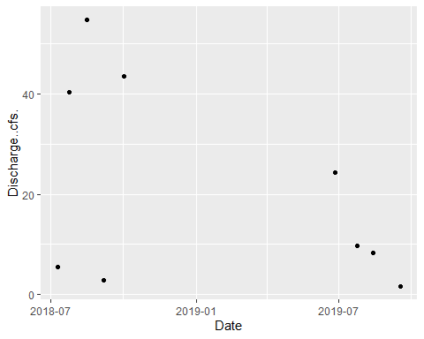

### Site ID: 13-WALK-22.8

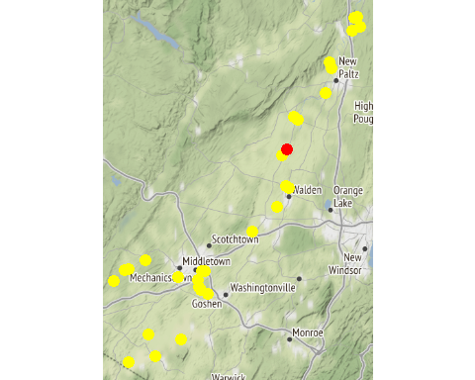

Chemistry Measurements: 13-WALK-22.8

| **SITE_ID** | **chemical_name** | **record_count** | **mean** | **num_exceed** | **min** | **max** | **median** |
| --- | --- | --- | --- | --- | --- | --- | --- |
| 13-WALK-22.8 | alkalinity, total (as caco3) | 10 | 126.760 | NA | 89.60 | 159.00 | 128.500 |
| 13-WALK-22.8 | aluminum | 10 | 253.330 | NA | 30.30 | 878.00 | 155.000 |
| 13-WALK-22.8 | arsenic | 9 | 1.396 | NA | 0.66 | 2.50 | 1.300 |
| 13-WALK-22.8 | cadmium | 1 | 0.550 | NA | 0.55 | 0.55 | 0.550 |
| 13-WALK-22.8 | calcium | 5 | 47080.000 | NA | 33900.00 | 55900.00 | 49500.000 |
| 13-WALK-22.8 | chloride (as cl) | 10 | 80.600 | NA | 47.20 | 108.00 | 84.250 |
| 13-WALK-22.8 | chlorophyll a | 10 | 12.741 | NA | 0.76 | 48.70 | 5.975 |
| 13-WALK-22.8 | conductivity at 25 degrees celsius | 5 | 622.400 | NA | 507.00 | 739.00 | 614.000 |
| 13-WALK-22.8 | copper | 10 | 3.770 | NA | 2.50 | 6.30 | 3.400 |
| 13-WALK-22.8 | hardness (as caco3) | 10 | 175.200 | NA | 121.00 | 206.00 | 181.000 |
| 13-WALK-22.8 | iron | 10 | 567.970 | NA | 86.00 | 2000.00 | 340.500 |
| 13-WALK-22.8 | lead | 7 | 1.084 | NA | 0.41 | 2.80 | 0.710 |
| 13-WALK-22.8 | magnesium | 10 | 12806.000 | NA | 8950.00 | 16000.00 | 13000.000 |
| 13-WALK-22.8 | nickel | 10 | 2.250 | NA | 1.30 | 3.50 | 2.150 |
| 13-WALK-22.8 | nitrate+nitrite as nitrogen | 9 | 1.188 | NA | 0.42 | 2.55 | 1.070 |
| 13-WALK-22.8 | nitrogen | 5 | 2.222 | NA | 1.46 | 3.95 | 1.770 |
| 13-WALK-22.8 | nitrogen, ammonia (as n) | 8 | 0.028 | NA | 0.01 | 0.06 | 0.025 |
| 13-WALK-22.8 | nitrogen, kjeldahl, total | 5 | 0.996 | NA | 0.63 | 1.40 | 0.990 |
| 13-WALK-22.8 | nitrogen, nitrate (as n) | 10 | 1.184 | NA | 0.40 | 2.53 | 1.100 |
| 13-WALK-22.8 | nitrogen, nitrite | 6 | 0.013 | NA | 0.01 | 0.02 | 0.010 |
| 13-WALK-22.8 | ph | 5 | 8.220 | NA | 7.96 | 8.58 | 8.120 |
| 13-WALK-22.8 | phosphorus, total (as p) | 10 | 0.181 | NA | 0.13 | 0.32 | 0.165 |
| 13-WALK-22.8 | temperature of ph analysis | 5 | 21.660 | NA | 19.40 | 26.30 | 20.700 |
| 13-WALK-22.8 | total dissolved solids (residue, filterable) | 10 | 319.800 | NA | 227.00 | 377.00 | 327.500 |
| 13-WALK-22.8 | turbidity | 9 | 7.618 | NA | 1.19 | 23.10 | 6.670 |
| 13-WALK-22.8 | zinc | 8 | 7.138 | NA | 3.30 | 18.60 | 4.700 |

In-Situ Measurements: 13-WALK-22.8

| **SITE_ID** | **chemical_name** | **record_count** | **mean** | **num_exceed** | **min** | **max** | **median** |
| --- | --- | --- | --- | --- | --- | --- | --- |
| 13-WALK-22.8 | conductance | 9 | 549.111 | NA | 295.00 | 1142.00 | 501.100 |
| 13-WALK-22.8 | dissolved oxygen | 18 | 9.082 | 0 | 7.20 | 11.50 | 8.700 |
| 13-WALK-22.8 | pct saturation | 7 | 108.900 | NA | 89.00 | 134.00 | 102.000 |
| 13-WALK-22.8 | ph | 9 | 8.100 | NA | 7.70 | 8.50 | 8.070 |
| 13-WALK-22.8 | salinity | 6 | 0.270 | NA | 0.14 | 0.56 | 0.225 |
| 13-WALK-22.8 | temperature | 9 | 22.222 | NA | 15.40 | 24.70 | 24.000 |

Dependent Measurements (Metals and Ammonia): 13-WALK-22.8

| **SITE_ID** | **chemical_name** | **record_count** | **mean** | **num_exceed** | **min** | **max** | **median** |
| --- | --- | --- | --- | --- | --- | --- | --- |
| 13-WALK-22.8 | zinc | 4 | 10.425 | 1 | 4.5 | 18.6 | 9.3 |

Numeric Nutrient Criteria: 13-WALK-22.8

| **SITE_ID** | **chemical_name** | **record_count** | **mean** | **num_exceed** | **min** | **max** | **median** |
| --- | --- | --- | --- | --- | --- | --- | --- |
| 13-WALK-22.8 | phosphorus, total (as p) | 10 | 0.181 | 0 | 0.13 | 0.32 | 0.165 |

BAP Score: 13-WALK-22.8

| **SITE_ID** | **DATE** | **BAP** | **SD** | **n** |
| --- | --- | --- | --- | --- |
| 13-WALK-22.8 | 8/3/2017 | 4.89 | 0.31 | 4 |

### Site ID: 13-WALK-19.0

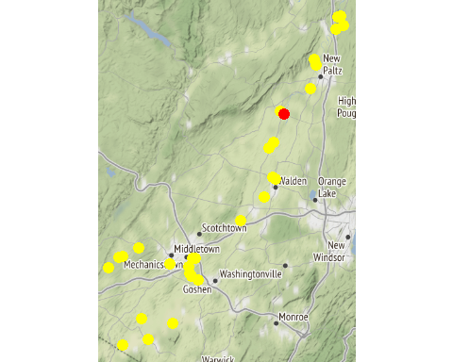

Chemistry Measurements: 13-WALK-19.0

| **SITE_ID** | **chemical_name** | **record_count** | **mean** | **num_exceed** | **min** | **max** | **median** |
| --- | --- | --- | --- | --- | --- | --- | --- |
| 13-WALK-19.0 | alkalinity, total (as caco3) | 15 | 117.160 | NA | 76.00 | 145.00 | 116.000 |
| 13-WALK-19.0 | aluminum | 13 | 474.008 | NA | 38.80 | 3310.00 | 123.000 |
| 13-WALK-19.0 | arsenic | 14 | 1.473 | NA | 0.63 | 2.60 | 1.400 |
| 13-WALK-19.0 | cadmium | 1 | 0.610 | NA | 0.61 | 0.61 | 0.610 |
| 13-WALK-19.0 | calcium | 10 | 43230.000 | NA | 27100.00 | 52800.00 | 44250.000 |
| 13-WALK-19.0 | chloride (as cl) | 15 | 73.487 | NA | 26.10 | 108.00 | 82.500 |
| 13-WALK-19.0 | chlorophyll a | 15 | 9.585 | NA | 0.49 | 67.90 | 2.430 |
| 13-WALK-19.0 | conductivity at 25 degrees celsius | 5 | 581.800 | NA | 497.00 | 721.00 | 562.000 |
| 13-WALK-19.0 | copper | 15 | 3.607 | NA | 2.20 | 8.40 | 3.100 |
| 13-WALK-19.0 | hardness (as caco3) | 15 | 161.207 | NA | 95.10 | 194.00 | 164.000 |
| 13-WALK-19.0 | iron | 15 | 680.547 | NA | 73.80 | 3630.00 | 171.000 |
| 13-WALK-19.0 | lead | 9 | 1.476 | NA | 0.31 | 5.00 | 0.710 |
| 13-WALK-19.0 | magnesium | 14 | 11899.286 | NA | 6660.00 | 15100.00 | 12050.000 |
| 13-WALK-19.0 | nickel | 15 | 2.147 | NA | 1.30 | 5.20 | 2.000 |
| 13-WALK-19.0 | nitrate+nitrite as nitrogen | 14 | 1.078 | NA | 0.40 | 2.50 | 0.890 |
| 13-WALK-19.0 | nitrogen | 10 | 2.019 | NA | 1.05 | 3.94 | 1.960 |
| 13-WALK-19.0 | nitrogen, ammonia (as n) | 10 | 0.029 | NA | 0.01 | 0.08 | 0.020 |
| 13-WALK-19.0 | nitrogen, kjeldahl, total | 10 | 0.864 | NA | 0.42 | 1.50 | 0.700 |
| 13-WALK-19.0 | nitrogen, nitrate (as n) | 15 | 1.105 | NA | 0.39 | 2.47 | 0.920 |
| 13-WALK-19.0 | nitrogen, nitrite | 5 | 0.014 | NA | 0.01 | 0.02 | 0.010 |
| 13-WALK-19.0 | ph | 5 | 8.300 | NA | 8.18 | 8.52 | 8.210 |
| 13-WALK-19.0 | phosphorus, total (as p) | 15 | 0.170 | NA | 0.10 | 0.32 | 0.140 |
| 13-WALK-19.0 | temperature of ph analysis | 5 | 21.700 | NA | 19.40 | 26.60 | 20.800 |
| 13-WALK-19.0 | total dissolved solids (residue, filterable) | 10 | 307.300 | NA | 226.00 | 367.00 | 315.000 |
| 13-WALK-19.0 | turbidity | 12 | 15.992 | NA | 1.15 | 100.00 | 6.085 |
| 13-WALK-19.0 | zinc | 10 | 9.210 | NA | 3.20 | 32.10 | 4.500 |

In-Situ Measurements: 13-WALK-19.0

| **SITE_ID** | **chemical_name** | **record_count** | **mean** | **num_exceed** | **min** | **max** | **median** |
| --- | --- | --- | --- | --- | --- | --- | --- |
| 13-WALK-19.0 | chl rfu | 4 | 0.375 | NA | 0.27 | 0.50 | 0.365 |
| 13-WALK-19.0 | chl ugl | 4 | 1.535 | NA | 1.10 | 2.00 | 1.520 |
| 13-WALK-19.0 | conductance | 14 | 497.464 | NA | 227.70 | 939.00 | 445.250 |
| 13-WALK-19.0 | dissolved oxygen | 28 | 9.649 | 0 | 6.99 | 12.74 | 9.500 |
| 13-WALK-19.0 | pc rfu | 3 | -0.003 | NA | -0.09 | 0.08 | 0.000 |
| 13-WALK-19.0 | pc ugl | 4 | 0.085 | NA | -0.10 | 0.40 | 0.020 |
| 13-WALK-19.0 | pct saturation | 12 | 115.192 | NA | 88.00 | 155.00 | 118.000 |
| 13-WALK-19.0 | ph | 13 | 8.277 | NA | 7.80 | 8.68 | 8.220 |
| 13-WALK-19.0 | salinity | 11 | 0.220 | NA | 0.11 | 0.30 | 0.200 |
| 13-WALK-19.0 | temperature | 14 | 23.150 | NA | 14.70 | 30.20 | 24.050 |

Dependent Measurements (Metals and Ammonia): 13-WALK-19.0

| **SITE_ID** | **chemical_name** | **record_count** | **mean** | **num_exceed** | **min** | **max** | **median** |
| --- | --- | --- | --- | --- | --- | --- | --- |
| 13-WALK-19.0 | zinc | 6 | 12.683 | 3 | 3.2 | 32.1 | 8.55 |

Numeric Nutrient Criteria: 13-WALK-19.0

| **SITE_ID** | **chemical_name** | **record_count** | **mean** | **num_exceed** | **min** | **max** | **median** |
| --- | --- | --- | --- | --- | --- | --- | --- |
| 13-WALK-19.0 | phosphorus, total (as p) | 15 | 0.17 | 0 | 0.1 | 0.32 | 0.14 |

BAP Score: 13-WALK-19.0

| **SITE_ID** | **DATE** | **BAP** | **SD** | **n** |
| --- | --- | --- | --- | --- |
| 13-WALK-19.0 | 8/27/2018 | 5.63 | 0.17 | 4 |
| 13-WALK-19.0 | 8/3/2017 | 5.10 | 0.63 | 4 |

### Site ID: 13-GUNK-0.4

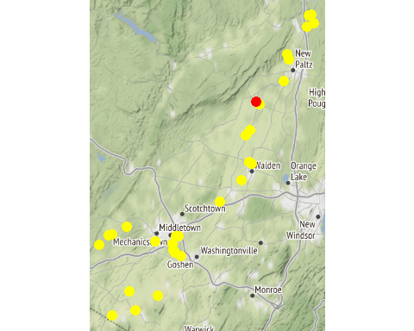

Chemistry Measurements: 13-GUNK-0.4

| **SITE_ID** | **chemical_name** | **record_count** | **mean** | **num_exceed** | **min** | **max** | **median** |
| --- | --- | --- | --- | --- | --- | --- | --- |
| 13-GUNK-0.4 | alkalinity, total (as caco3) | 10 | 63.560 | NA | 43.60 | 80.00 | 70.200 |
| 13-GUNK-0.4 | aluminum | 10 | 368.290 | NA | 65.90 | 1100.00 | 129.000 |
| 13-GUNK-0.4 | arsenic | 7 | 0.966 | NA | 0.56 | 1.70 | 0.990 |
| 13-GUNK-0.4 | cadmium | 2 | 0.315 | NA | 0.07 | 0.56 | 0.315 |
| 13-GUNK-0.4 | calcium | 5 | 20060.000 | NA | 15400.00 | 25700.00 | 18400.000 |
| 13-GUNK-0.4 | chloride (as cl) | 10 | 36.470 | NA | 22.40 | 47.70 | 40.300 |
| 13-GUNK-0.4 | chlorophyll a | 10 | 2.253 | NA | 0.62 | 6.73 | 1.260 |
| 13-GUNK-0.4 | conductivity at 25 degrees celsius | 5 | 327.800 | NA | 303.00 | 358.00 | 325.000 |
| 13-GUNK-0.4 | copper | 10 | 2.800 | NA | 1.30 | 9.60 | 1.900 |
| 13-GUNK-0.4 | hardness (as caco3) | 10 | 81.800 | NA | 51.50 | 113.00 | 86.050 |
| 13-GUNK-0.4 | iron | 10 | 700.900 | NA | 238.00 | 1680.00 | 373.500 |
| 13-GUNK-0.4 | lead | 6 | 1.075 | NA | 0.29 | 1.80 | 1.155 |
| 13-GUNK-0.4 | magnesium | 10 | 4545.000 | NA | 3150.00 | 5470.00 | 4825.000 |
| 13-GUNK-0.4 | nickel | 10 | 1.563 | NA | 0.76 | 2.40 | 1.450 |
| 13-GUNK-0.4 | nitrate+nitrite as nitrogen | 10 | 0.218 | NA | 0.11 | 0.38 | 0.205 |
| 13-GUNK-0.4 | nitrogen | 5 | 0.782 | NA | 0.55 | 0.95 | 0.750 |
| 13-GUNK-0.4 | nitrogen, ammonia (as n) | 8 | 0.018 | NA | 0.01 | 0.03 | 0.020 |
| 13-GUNK-0.4 | nitrogen, kjeldahl, total | 5 | 0.582 | NA | 0.43 | 0.73 | 0.590 |
| 13-GUNK-0.4 | nitrogen, nitrate (as n) | 10 | 0.218 | NA | 0.11 | 0.38 | 0.205 |
| 13-GUNK-0.4 | ph | 5 | 7.964 | NA | 7.76 | 8.17 | 7.910 |
| 13-GUNK-0.4 | phosphorus, total (as p) | 10 | 0.069 | NA | 0.04 | 0.09 | 0.070 |
| 13-GUNK-0.4 | temperature of ph analysis | 5 | 21.600 | NA | 19.40 | 26.10 | 20.800 |
| 13-GUNK-0.4 | total dissolved solids (residue, filterable) | 10 | 153.200 | NA | 111.00 | 178.00 | 160.000 |
| 13-GUNK-0.4 | turbidity | 9 | 7.839 | NA | 2.69 | 18.60 | 5.760 |
| 13-GUNK-0.4 | zinc | 5 | 7.860 | NA | 3.70 | 11.30 | 7.800 |

In-Situ Measurements: 13-GUNK-0.4

| **SITE_ID** | **chemical_name** | **record_count** | **mean** | **num_exceed** | **min** | **max** | **median** |
| --- | --- | --- | --- | --- | --- | --- | --- |
| 13-GUNK-0.4 | conductance | 13 | 370.092 | NA | 126.00 | 1047.00 | 289.00 |
| 13-GUNK-0.4 | dissolved oxygen | 26 | 8.290 | 2 | 3.84 | 10.20 | 8.50 |
| 13-GUNK-0.4 | pct saturation | 7 | 93.171 | NA | 46.00 | 121.00 | 97.00 |
| 13-GUNK-0.4 | ph | 13 | 7.978 | NA | 6.97 | 8.70 | 8.10 |
| 13-GUNK-0.4 | salinity | 8 | 0.220 | NA | 0.12 | 0.52 | 0.14 |
| 13-GUNK-0.4 | temperature | 13 | 23.315 | NA | 17.20 | 28.10 | 23.60 |

Dependent Measurements (Metals and Ammonia): 13-GUNK-0.4

| **SITE_ID** | **chemical_name** | **record_count** | **mean** | **num_exceed** | **min** | **max** | **median** |
| --- | --- | --- | --- | --- | --- | --- | --- |
| 13-GUNK-0.4 | zinc | 3 | 9.333 | 1 | 7.8 | 11.3 | 8.9 |

Numeric Nutrient Criteria: 13-GUNK-0.4

| **SITE_ID** | **chemical_name** | **record_count** | **mean** | **num_exceed** | **min** | **max** | **median** |
| --- | --- | --- | --- | --- | --- | --- | --- |
| 13-GUNK-0.4 | phosphorus, total (as p) | 10 | 0.069 | 0 | 0.04 | 0.09 | 0.07 |

BAP Score: 13-GUNK-0.4

| **SITE_ID** | **DATE** | **BAP** | **SD** | **n** |
| --- | --- | --- | --- | --- |
| 13-GUNK-0.4 | 8/27/2018 | 7.87 | 0.07 | 4 |
| 13-GUNK-0.4 | 8/3/2017 | 7.28 | 0.32 | 4 |

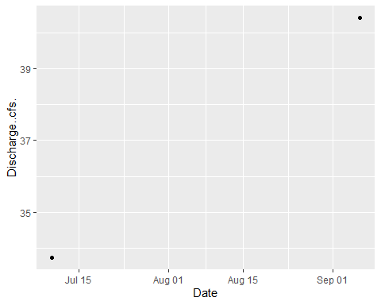

### Site ID: 13-PKIL-0.4

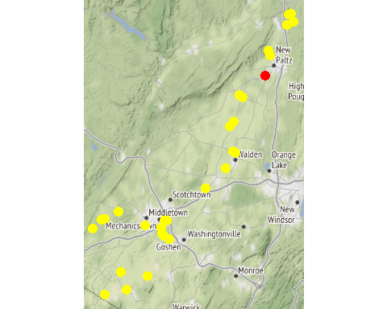

Chemistry Measurements: 13-PKIL-0.4

| **SITE_ID** | **chemical_name** | **record_count** | **mean** | **num_exceed** | **min** | **max** | **median** |
| --- | --- | --- | --- | --- | --- | --- | --- |
| 13-PKIL-0.4 | alkalinity, total (as caco3) | 10 | 92.780 | NA | 74.80 | 113.00 | 91.000 |
| 13-PKIL-0.4 | aluminum | 8 | 138.550 | NA | 33.50 | 280.00 | 142.000 |
| 13-PKIL-0.4 | arsenic | 10 | 1.270 | NA | 0.69 | 1.70 | 1.400 |
| 13-PKIL-0.4 | cadmium | 1 | 0.550 | NA | 0.55 | 0.55 | 0.550 |
| 13-PKIL-0.4 | calcium | 10 | 36700.000 | NA | 28600.00 | 42500.00 | 37650.000 |
| 13-PKIL-0.4 | chloride (as cl) | 10 | 58.580 | NA | 47.20 | 79.60 | 54.800 |
| 13-PKIL-0.4 | chlorophyll a | 10 | 4.471 | NA | 0.31 | 29.50 | 1.030 |
| 13-PKIL-0.4 | copper | 10 | 1.462 | NA | 0.81 | 2.40 | 1.500 |
| 13-PKIL-0.4 | hardness (as caco3) | 10 | 114.760 | NA | 89.60 | 135.00 | 117.500 |
| 13-PKIL-0.4 | iron | 10 | 331.840 | NA | 74.50 | 746.00 | 297.500 |
| 13-PKIL-0.4 | lead | 6 | 0.615 | NA | 0.31 | 1.20 | 0.540 |
| 13-PKIL-0.4 | magnesium | 9 | 5607.778 | NA | 4440.00 | 6940.00 | 5800.000 |
| 13-PKIL-0.4 | nickel | 10 | 0.918 | NA | 0.68 | 1.30 | 0.840 |
| 13-PKIL-0.4 | nitrate+nitrite as nitrogen | 9 | 0.273 | NA | 0.00 | 0.45 | 0.270 |
| 13-PKIL-0.4 | nitrogen | 10 | 0.677 | NA | 0.33 | 0.97 | 0.755 |
| 13-PKIL-0.4 | nitrogen, ammonia (as n) | 5 | 0.014 | NA | 0.01 | 0.02 | 0.010 |
| 13-PKIL-0.4 | nitrogen, kjeldahl, total | 10 | 0.425 | NA | 0.11 | 0.79 | 0.405 |
| 13-PKIL-0.4 | nitrogen, nitrate (as n) | 9 | 0.317 | NA | 0.18 | 0.44 | 0.330 |
| 13-PKIL-0.4 | nitrogen, nitrite | 2 | 0.010 | NA | 0.01 | 0.01 | 0.010 |
| 13-PKIL-0.4 | phosphorus, total (as p) | 10 | 0.063 | NA | 0.04 | 0.11 | 0.060 |
| 13-PKIL-0.4 | total dissolved solids (residue, filterable) | 5 | 223.800 | NA | 199.00 | 250.00 | 222.000 |
| 13-PKIL-0.4 | turbidity | 8 | 5.200 | NA | 1.98 | 16.00 | 3.355 |
| 13-PKIL-0.4 | zinc | 3 | 4.533 | NA | 3.00 | 6.40 | 4.200 |

In-Situ Measurements: 13-PKIL-0.4

| **SITE_ID** | **chemical_name** | **record_count** | **mean** | **num_exceed** | **min** | **max** | **median** |
| --- | --- | --- | --- | --- | --- | --- | --- |
| 13-PKIL-0.4 | chl rfu | 5 | 0.804 | NA | 0.11 | 2.46 | 0.57 |
| 13-PKIL-0.4 | chl ugl | 5 | 3.200 | NA | 0.70 | 9.80 | 2.10 |
| 13-PKIL-0.4 | conductance | 13 | 408.123 | NA | 37.70 | 752.90 | 390.30 |
| 13-PKIL-0.4 | dissolved oxygen | 13 | 8.713 | NA | 4.10 | 11.88 | 8.90 |
| 13-PKIL-0.4 | pc rfu | 5 | 0.152 | NA | -0.07 | 0.78 | 0.02 |
| 13-PKIL-0.4 | pc ugl | 5 | 0.162 | NA | -0.03 | 0.78 | 0.02 |
| 13-PKIL-0.4 | pct saturation | 12 | 94.475 | NA | 49.00 | 109.00 | 98.45 |
| 13-PKIL-0.4 | ph | 13 | 7.970 | NA | 7.06 | 8.89 | 8.00 |
| 13-PKIL-0.4 | salinity | 11 | 0.180 | NA | 0.02 | 0.25 | 0.19 |
| 13-PKIL-0.4 | temperature | 13 | 19.069 | NA | 4.70 | 25.10 | 21.30 |

Dependent Measurements (Metals and Ammonia): 13-PKIL-0.4

| **SITE_ID** | **chemical_name** | **record_count** | **mean** | **num_exceed** | **min** | **max** | **median** |
| --- | --- | --- | --- | --- | --- | --- | --- |
| 13-PKIL-0.4 | zinc | 3 | 4.533 | 2 | 3 | 6.4 | 4.2 |

Numeric Nutrient Criteria: 13-PKIL-0.4

| **SITE_ID** | **chemical_name** | **record_count** | **mean** | **num_exceed** | **min** | **max** | **median** |
| --- | --- | --- | --- | --- | --- | --- | --- |
| 13-PKIL-0.4 | phosphorus, total (as p) | 10 | 0.063 | 0 | 0.04 | 0.11 | 0.06 |

BAP Score: 13-PKIL-0.4

| **SITE_ID** | **DATE** | **BAP** | **SD** | **n** |
| --- | --- | --- | --- | --- |
| 13-PKIL-0.4 | 8/27/2018 | 6.95 | 0.66 | 4 |
| 13-PKIL-0.4 | 8/8/2019 | 7.12 | 0.77 | 4 |

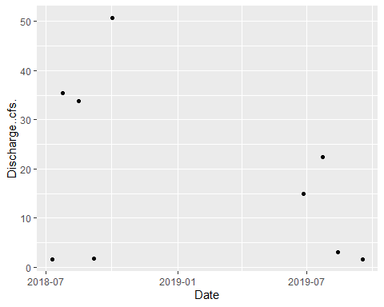

### Site ID: 13-WALK-9.8

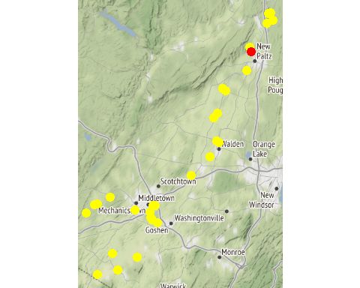

Chemistry Measurements: 13-WALK-9.8

| **SITE_ID** | **chemical_name** | **record_count** | **mean** | **num_exceed** | **min** | **max** | **median** |
| --- | --- | --- | --- | --- | --- | --- | --- |
| 13-WALK-9.8 | alkalinity, total (as caco3) | 9 | 113.467 | NA | 78.40 | 138.00 | 126.00 |
| 13-WALK-9.8 | aluminum | 7 | 286.114 | NA | 77.70 | 697.00 | 123.00 |
| 13-WALK-9.8 | arsenic | 9 | 1.633 | NA | 1.20 | 2.20 | 1.60 |
| 13-WALK-9.8 | calcium | 9 | 41944.444 | NA | 30400.00 | 49600.00 | 44100.00 |
| 13-WALK-9.8 | chloride (as cl) | 8 | 71.200 | NA | 40.30 | 99.70 | 74.40 |
| 13-WALK-9.8 | chlorophyll a | 9 | 16.076 | NA | 0.44 | 109.00 | 2.83 |
| 13-WALK-9.8 | copper | 9 | 3.211 | NA | 2.40 | 4.40 | 3.30 |
| 13-WALK-9.8 | hardness (as caco3) | 9 | 152.333 | NA | 109.00 | 183.00 | 164.00 |
| 13-WALK-9.8 | iron | 9 | 552.000 | NA | 138.00 | 1600.00 | 253.00 |
| 13-WALK-9.8 | lead | 5 | 1.042 | NA | 0.45 | 1.90 | 0.76 |
| 13-WALK-9.8 | magnesium | 8 | 11688.750 | NA | 7280.00 | 14800.00 | 12950.00 |
| 13-WALK-9.8 | nickel | 9 | 1.689 | NA | 1.30 | 2.60 | 1.50 |
| 13-WALK-9.8 | nitrate+nitrite as nitrogen | 9 | 0.930 | NA | 0.02 | 1.75 | 0.85 |
| 13-WALK-9.8 | nitrogen | 9 | 1.644 | NA | 0.80 | 2.53 | 1.54 |
| 13-WALK-9.8 | nitrogen, ammonia (as n) | 6 | 0.083 | NA | 0.02 | 0.29 | 0.05 |
| 13-WALK-9.8 | nitrogen, kjeldahl, total | 9 | 0.776 | NA | 0.55 | 1.16 | 0.72 |
| 13-WALK-9.8 | nitrogen, nitrate (as n) | 9 | 0.921 | NA | 0.02 | 1.74 | 0.85 |
| 13-WALK-9.8 | nitrogen, nitrite | 5 | 0.014 | NA | 0.01 | 0.02 | 0.01 |
| 13-WALK-9.8 | phosphorus, total (as p) | 9 | 0.162 | NA | 0.12 | 0.22 | 0.14 |
| 13-WALK-9.8 | silver | 1 | 0.060 | NA | 0.06 | 0.06 | 0.06 |
| 13-WALK-9.8 | total dissolved solids (residue, filterable) | 4 | 262.750 | NA | 199.00 | 320.00 | 266.00 |
| 13-WALK-9.8 | turbidity | 7 | 10.930 | NA | 4.75 | 31.00 | 7.92 |
| 13-WALK-9.8 | zinc | 8 | 6.487 | NA | 2.80 | 14.70 | 4.45 |

In-Situ Measurements: 13-WALK-9.8

| **SITE_ID** | **chemical_name** | **record_count** | **mean** | **num_exceed** | **min** | **max** | **median** |
| --- | --- | --- | --- | --- | --- | --- | --- |
| 13-WALK-9.8 | chl rfu | 4 | 0.840 | NA | 0.20 | 1.44 | 0.86 |
| 13-WALK-9.8 | chl ugl | 4 | 3.585 | NA | 0.90 | 5.94 | 3.75 |
| 13-WALK-9.8 | conductance | 9 | 526.489 | NA | 382.90 | 663.00 | 538.00 |
| 13-WALK-9.8 | dissolved oxygen | 18 | 9.276 | 0 | 6.51 | 15.50 | 8.30 |
| 13-WALK-9.8 | pc rfu | 4 | 0.065 | NA | 0.00 | 0.14 | 0.06 |
| 13-WALK-9.8 | pc ugl | 4 | 0.085 | NA | 0.00 | 0.18 | 0.08 |
| 13-WALK-9.8 | pct saturation | 9 | 108.256 | NA | 73.50 | 197.00 | 91.00 |
| 13-WALK-9.8 | ph | 8 | 8.136 | NA | 7.74 | 8.66 | 8.08 |
| 13-WALK-9.8 | salinity | 8 | 0.246 | NA | 0.18 | 0.30 | 0.25 |
| 13-WALK-9.8 | temperature | 9 | 22.600 | NA | 15.00 | 27.40 | 24.20 |

Dependent Measurements (Metals and Ammonia): 13-WALK-9.8

| **SITE_ID** | **chemical_name** | **record_count** | **mean** | **num_exceed** | **min** | **max** | **median** |
| --- | --- | --- | --- | --- | --- | --- | --- |
| 13-WALK-9.8 | zinc | 8 | 6.487 | 7 | 2.8 | 14.7 | 4.45 |

Numeric Nutrient Criteria: 13-WALK-9.8

| **SITE_ID** | **chemical_name** | **record_count** | **mean** | **num_exceed** | **min** | **max** | **median** |
| --- | --- | --- | --- | --- | --- | --- | --- |
| 13-WALK-9.8 | phosphorus, total (as p) | 9 | 0.162 | 0 | 0.12 | 0.22 | 0.14 |

BAP Score: 13-WALK-9.8

| **SITE_ID** | **DATE** | **BAP** | **SD** | **n** |
| --- | --- | --- | --- | --- |

### Site ID: 13-WKLEI-0.6

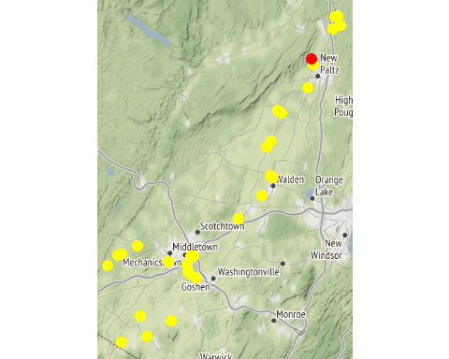

Chemistry Measurements: 13-WKLEI-0.6

| **SITE_ID** | **chemical_name** | **record_count** | **mean** | **num_exceed** | **min** | **max** | **median** |
| --- | --- | --- | --- | --- | --- | --- | --- |
| 13-WKLEI-0.6 | alkalinity, total (as caco3) | 10 | 81.800 | NA | 5.44e+01 | 1.06e+02 | 8.520e+01 |
| 13-WKLEI-0.6 | aluminum | 10 | 1663.100 | NA | 4.10e+02 | 6.09e+03 | 1.032e+03 |
| 13-WKLEI-0.6 | arsenic | 9 | 1.316 | NA | 5.30e-01 | 3.30e+00 | 1.200e+00 |
| 13-WKLEI-0.6 | cadmium | 2 | 0.100 | NA | 1.00e-01 | 1.00e-01 | 1.000e-01 |
| 13-WKLEI-0.6 | calcium | 5 | 25760.000 | NA | 1.69e+04 | 3.55e+04 | 2.140e+04 |
| 13-WKLEI-0.6 | chloride (as cl) | 9 | 18.556 | NA | 1.12e+01 | 2.60e+01 | 1.940e+01 |
| 13-WKLEI-0.6 | chlorophyll a | 10 | 6.100 | NA | 5.70e-01 | 3.11e+01 | 2.925e+00 |
| 13-WKLEI-0.6 | conductivity at 25 degrees celsius | 5 | 271.800 | NA | 2.52e+02 | 3.00e+02 | 2.700e+02 |
| 13-WKLEI-0.6 | hardness (as caco3) | 10 | 106.200 | NA | 6.01e+01 | 1.30e+02 | 1.190e+02 |
| 13-WKLEI-0.6 | iron | 9 | 3184.667 | NA | 6.82e+02 | 1.16e+04 | 1.770e+03 |
| 13-WKLEI-0.6 | magnesium | 10 | 6727.000 | NA | 4.33e+03 | 1.02e+04 | 6.560e+03 |
| 13-WKLEI-0.6 | nitrate+nitrite as nitrogen | 10 | 0.046 | NA | 0.00e+00 | 7.00e-02 | 4.500e-02 |
| 13-WKLEI-0.6 | nitrogen | 5 | 0.706 | NA | 3.90e-01 | 1.03e+00 | 7.200e-01 |
| 13-WKLEI-0.6 | nitrogen, kjeldahl, total | 4 | 0.738 | NA | 3.90e-01 | 1.00e+00 | 7.800e-01 |
| 13-WKLEI-0.6 | nitrogen, nitrate (as n) | 8 | 0.051 | NA | 3.00e-02 | 7.00e-02 | 5.500e-02 |
| 13-WKLEI-0.6 | nitrogen, nitrite | 1 | 0.010 | NA | 1.00e-02 | 1.00e-02 | 1.000e-02 |
| 13-WKLEI-0.6 | ph | 10 | 7.684 | 0 | 7.54e+00 | 7.96e+00 | 7.660e+00 |
| 13-WKLEI-0.6 | phosphorus, total (as p) | 10 | 0.087 | NA | 4.00e-02 | 2.20e-01 | 8.000e-02 |
| 13-WKLEI-0.6 | temperature of ph analysis | 5 | 21.700 | NA | 1.95e+01 | 2.65e+01 | 2.080e+01 |
| 13-WKLEI-0.6 | total dissolved solids (residue, filterable) | 10 | 146500.000 | NA | 1.07e+05 | 1.75e+05 | 1.435e+05 |
| 13-WKLEI-0.6 | turbidity | 9 | 42.826 | NA | 6.83e+00 | 1.02e+02 | 3.630e+01 |

In-Situ Measurements: 13-WKLEI-0.6

| **SITE_ID** | **chemical_name** | **record_count** | **mean** | **num_exceed** | **min** | **max** | **median** |
| --- | --- | --- | --- | --- | --- | --- | --- |
| 13-WKLEI-0.6 | conductance | 7 | 407.500 | NA | 157.00 | 1315.00 | 298.50 |
| 13-WKLEI-0.6 | dissolved oxygen | 14 | 6.296 | 2 | 4.50 | 8.57 | 6.70 |
| 13-WKLEI-0.6 | pct saturation | 7 | 72.543 | NA | 51.00 | 86.00 | 81.00 |
| 13-WKLEI-0.6 | ph | 14 | 7.463 | 0 | 7.08 | 7.88 | 7.45 |
| 13-WKLEI-0.6 | salinity | 7 | 0.196 | NA | 0.07 | 0.65 | 0.14 |
| 13-WKLEI-0.6 | temperature | 7 | 22.443 | NA | 15.60 | 26.50 | 22.90 |

Dependent Measurements (Metals and Ammonia): 13-WKLEI-0.6

| **SITE_ID** | **chemical_name** | **record_count** | **mean** | **num_exceed** | **min** | **max** | **median** |
| --- | --- | --- | --- | --- | --- | --- | --- |
| 13-WKLEI-0.6 | copper | 1 | 2.70 | 1 | 2.70 | 2.70 | 2.70 |
| 13-WKLEI-0.6 | lead | 1 | 0.51 | 0 | 0.51 | 0.51 | 0.51 |
| 13-WKLEI-0.6 | nickel | 1 | 11.50 | 1 | 11.50 | 11.50 | 11.50 |
| 13-WKLEI-0.6 | zinc | 2 | 8.95 | 1 | 3.80 | 14.10 | 8.95 |

Numeric Nutrient Criteria: 13-WKLEI-0.6

| **SITE_ID** | **chemical_name** | **record_count** | **mean** | **num_exceed** | **min** | **max** | **median** |
| --- | --- | --- | --- | --- | --- | --- | --- |
| 13-WKLEI-0.6 | phosphorus, total (as p) | 10 | 0.087 | 0 | 0.04 | 0.22 | 0.08 |

BAP Score: 13-WKLEI-0.6

| **SITE_ID** | **DATE** | **BAP** | **SD** | **n** |
| --- | --- | --- | --- | --- |

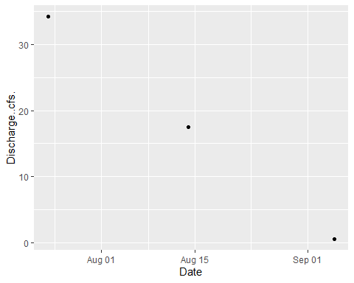

### Site ID: 13-WALK-2.1

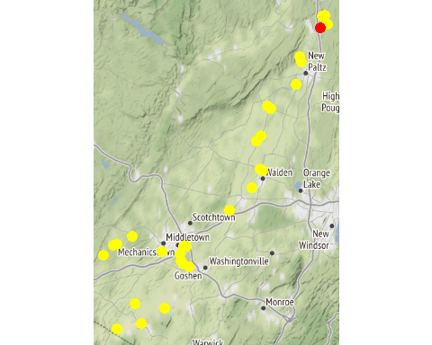

Chemistry Measurements: 13-WALK-2.1

| **SITE_ID** | **chemical_name** | **record_count** | **mean** | **num_exceed** | **min** | **max** | **median** |
| --- | --- | --- | --- | --- | --- | --- | --- |
| 13-WALK-2.1 | alkalinity, total (as caco3) | 10 | 106.020 | NA | 78.80 | 129.00 | 112.000 |
| 13-WALK-2.1 | aluminum | 10 | 345.400 | NA | 102.00 | 989.00 | 180.000 |
| 13-WALK-2.1 | arsenic | 9 | 1.418 | NA | 0.40 | 2.90 | 1.300 |
| 13-WALK-2.1 | calcium | 5 | 37520.000 | NA | 28600.00 | 44200.00 | 36500.000 |
| 13-WALK-2.1 | chloride (as cl) | 9 | 67.144 | NA | 38.20 | 82.70 | 72.600 |
| 13-WALK-2.1 | chlorophyll a | 10 | 27.960 | NA | 1.25 | 82.70 | 17.800 |
| 13-WALK-2.1 | conductivity at 25 degrees celsius | 5 | 514.600 | NA | 431.00 | 572.00 | 519.000 |
| 13-WALK-2.1 | copper | 10 | 3.040 | NA | 2.20 | 4.80 | 2.650 |
| 13-WALK-2.1 | hardness (as caco3) | 10 | 144.000 | NA | 102.00 | 173.00 | 152.000 |
| 13-WALK-2.1 | iron | 9 | 580.556 | NA | 208.00 | 1700.00 | 361.000 |
| 13-WALK-2.1 | lead | 7 | 1.256 | NA | 0.46 | 2.90 | 0.610 |
| 13-WALK-2.1 | magnesium | 10 | 9913.000 | NA | 7360.00 | 12700.00 | 10155.000 |
| 13-WALK-2.1 | nickel | 10 | 2.140 | NA | 1.40 | 2.90 | 2.000 |
| 13-WALK-2.1 | nitrate+nitrite as nitrogen | 10 | 0.651 | NA | 0.04 | 1.67 | 0.700 |
| 13-WALK-2.1 | nitrogen | 5 | 1.626 | NA | 1.09 | 2.98 | 1.440 |
| 13-WALK-2.1 | nitrogen, ammonia (as n) | 9 | 0.078 | NA | 0.01 | 0.24 | 0.040 |
| 13-WALK-2.1 | nitrogen, kjeldahl, total | 5 | 0.976 | NA | 0.64 | 1.31 | 1.000 |
| 13-WALK-2.1 | nitrogen, nitrate (as n) | 10 | 0.643 | NA | 0.04 | 1.65 | 0.690 |
| 13-WALK-2.1 | nitrogen, nitrite | 5 | 0.018 | NA | 0.01 | 0.02 | 0.020 |
| 13-WALK-2.1 | ph | 5 | 8.136 | NA | 7.63 | 8.79 | 8.050 |
| 13-WALK-2.1 | phosphorus, total (as p) | 10 | 0.151 | NA | 0.11 | 0.24 | 0.135 |
| 13-WALK-2.1 | silver | 1 | 0.080 | NA | 0.08 | 0.08 | 0.080 |
| 13-WALK-2.1 | temperature of ph analysis | 5 | 21.780 | NA | 19.50 | 26.80 | 20.700 |
| 13-WALK-2.1 | total dissolved solids (residue, filterable) | 10 | 262.000 | NA | 183.00 | 305.00 | 269.500 |
| 13-WALK-2.1 | turbidity | 9 | 10.852 | NA | 2.79 | 28.50 | 8.200 |
| 13-WALK-2.1 | zinc | 6 | 9.317 | NA | 3.90 | 15.60 | 8.950 |

In-Situ Measurements: 13-WALK-2.1

| **SITE_ID** | **chemical_name** | **record_count** | **mean** | **num_exceed** | **min** | **max** | **median** |
| --- | --- | --- | --- | --- | --- | --- | --- |
| 13-WALK-2.1 | conductance | 7 | 461.127 | NA | 308.00 | 700.00 | 465.10 |
| 13-WALK-2.1 | dissolved oxygen | 14 | 9.379 | 0 | 6.65 | 14.63 | 8.11 |
| 13-WALK-2.1 | pct saturation | 7 | 113.486 | NA | 82.90 | 181.00 | 89.00 |
| 13-WALK-2.1 | ph | 7 | 7.833 | NA | 6.99 | 9.05 | 7.62 |
| 13-WALK-2.1 | salinity | 5 | 0.218 | NA | 0.15 | 0.34 | 0.16 |
| 13-WALK-2.1 | temperature | 7 | 24.229 | NA | 16.20 | 32.30 | 26.40 |

Dependent Measurements (Metals and Ammonia): 13-WALK-2.1

| **SITE_ID** | **chemical_name** | **record_count** | **mean** | **num_exceed** | **min** | **max** | **median** |
| --- | --- | --- | --- | --- | --- | --- | --- |
| 13-WALK-2.1 | zinc | 4 | 12.025 | 1 | 6.3 | 15.6 | 13.1 |

Numeric Nutrient Criteria: 13-WALK-2.1

| **SITE_ID** | **chemical_name** | **record_count** | **mean** | **num_exceed** | **min** | **max** | **median** |
| --- | --- | --- | --- | --- | --- | --- | --- |
| 13-WALK-2.1 | phosphorus, total (as p) | 10 | 0.151 | 0 | 0.11 | 0.24 | 0.135 |

BAP Score: 13-WALK-2.1

| **SITE_ID** | **DATE** | **BAP** | **SD** | **n** |
| --- | --- | --- | --- | --- |
| 13-WALK-2.1 | 8/24/2017 | 5.19 | 0.72 | 2 |

### Site ID: 13-SWAK-1.7

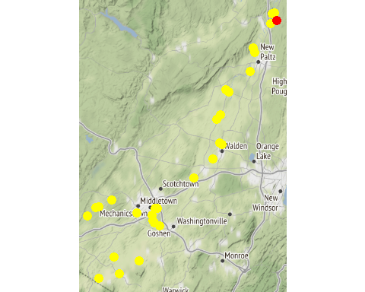

Chemistry Measurements: 13-SWAK-1.7

| **SITE_ID** | **chemical_name** | **record_count** | **mean** | **num_exceed** | **min** | **max** | **median** |
| --- | --- | --- | --- | --- | --- | --- | --- |
| 13-SWAK-1.7 | alkalinity, total (as caco3) | 10 | 75.920 | NA | 45.20 | 89.60 | 77.400 |
| 13-SWAK-1.7 | aluminum | 8 | 24.287 | NA | 5.80 | 43.10 | 23.500 |
| 13-SWAK-1.7 | arsenic | 10 | 0.694 | NA | 0.46 | 1.20 | 0.615 |
| 13-SWAK-1.7 | calcium | 10 | 29290.000 | NA | 17900.00 | 34300.00 | 28850.000 |
| 13-SWAK-1.7 | chloride (as cl) | 9 | 24.467 | NA | 15.10 | 30.40 | 24.800 |
| 13-SWAK-1.7 | chlorophyll a | 10 | 0.887 | NA | 0.14 | 2.59 | 0.610 |
| 13-SWAK-1.7 | copper | 3 | 0.727 | NA | 0.69 | 0.76 | 0.730 |
| 13-SWAK-1.7 | hardness (as caco3) | 10 | 87.170 | NA | 52.90 | 102.00 | 85.500 |
| 13-SWAK-1.7 | iron | 9 | 233.922 | NA | 29.60 | 720.00 | 192.000 |
| 13-SWAK-1.7 | lead | 5 | 0.282 | NA | 0.14 | 0.52 | 0.170 |
| 13-SWAK-1.7 | magnesium | 9 | 3403.333 | NA | 2010.00 | 3930.00 | 3410.000 |
| 13-SWAK-1.7 | nickel | 10 | 0.584 | NA | 0.37 | 0.85 | 0.535 |
| 13-SWAK-1.7 | nitrate+nitrite as nitrogen | 10 | 0.076 | NA | 0.00 | 0.16 | 0.085 |
| 13-SWAK-1.7 | nitrogen | 9 | 0.644 | NA | 0.31 | 1.07 | 0.640 |
| 13-SWAK-1.7 | nitrogen, ammonia (as n) | 1 | 0.010 | NA | 0.01 | 0.01 | 0.010 |
| 13-SWAK-1.7 | nitrogen, kjeldahl, total | 10 | 0.554 | NA | 0.21 | 1.04 | 0.550 |
| 13-SWAK-1.7 | nitrogen, nitrate (as n) | 7 | 0.101 | NA | 0.03 | 0.16 | 0.100 |
| 13-SWAK-1.7 | phosphorus, total (as p) | 10 | 0.044 | NA | 0.02 | 0.07 | 0.040 |
| 13-SWAK-1.7 | total dissolved solids (residue, filterable) | 5 | 159.600 | NA | 96.00 | 195.00 | 168.000 |
| 13-SWAK-1.7 | turbidity | 5 | 3.076 | NA | 1.44 | 5.17 | 2.120 |
| 13-SWAK-1.7 | zinc | 1 | 2.800 | NA | 2.80 | 2.80 | 2.800 |

In-Situ Measurements: 13-SWAK-1.7

| **SITE_ID** | **chemical_name** | **record_count** | **mean** | **num_exceed** | **min** | **max** | **median** |
| --- | --- | --- | --- | --- | --- | --- | --- |
| 13-SWAK-1.7 | chl rfu | 5 | 1.066 | NA | 0.50 | 2.47 | 0.700 |
| 13-SWAK-1.7 | chl ugl | 5 | 3.792 | NA | 0.46 | 9.60 | 2.800 |
| 13-SWAK-1.7 | conductance | 12 | 228.917 | NA | 89.60 | 479.90 | 231.350 |
| 13-SWAK-1.7 | dissolved oxygen | 24 | 9.196 | 0 | 5.44 | 12.67 | 8.245 |
| 13-SWAK-1.7 | pc rfu | 5 | 0.008 | NA | -0.20 | 0.20 | 0.010 |
| 13-SWAK-1.7 | pc ugl | 5 | 0.070 | NA | -0.06 | 0.30 | 0.010 |
| 13-SWAK-1.7 | pct saturation | 12 | 91.275 | NA | 64.20 | 98.50 | 93.550 |
| 13-SWAK-1.7 | ph | 12 | 7.727 | NA | 7.42 | 8.00 | 7.790 |
| 13-SWAK-1.7 | salinity | 12 | 0.110 | NA | 0.04 | 0.23 | 0.110 |
| 13-SWAK-1.7 | temperature | 12 | 15.975 | NA | 2.50 | 24.00 | 21.100 |

Dependent Measurements (Metals and Ammonia): 13-SWAK-1.7

| **SITE_ID** | **chemical_name** | **record_count** | **mean** | **num_exceed** | **min** | **max** | **median** |
| --- | --- | --- | --- | --- | --- | --- | --- |
| 13-SWAK-1.7 | zinc | 1 | 2.8 | 0 | 2.8 | 2.8 | 2.8 |

Numeric Nutrient Criteria: 13-SWAK-1.7

| **SITE_ID** | **chemical_name** | **record_count** | **mean** | **num_exceed** | **min** | **max** | **median** |
| --- | --- | --- | --- | --- | --- | --- | --- |
| 13-SWAK-1.7 | phosphorus, total (as p) | 10 | 0.044 | 0 | 0.02 | 0.07 | 0.04 |

BAP Score: 13-SWAK-1.7

| **SITE_ID** | **DATE** | **BAP** | **SD** | **n** |
| --- | --- | --- | --- | --- |
| 13-SWAK-1.7 | 8/8/2019 | 6.72 | 0.72 | 4 |

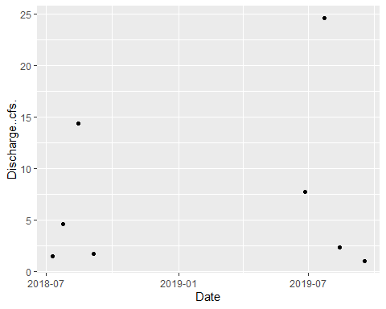

### Site ID: 13-WALK-0.7

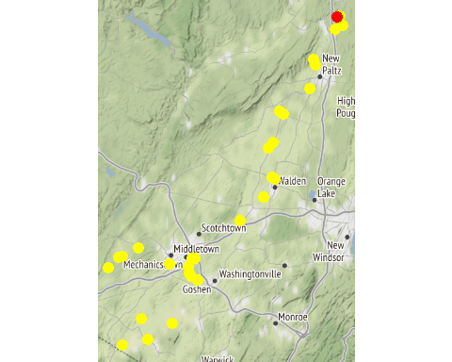

Chemistry Measurements: 13-WALK-0.7

| **SITE_ID** | **chemical_name** | **record_count** | **mean** | **num_exceed** | **min** | **max** | **median** |
| --- | --- | --- | --- | --- | --- | --- | --- |
| 13-WALK-0.7 | alkalinity, total (as caco3) | 2 | 94.700 | NA | 80.40 | 109.00 | 94.700 |
| 13-WALK-0.7 | aluminum | 2 | 178.400 | NA | 39.80 | 317.00 | 178.400 |
| 13-WALK-0.7 | arsenic | 2 | 2.050 | NA | 2.00 | 2.10 | 2.050 |
| 13-WALK-0.7 | calcium | 2 | 39100.000 | NA | 36500.00 | 41700.00 | 39100.000 |
| 13-WALK-0.7 | chloride (as cl) | 2 | 64.400 | NA | 47.60 | 81.20 | 64.400 |
| 13-WALK-0.7 | chlorophyll a | 2 | 17.005 | NA | 2.11 | 31.90 | 17.005 |
| 13-WALK-0.7 | copper | 2 | 3.450 | NA | 3.20 | 3.70 | 3.450 |
| 13-WALK-0.7 | hardness (as caco3) | 2 | 136.500 | NA | 123.00 | 150.00 | 136.500 |
| 13-WALK-0.7 | iron | 2 | 444.500 | NA | 105.00 | 784.00 | 444.500 |
| 13-WALK-0.7 | lead | 2 | 0.775 | NA | 0.35 | 1.20 | 0.775 |
| 13-WALK-0.7 | magnesium | 2 | 9380.000 | NA | 7660.00 | 11100.00 | 9380.000 |
| 13-WALK-0.7 | nickel | 2 | 1.750 | NA | 1.50 | 2.00 | 1.750 |
| 13-WALK-0.7 | nitrate+nitrite as nitrogen | 2 | 0.940 | NA | 0.14 | 1.74 | 0.940 |
| 13-WALK-0.7 | nitrogen | 2 | 1.950 | NA | 0.98 | 2.92 | 1.950 |
| 13-WALK-0.7 | nitrogen, ammonia (as n) | 2 | 0.075 | NA | 0.04 | 0.11 | 0.075 |
| 13-WALK-0.7 | nitrogen, kjeldahl, total | 2 | 1.010 | NA | 0.84 | 1.18 | 1.010 |
| 13-WALK-0.7 | nitrogen, nitrate (as n) | 2 | 0.920 | NA | 0.12 | 1.72 | 0.920 |
| 13-WALK-0.7 | nitrogen, nitrite | 2 | 0.020 | NA | 0.02 | 0.02 | 0.020 |
| 13-WALK-0.7 | phosphorus, total (as p) | 2 | 0.160 | NA | 0.11 | 0.21 | 0.160 |
| 13-WALK-0.7 | silver | 1 | 0.070 | NA | 0.07 | 0.07 | 0.070 |
| 13-WALK-0.7 | total dissolved solids (residue, filterable) | 2 | 264.500 | NA | 247.00 | 282.00 | 264.500 |
| 13-WALK-0.7 | turbidity | 2 | 9.000 | NA | 2.80 | 15.20 | 9.000 |
| 13-WALK-0.7 | zinc | 1 | 7.800 | NA | 7.80 | 7.80 | 7.800 |

In-Situ Measurements: 13-WALK-0.7

| **SITE_ID** | **chemical_name** | **record_count** | **mean** | **num_exceed** | **min** | **max** | **median** |
| --- | --- | --- | --- | --- | --- | --- | --- |
| 13-WALK-0.7 | conductance | 2 | 354.445 | NA | 277.89 | 431.00 | 354.445 |
| 13-WALK-0.7 | dissolved oxygen | 4 | 8.250 | 0 | 6.83 | 9.67 | 8.250 |
| 13-WALK-0.7 | pct saturation | 2 | 95.150 | NA | 69.30 | 121.00 | 95.150 |
| 13-WALK-0.7 | ph | 2 | 8.100 | NA | 7.70 | 8.50 | 8.100 |
| 13-WALK-0.7 | salinity | 2 | 0.170 | NA | 0.13 | 0.21 | 0.170 |
| 13-WALK-0.7 | temperature | 2 | 21.550 | NA | 16.40 | 26.70 | 21.550 |

Dependent Measurements (Metals and Ammonia): 13-WALK-0.7

| **SITE_ID** | **chemical_name** | **record_count** | **mean** | **num_exceed** | **min** | **max** | **median** |
| --- | --- | --- | --- | --- | --- | --- | --- |
| 13-WALK-0.7 | zinc | 1 | 7.8 | 1 | 7.8 | 7.8 | 7.8 |

Numeric Nutrient Criteria: 13-WALK-0.7

| **SITE_ID** | **chemical_name** | **record_count** | **mean** | **num_exceed** | **min** | **max** | **median** |
| --- | --- | --- | --- | --- | --- | --- | --- |
| 13-WALK-0.7 | phosphorus, total (as p) | 2 | 0.16 | 0 | 0.11 | 0.21 | 0.16 |

BAP Score: 13-WALK-0.7

| **SITE_ID** | **DATE** | **BAP** | **SD** | **n** |
| --- | --- | --- | --- | --- |

### Site ID: 13-WALK-0.8

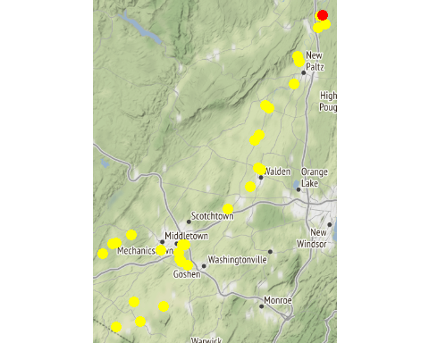

Chemistry Measurements: 13-WALK-0.8

| **SITE_ID** | **chemical_name** | **record_count** | **mean** | **num_exceed** | **min** | **max** | **median** |
| --- | --- | --- | --- | --- | --- | --- | --- |
| 13-WALK-0.8 | alkalinity, total (as caco3) | 3 | 99.800 | NA | 68.40 | 120.00 | 111.00 |
| 13-WALK-0.8 | aluminum | 3 | 121.667 | NA | 64.60 | 228.00 | 72.40 |
| 13-WALK-0.8 | arsenic | 3 | 1.460 | NA | 0.98 | 1.80 | 1.60 |
| 13-WALK-0.8 | calcium | 3 | 34933.333 | NA | 26100.00 | 40100.00 | 38600.00 |
| 13-WALK-0.8 | chloride (as cl) | 2 | 58.050 | NA | 32.50 | 83.60 | 58.05 |
| 13-WALK-0.8 | chlorophyll a | 3 | 20.943 | NA | 3.93 | 30.40 | 28.50 |
| 13-WALK-0.8 | copper | 3 | 2.667 | NA | 2.40 | 3.10 | 2.50 |
| 13-WALK-0.8 | hardness (as caco3) | 3 | 124.600 | NA | 88.80 | 144.00 | 141.00 |
| 13-WALK-0.8 | iron | 2 | 312.500 | NA | 183.00 | 442.00 | 312.50 |
| 13-WALK-0.8 | lead | 3 | 0.390 | NA | 0.31 | 0.47 | 0.39 |
| 13-WALK-0.8 | magnesium | 3 | 9106.667 | NA | 5720.00 | 10900.00 | 10700.00 |
| 13-WALK-0.8 | nickel | 3 | 1.300 | NA | 1.30 | 1.30 | 1.30 |
| 13-WALK-0.8 | nitrate+nitrite as nitrogen | 3 | 0.467 | NA | 0.05 | 0.89 | 0.46 |
| 13-WALK-0.8 | nitrogen | 3 | 1.337 | NA | 1.17 | 1.59 | 1.25 |
| 13-WALK-0.8 | nitrogen, ammonia (as n) | 2 | 0.020 | NA | 0.01 | 0.03 | 0.02 |
| 13-WALK-0.8 | nitrogen, kjeldahl, total | 3 | 0.873 | NA | 0.70 | 1.12 | 0.80 |
| 13-WALK-0.8 | nitrogen, nitrate (as n) | 3 | 0.460 | NA | 0.05 | 0.89 | 0.44 |
| 13-WALK-0.8 | nitrogen, nitrite | 1 | 0.010 | NA | 0.01 | 0.01 | 0.01 |
| 13-WALK-0.8 | phosphorus, total (as p) | 3 | 0.107 | NA | 0.10 | 0.12 | 0.10 |
| 13-WALK-0.8 | total dissolved solids (residue, filterable) | 3 | 231.667 | NA | 166.00 | 281.00 | 248.00 |
| 13-WALK-0.8 | turbidity | 3 | 4.340 | NA | 3.13 | 5.48 | 4.41 |
| 13-WALK-0.8 | zinc | 3 | 9.400 | NA | 2.60 | 18.50 | 7.10 |

In-Situ Measurements: 13-WALK-0.8

| **SITE_ID** | **chemical_name** | **record_count** | **mean** | **num_exceed** | **min** | **max** | **median** |
| --- | --- | --- | --- | --- | --- | --- | --- |
| 13-WALK-0.8 | conductance | 3 | 562.000 | NA | 479.00 | 670.00 | 537.00 |
| 13-WALK-0.8 | dissolved oxygen | 6 | 5.533 | 1 | 4.90 | 6.20 | 5.50 |
| 13-WALK-0.8 | pct saturation | 3 | 68.600 | NA | 62.80 | 75.00 | 68.00 |
| 13-WALK-0.8 | ph | 3 | 8.193 | NA | 7.92 | 8.40 | 8.26 |
| 13-WALK-0.8 | salinity | 3 | 0.270 | NA | 0.23 | 0.32 | 0.26 |
| 13-WALK-0.8 | temperature | 3 | 26.167 | NA | 25.60 | 27.30 | 25.60 |

Dependent Measurements (Metals and Ammonia): 13-WALK-0.8

| **SITE_ID** | **chemical_name** | **record_count** | **mean** | **num_exceed** | **min** | **max** | **median** |
| --- | --- | --- | --- | --- | --- | --- | --- |
| 13-WALK-0.8 | zinc | 3 | 9.4 | 2 | 2.6 | 18.5 | 7.1 |

Numeric Nutrient Criteria: 13-WALK-0.8

| **SITE_ID** | **chemical_name** | **record_count** | **mean** | **num_exceed** | **min** | **max** | **median** |
| --- | --- | --- | --- | --- | --- | --- | --- |
| 13-WALK-0.8 | phosphorus, total (as p) | 3 | 0.107 | 0 | 0.1 | 0.12 | 0.1 |

BAP Score: 13-WALK-0.8

| **SITE_ID** | **DATE** | **BAP** | **SD** | **n** |
| --- | --- | --- | --- | --- |